Top Tips for caring for QuaranTEENs

We know that young people who have experienced developmental trauma struggle with their emotions and feelings. At times of stress this becomes EVEN MORE challenging for them. In the current situation there is a lot of uncertainty and worry that our young people will be very much aware of. If you think of it like this; due to their experiences their foundations (sense of safety and security in the world) are wobbly to begin with, so all worries and changes that have happened due to the

pandemic will make their foundations even more unsteady at the moment. With this in mind we thought it may be helpful to have some ideas about how to support your young people through this tricky time! Of course you will all know your teenagers very well indeed, and will know what works well for them, so this is just some general guidance that may be helpful for you to think about.

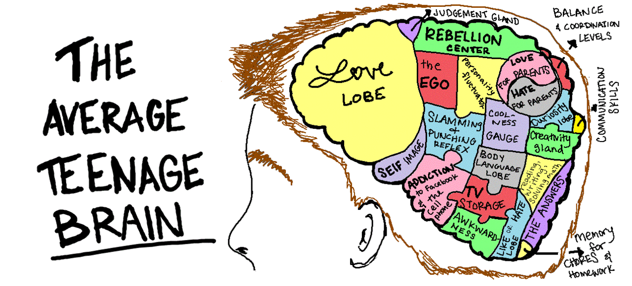
- Empathise with them. It is perfectly natural to have worries about the current situation, spending time listening (that also means resisting the urge to try and fix everything) to your teenagers is going to help them feel understood. If you see that they are struggling (whether they are withdrawn, anxious, angry etc) notice this with them when the time is right- help them make sense of why they may be feeling like that.

- Connect with them. Try to make some time where you can do something fun together (depending on what your young person likes!). So could be doing nails, having a project you can complete together or going out in the garden/ for a walk together). Competitive games can be a bit problematic as our young people can really struggle with losing. So doing something co-operative is safer and less stressful.

- Some teenagers will have school work being sent home. If they are struggling with this allow them some time out to do something that calms them/grounds them. They won’t be able to learn if they are under lots of stress. During this difficult time helping them feel safe is the most important thing.

- Encourage them to virtually connect with friends. For teenagers their peer group is massively important for their sense of identity. However, at the same time we know for some of our young people friendships/relationships can be difficult. So they may need your support with this - which could just mean checking in with them and keeping lines of communication as open as you can.

- Same as above for those children who have family time virtually. For teenagers missing their family it is really important to empathise with them. Recognising how tough the current situation is, whilst resisting putting a silver-lining on it or trying to fix it, may help them feel more seen and understood.

- Remember their threat system (flight,fight, freeze) is sensitive and may be more easily activated at the moment. If they need to run can you pre-arrange a safe place they can run to (the garden, their room) this may reduce the risk of them going missing.

- Have a think about their usual coping strategies - are they able to do them now with the current restrictions? For example, if you have a teenager who needed to go on a walk when they were feeling stressed could you do this together? Or do a fun exercise video together? You may have to think of safe alternatives with them. If you see that they are regressing or falling back on old coping strategies, notice this with them in a sensitive, non-judgmental way.

- Keeping to some level of routine in the day. Routine, structure and predictability makes teenagers feel safe, as much as they might say or act otherwise! Try and keep to some level of routine, even if it’s a small thing like a meal together at the normal time or a tradition of film-night Fridays. Try to give some predictability to the day and the week.

- BE KIND TO YOURSELVES AND CUT YOURSELVES SOME SLACK! Easier said than done but take this seriously. Take time where you can to be kind to yourselves. Please don’t beat yourselves up if you’re not nailing it in your new-found role of being teacher, counsellor, entertainer, virologist and parent all at once! That is a near superhuman task, even for you lot!

