Curriculum | Weekly Learning Projects
Making a wind chime
A wind chime adds an extra sensory element to your garden. Why not create wind chimes and mobiles using recycled items or natural materials.
What you need:
• A selection of recycled items (keys, CDs, beads, buttons)
• A selection of natural materials (pinecones, shells, twigs)
• Scissors
• String
What to do:
1. Provide children with books and access to the Internet to research different wind chime designs.
2. Ask the children to select a base for their wind chime. The other materials will be attached to this base so it should be both sturdy and large enough to fit the chimes on.
3. Ask the children to then select the materials they will use for their chimes. These could be all-natural materials, all recycled materials or a mixture.
4. Encourage the children to think about how their choices will sound and look as they move in the breeze.
5. Provide string and scissors for the children to attach their chimes to their base.
6. Display the wind chimes around the garden.

Ways to extend this activity:
Children could make wind socks to investigate weather patterns. Children could use this activity as part of a project on sound and could investigate how they hear the different wind chimes.

National Curriculum Links: Identify which part of the body is associated with each sense. Observe and describe the weather. Identify and compare the suitability of different materials for particular uses. Recognise that vibrations from sounds travel through a medium to the ear. Recognise that sounds get fainter as the distance from the sound source increases. Design purposeful, functional and appealing products. Select from and use a range of materials according to their characteristics.

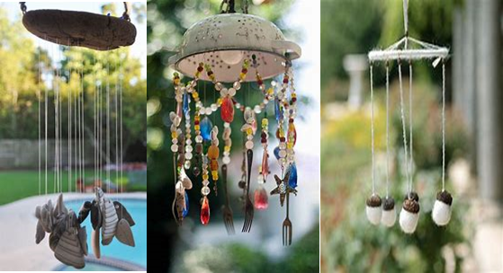

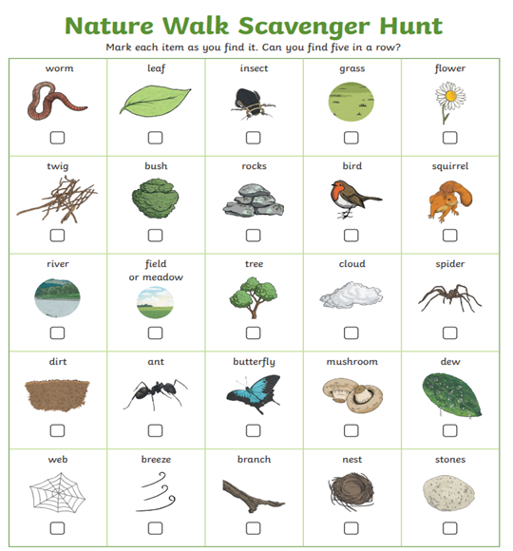
Nature Walk and Scavenger Hunt

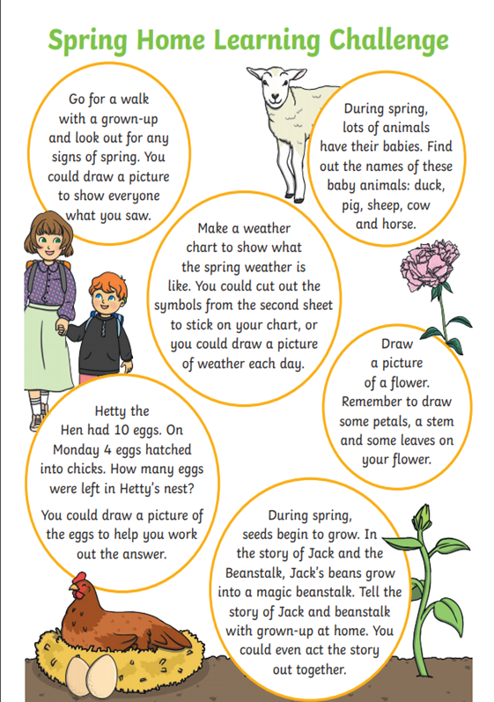

Our theme this week is ‘The Three Little Pigs’.

Building
Can you build a house for the Three Little Pigs? They used straw, sticks and bricks, what could you build with?
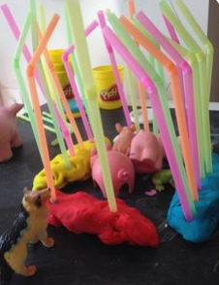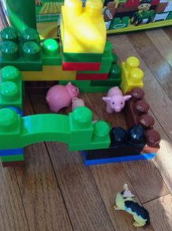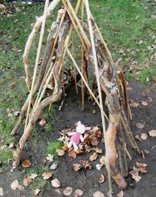

Can you build a den that is big enough for you to fit inside?

Cooking
Make snack time more exciting with these tasty piggy treats!

- Homemade biscuits with marshmallow and chocolate face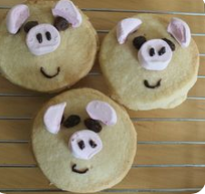

- Cheese, ham and crackers
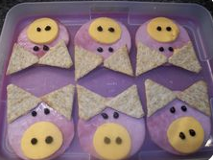

- Rice cakes with fruit and yoghurt

Arts and crafts
Be creative with materials you can find around the house and add cute googly eyes!
Handprint painting - great for those who love getting their hands dirty!
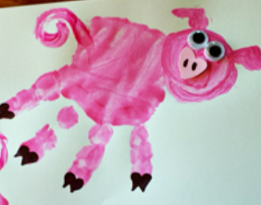

Cotton wool dipped in paint, ink or food colouring - Fantastic for developing fine motor skills by gripping and dipping the cotton wool.

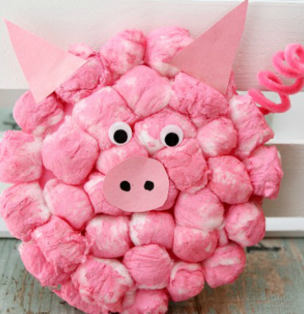

Flower pot pigs - These could be just for decoration, or decorate them the other ways up and use them for planting seeds. You could use other containers, e.g. yoghurt pots or paper cups
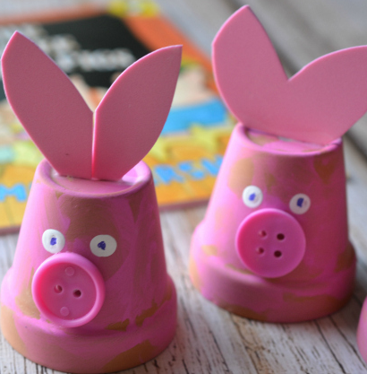

Art Focus: Flower picking for Grandma in Little Red Riding Hood
- Create tissue or paper flowers.
- Paint or draw a bunch of flowers for grandma.
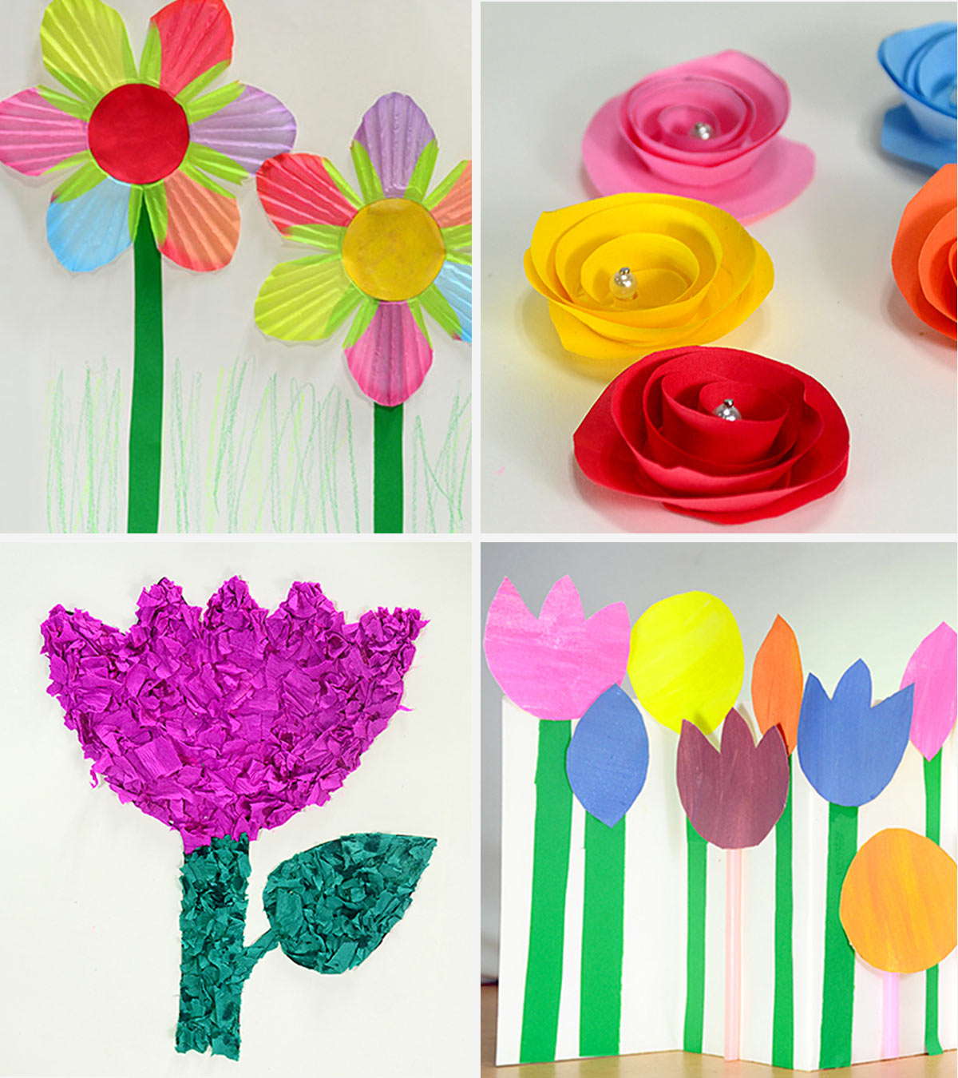
- Go on a local walk and collect some wild flowers to deliver to a visitor or member of your family.

Reading focus: Book themed day- build a Red Riding Hood reading den
- Go on a woodland walk and collect fallen leaves and twigs and take photos
- Create a Grandma’s House role-play area with a bed, costumes (nightdress, a nightcap, a red cape, a basket and a wolf costume or mask), trees outside the house windows and pencils and paper to write letters from the wolf or grandma.
- Make your own Red Riding Hood mask and finger puppets.
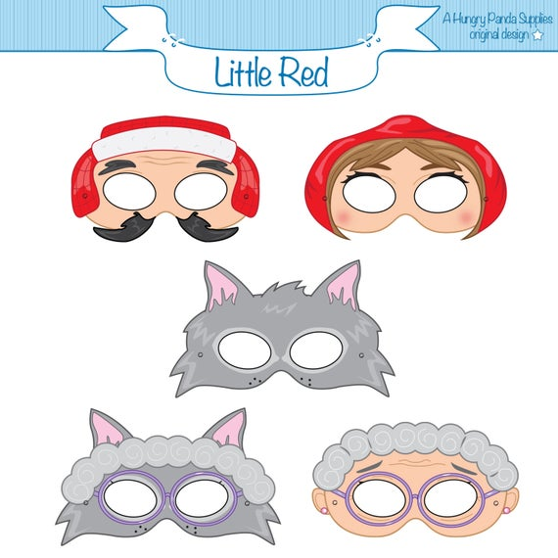
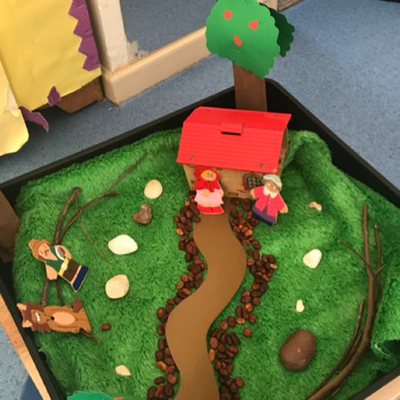
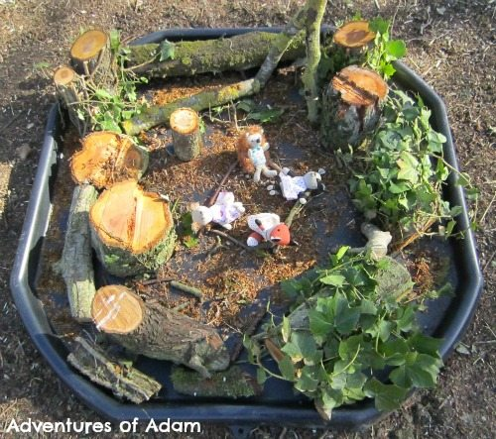
Food technology focus: Basket of food picnic for Grandma
- Collect some different picnic ideas and recipes you would like to use for your grandma’s picnic:
- Little Red Riding Hood cutting skills activities- See the school website for this resource
- Red Riding Hood cocktail sticks- See the school website for this resource
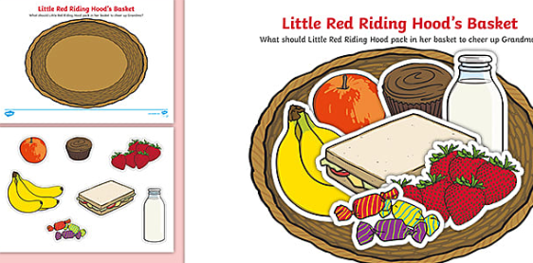
- Make some simple sandwiches

Theme: The Day the Crayons Quit by Drew Daywalt
Use the following link to listen to the story of ‘The Day the Crayons Quit’ by Drew Daywalt and discuss your thoughts on this. Did you enjoy the story and why?
https://www.youtube.com/watch?v=489micE6eHU&safe=true

Draw the characters!
Select your favourite crayon and try to draw the character! Can you change the emotions of the crayon? E.g. make the character look happy, sad, shocked etc.
Can you draw all of the things that this character colours, too?
Which materials are you going to use for your art project?
Write a letter!
Write a letter from Duncan to a crayon of your choice. What might he say back to the crayon? How should a letter be laid out and what features do you need to include?
Write a new story!
Can you write a new story based on ‘The Day the Crayons Quit’? Select another everyday object and write a range of letters to the owner. Think about the function of the object - what issues could arise for the object?
Re-Grow Fruit and Vegetables from Scraps:
Create your own fruit and vegetable garden with the scraps of your fruit and vegetables that you have in your kitchen at home.

Potatoes
Any chunky sections of potato peel or pieces of potato that include an ‘eye’ on them (those small indentations from which the shoots grow) can be replanted to grow new potato plants.
Simply take your potato scraps, leave them to dry out slightly overnight and plant them in the soil with the eyes facing up in the same way that you would plant seed potatoes.
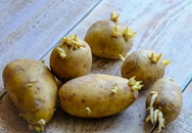

Celery
Celery is one of the easiest plants to re-grow from scraps.
You simply have to cut off the bottom of the celery and place it in a shallow container with a little warm water in the bottom. The bowl should be kept in a sunny and relatively warm place.
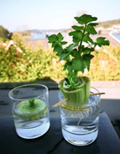
Carrots
Soak carrot tops in a shallow pool of water for one week and transfer to soil when roots form.
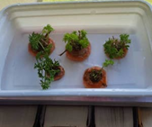

Avocado
For a long-term project, try sprouting an avocado pit to grow a tree. After sprouting the pit (which can take up to eight weeks) transfer the pit into soil and let it grow. The growth will be slow, but it's totally worth it for an avocado tree!
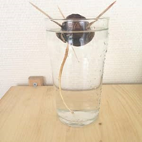

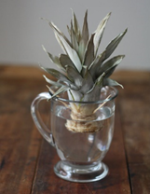
Pineapple
Choose a pineapple with fresh green leaves. Remove the top of the pineapple by twisting off the leaves. Peel back around the base so the bottom layers are exposed. Cut off the tip of the base and remove any excess fruit. Poke three or four toothpicks into the base of the pineapple leaves and suspend over a bowl. Fill the bowl with water. Change the water every few days. When the roots are fully formed, plant the top of the pineapple in soil.
Strawberries
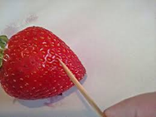
Using a toothpick, pick out at least 12 seeds. Deposit the seeds at the bottom of a paper cup, where they can dry at room temperature for two to three days. Add soil.
Once your strawberries begin to sprout (in around four to six weeks) place them in an area with moderate sunlight, either outdoors (during warm weather) or indoors. After six weeks of growth, transfer the strawberry plants to your garden or a larger pot.

Tomatoes
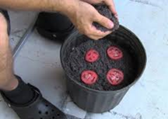
Place a few centimetres of soil in the bottom of the cup. Place the tomato slice on top of the soil. Place a few centimetres of soil on top of the tomato slice. Spray lightly with water. Keep in a warm spot until plants begin to sprout (can take between 30 and 100 days, depending on which variety of tomato you have). Transfer to a larger pot when plants reach three inches in height.
Tomatoes can be grown indoors or out and require little watering to thrive.

Cooking with Food Scraps:
Create food and snacks for you and your family with the scraps of your fruit and vegetables that you have in your kitchen at home.

Banana Peel Cake
Ingredients
180g unsalted butter, softened, plus extra for greasing
2 medium whole ripe bananas, washed, ends trimmed, flesh and peel roughly chopped
180g golden caster sugar
3 large eggs
1 tsp vanilla extract
210g self-raising flour
1 tsp baking powder
1 tsp ground cinnamon
70g walnut pieces, roughly chopped
150g icing sugar
40ml milk or coconut milk
30g pack toasted coconut flakes
Method
Preheat the oven to gas 6, 200°C, fan 180°C. Grease and line a deep 20cm round cake tin with non-stick baking paper. Put the bananas and peel in a food processor with 70ml boiling water and blitz until smooth. Set aside to cool a little.
Meanwhile, beat the butter and caster sugar in a large bowl with an electric whisk for 3-4 minutes (or a wooden spoon for 7-8 minutes) until light and fluffy, then beat in the eggs one at a time. Stir in the vanilla.
In a separate bowl, mix the flour, baking powder and cinnamon with a pinch of salt. Fold half into the butter mixture with a metal spoon until just combined. Fold in the pureed banana, then the remaining flour mixture and the walnuts. Pour into the tin, level the top and bake for 50-55 minutes or until a skewer inserted into the centre comes out clean. Leave to cool in the tin for 10 minutes, then remove and transfer to a wire rack to cool completely.
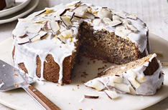
To make the icing, whisk the icing sugar and milk in a bowl until well combined – the consistency should be like PVA glue. If it's too thick, add more milk, 1 tsp at a time, to loosen. Put the cake on a plate and pour the icing onto the centre, then spread out until it just drips down the sides. Scatter over the coconut flakes and leave to set. Will keep, chilled, in an airtight container for up to 2 days.

Baked Bruised Apple Crisps
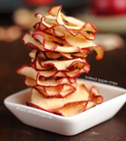
Ingredients
Bruised apples
Cinnamon
Method
1. Preheat oven to 225-degree oven
2. Cut apples into slices and arrange in a lined baking sheet and sprinkle with cinnamon
3. Bake for two hours, flipping the slices over after an hour.

Broccoli Stem & Cauliflower Coleslaw
Ingredients
Broccoli Stems
Cauliflower Cores
Carrot Shavings
Bruised Granny Smith Apple
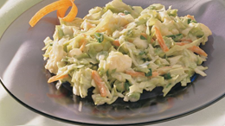
Leftover Celery
Dijon Mustard
Cider Vinegar
Salt
Pepper
1 clove of garlic
Method
1. Thinly slice all the leftover veggies and fruits, make sure all the shavings are the same size.
2. Add the mustard, vinegar, mayo and sliced garlic.
3. Mix all the ingredients and add salt and pepper to taste. Let the slaw sit for an hour before serving.

Baked Potato Peel Chips
Ingredients
Potato peelings
Olive oil
Seasonings (suggestions include vinegar and salt, paprika or Sriracha)

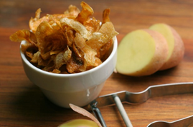
Method
Preheat oven to 400 degrees Fahrenheit.
In a medium sized bowl, toss peels, oil and seasonings
Lay coated peelings fat on baking sheet and bake for 15 or 20 minutes, flipping halfway through.

Vegetable Scrap Lentil Soup
(any vegetable scraps you have can be used in this recipe)
Ingredients
1 tsp olive oil
2 cloves of garlic, minced
1 small onion, diced
3 wilted celery stalks, minced
Carrot peels and tops
Green bean ends
1-2 handfuls wilted spinach or other leafy green
130g uncooked red lentils (or other grain of choice)
400ml vegetable stock
400g tin chopped tomatoes
½ tsp smoked paprika
2 tsp chili powder
1 tsp ground cumin
Salt and pepper to taste

Method
In large saucepan, heat the oil over medium heat and add onion and garlic and sauté for 5-6 minutes, until translucent.
Add wilted celery, carrot scraps, and green beans ends and sauté for a few more minutes and then add spices (except salt and pepper), stir to combine, and sauté for a couple more minutes.
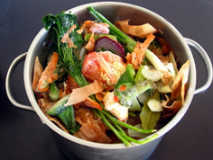
Stir in the tomatoes and their juice, the broth, and the washed lentils. Bring mixture to a boil, reduce heat to medium simmer (uncovered) for 2-25 minutes, until lentils are tender.
Season with salt and pepper. Stir in the wilted greens until combined and serve hot.

Food Art:
How food looks on a plate plays a great part of the overall pleasure of eating. Why not try to see if you can turn your plate of food into a piece of art?
Chewbacca Noodles
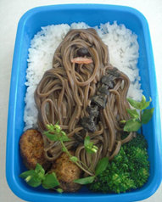
Hot Dog Mummies
Panda Sushi
Angry Bird Sandwiches
Octopus Pie
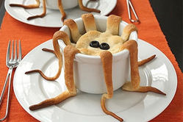
Pasta Nest
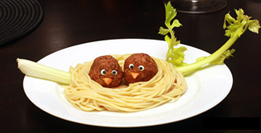

Don’t forget to take pictures of your activities and send them to school via Class Dojo!

