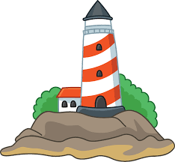
Paper cup lighthouses

Can you make a lighthouse using a paper cup? Try to decorate it in an eye catching way. This will make it easier for boats to see it.

You can use yellow paper for the light or if you have one a battery tea light.

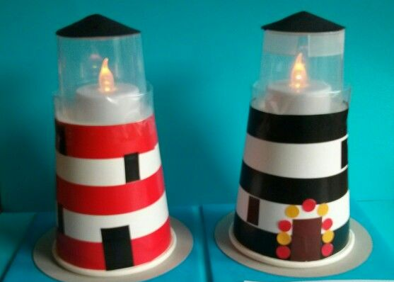
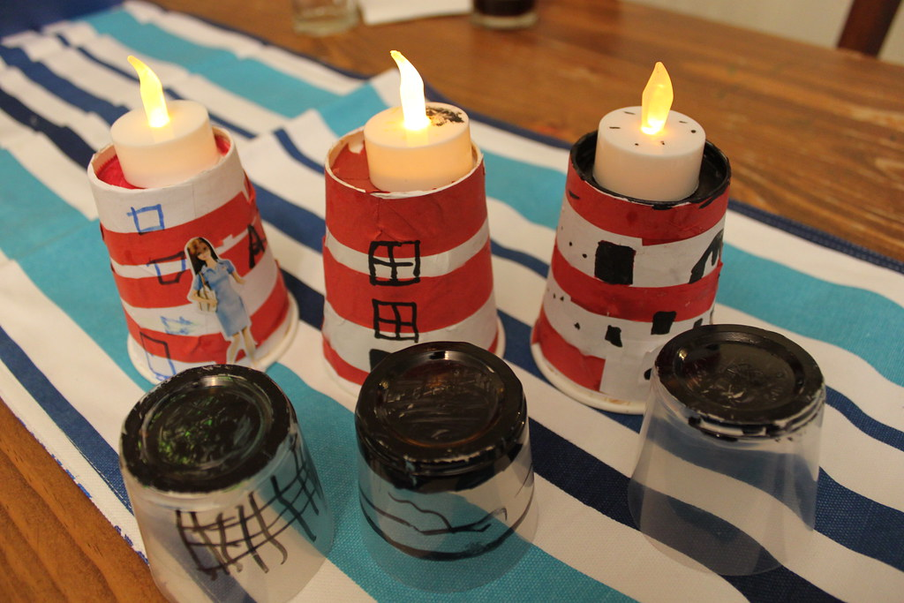
Get a grown up to help you and keep a look out for the ones we make at school.

