Year 2 Long Term Plan
 | Autumn | Spring | Summer
Driver/POD | The First Moon Landing  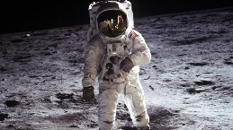 | London and the Monarchy  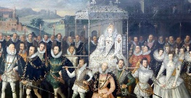 | 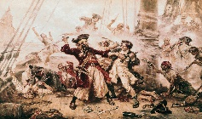  Explorers of the Sea
Trips | VR Experience | Trip to Cave Castle  Lab Rascals | Trip to seaside with links to Pirates/Hull Maritime Museum
Overall Enquiry Question | How do astronauts get into space? | Do all Royalty live in London? | Who sails the seas?
Science | Animals including Humans | Everyday Materials  Plants | Living things and their Habitats
History | Changes within living Memory  Lives of significant Individuals  Events beyond living Memory | Lives of significant Individuals  Events beyond living Memory  Significant historical events, people and places in own locality | Lives of significant Individuals  Events beyond living Memory
Geography | Locational Knowledge  Human and Physical features of contrasting localities  Use maps, globes and atlases | Locational Knowledge  Use maps, globes and atlases  Use aerial photographs to recognise landmarks and basic human and physical features | Locational Knowledge  Human and Physical features of contrasting localities  Location of hot and cold places  Devise a simple map with a key  Use maps, globes and atlases  Use simple compass directions
Art | Painting and Sculpture | TBA | TBA
D&T | Construction – Moon Buggy | Cooking – Queen’s Tea Party | Textiles – Pirate Puppets
Computing | Unit 2.1 Coding  Unit 2.2 Online Safety  Unit 2.3 Spreadsheets | Unit 2.4 Questioning  Unit 2.5 Effective Searching | Unit 2.6 Creating Pictures  Unit 2.7 Making Music  Unit 2.8 Presenting Ideas
Music | Autumn 1 – Explore music styles  Autumn 2 – Boom Whackers and Christmas Songs | Spring 1 – Make our own Boom Whacker Song  Spring 2 – Charanga – Hand, Feet, Heart | Summer 1 – Make a music story  Summer 2 – Sea Shanties
PE | Dance (water and explorers), FMS (ball skills – hand and feet) | Gymnastics (Linking and Pathways), Locomotion (dodging), FMS (ball skills – hands) | Locomotion (jumping), Games for understanding, Health and Wellbeing
RE | What does it mean to belong? | How do people demonstrate their beliefs? | What are the BIG questions?
PSHCE | Being in my World  Celebrating Differences | Dreams and Goals  Healthy Me | Relationships  Changing Me

