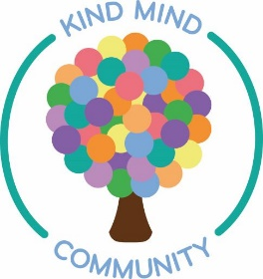
World Mental Health Day
2020

World Mental Health Day 2020 is the most important one yet.

This year has been a tough one for us all. The months of lockdown
have had a huge impact on our mental health and wellbeing.
Issues such as fear of the unknown, struggling to access food or medication,
missing our loved ones, losing routine and purpose have been experienced by many.

So, what can you do about it?
Here’s our top tips for improving your wellbeing

- Bake a cake
This is no ordinary cake, this is the Depressed Cake Shop
These cakes have an element of grey to signify the grey cloud that can descend over a beautiful world when someone is struggling with mental health issues. The inside has a pop of colour to represent hope for the future.

For instructions on how to make this please visit
http://shewhobakes.co.uk/recipes/depressed-cake-shop-fudge/

for more info on the Depressed Cake Shop please visit www.depressedcakeshop.org

Once you’ve made your fudge, we’d love to see it so take a photo and post on our Facebook
group Kind Mind Community: https://www.facebook.com/groups/2581719348713920

- Give your brain a workout

Research shows that learning a new skill improves your mental health by boosting
your confidence and self-esteem and building a sense of purpose.

All the words in this word search are connected to positive mental health and wellbeing

- There’s an app for that

There are many apps out there to offer support, motivation and information on
keeping yourself safe and well. Find them at your usual app store.

MindShift
MindShift is a free app designed to help teens and young adults cope with anxiety. Rather than
try to avoid anxious feelings, MindShift stresses the importance of changing the way you
think about anxiety. It can encourage you to take charge of your life, ride out intense emotions
and face challenging situations.

Happify
Need a happy fix? With its psychologist-approved mood-training, the Happify app is your
fast-track to a good mood through games, activity suggestions and gratitude prompts.
Train your brain to overcome negative thoughts.

Meditation has been shown to help people stress less, focus more and even
sleep better. Headspace is meditation made simple. We'll teach you the
life-changing skills of meditation and mindfulness in just a few minutes a day.

Calm provides people experiencing stress and anxiety with guided meditation,
sleep stories, breathing programmes and relaxing music. Suitable for beginners
and those more experienced in meditation.

What do you call a dinosaur with crippling anxiety?
Nervous Rex

- F A C E C O V I D

F – focus on what’s in your control. When we are facing a crisis of any sort, we are bound to
feel both fear and anxiety. These are normal responses to challenging situations.
It’s all too easy to get lots in worrying and ruminating about all sorts of things which are out
of your control.
You can’t control what happens in the future, you can’t control Covid-19 or your feelings but
you can control what you do and how you handle it.

A – acknowledge your thoughts and feelings. What thoughts, feelings, emotions and
memories does this throw up for you?

C – come back into your body. Connect with your physical body.

E – engage in what you are doing. Focus your attention on the activity you are doing.

C – committed action. What are the simple ways to look after yourself?

O – opening up. Make room for difficult feelings and be kind to yourself. Treat yourself
as well as you’d treat a friend.

V – values. Be guided by your what you value in life. What sort of person do you want to be?

I – identify resources. Offer support to others and use trustworthy and reliable guidance
(NHS or Gov websites).

D – disinfect and distance physically. Wash your hands regularly and keep your distance from others.

For more info go to
https://www.actmindfully.com.au/wp-content/uploads/2020/03/FACE-COVID-eBook-by-Russ-Harris-March-2020.pdf

- Look after your WELLBEING by finding balance

With the current situation, many of our normal routines and daily activities are changing.
Naturally this can be upsetting and many of the things we would normally do to look after
our wellbeing have become difficult. Whatever your life looks like now, it can be helpful to
organise a daily routine that involves a balance of activities that –
- Give you a sense of achievement
- Help you feel connected to others
- Are just for pleasure
Achievement
We feel good when we have achieved something so it is helpful to include activities each day which give you a sense of accomplishment.
For example, doing some housework, gardening, cook a new recipe, exercise, complete a task you’ve put of such as paying a bill.

Pleasure

When we struggle with anxiety or worry we can lose touch with the things we used to do for pleasure.

Plan to do some activities each day which give you pleasure and make you feel joyful e.g. read a good book, watch a comedy, dance or sing to your favourite song, have a relaxing bath or eat your favourite food.

Connection
We are social animals who crave closeness and connection with other people. With the current Covid situation, we may be physically isolated from others so it’s important we consider creative ways to connect in order that we don’t become lonely or socially isolated.
How can you connect safely with friends and family? How about phone, social media, Skype, Zoom, Whatsapp or virtual activities such as book or film club, online neighbourhood group or getting involved in helping your local community.

Activities which give a good balance of pleasure, achievement and connection will lift
your mood and help you cope with the difficulties of dealing with Covid-19.

The human body is 80% water.
So basically, we’re just cucumbers with anxiety

- Challenge Yourself

See how many of these acts of kindness you can do for yourself and others over the
next month. Notice how this impacts on your wellbeing.

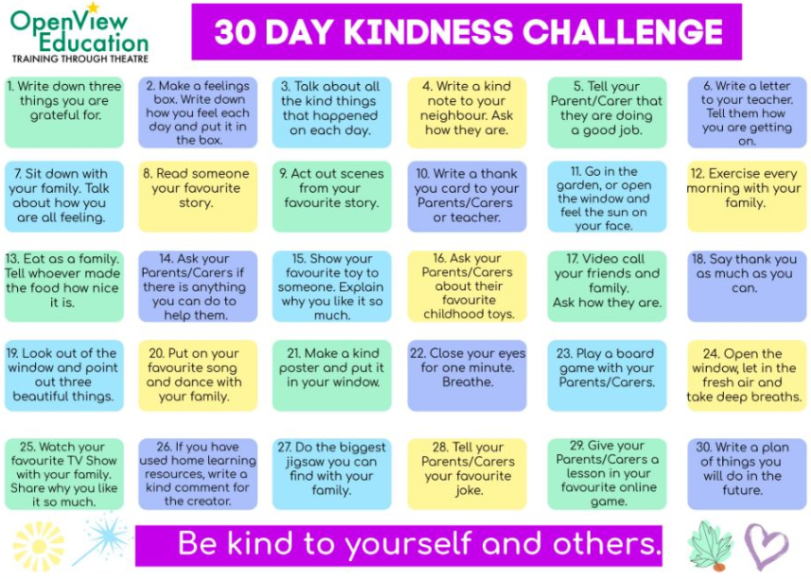
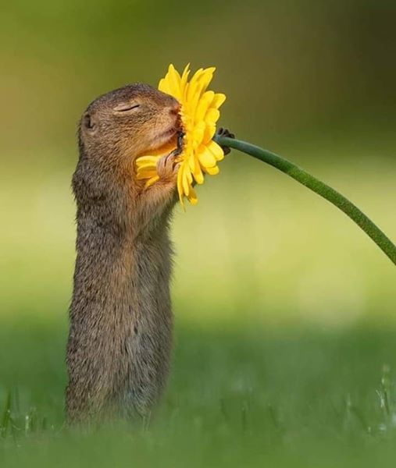

- Learn a new skill

- What job did Simon Cowell have before he made it big?
- Model
- Tea boy
- Bin man

- If you have cryophobia, what are you afraid of?
- Crying
- Cold
- Cheese

- How long do the majority of people with a mental health problem wait before telling
friends and family?
- 3 Months
- 7 months
- Over a year

- What is the most sold flavour of Walkers crisps?
- Cheese and onion
- Salt and vinegar
- Ready salted

- Before the Mental Health Discrimination Act came into force in 2013 what were some
people with mental health issues unable to do?
- Be a psychologist
- Serve as an MP
- Represent GB at the Olympics

- In what year did the Beatles split up?
- 1968
- 1970
- 1972

- Which 2 musicians collaborated on ‘Another Way to Die’ the theme tune to the Bond film
‘Quantum of Solace’ in 2008
- Alicia Keys and Jack White
- Sting and Sara Bareilles
- Gavin Rossdale and Leona Lewis

- Who won Sports Personality of the Year 2019?
- Andy Murray
- Mo Farrah
- Ben Stokes

- Which group of people are more likely to experience mental health issues?
- Black or Black British people
- Young women aged 16-24
- People who identify as LGBTIQ + (lesbian, gay, bisexual, trans, intersex, queer or questioning)
- People who have issues with homelessness, substance misuse or contact with the
criminal justice system

- What is the longest river in the world?
- Mississippi
- Nile
- Amazon

- Who was Henry VIII’s last wife?
- Catherine Parr
- Catherine of Aragon
- Jane Seymour

- What nuts are used in marzipan?
- Cashews
- Peanuts
- Almonds

- What is the biggest killer of men under the age of 50?
- Heart attack
- Suicide
- Diabetes

- In what year was the first episode of Coronation Street first shown?
- 1960
- 1962
- 1964

- Which famous Hollywood actress had cameo appearances in the TV show Doc Martin in 2019?
- Susan Sarandon
- Christine Baranski
- Sigourney Weaver

- Who is the only singer to have performed more than one James Bond theme tune?
- Shirley Bassey
- Paul McCartney
- Carly Simon

- Half of all adult mental health issues start at what age?
- Before 14 years
- Between 14-18 years
- They don’t usually start until adulthood

- How many MPs does the UK have?
- 250
- 450
- 650

- In tennis what piece of fruit can be found at the top of the Men’s Wimbledon Trophy?
- Pomegranate
- Pineapple
- Plum

- In what year did the Jarrow march take place?
- 1934
- 1935
- 1936
(Answers at the bottom of this page)
Resources

- If you or someone you know need urgent help with their mental health please contact the
Crisis Team on 0303 123 1145. If there is an immediate risk please ring 999
- Samaritans 116 123
- Listening Ear Jarrow email: listeningearjarrow@gmail.com

We hope you enjoyed this World Mental Health Day 2020 booklet.
If you would like more information on what Even Better and Kind Mind Community do or would like to
get involved please get in touch

- Kind Mind Community email: STRecoveryCollege@mentalhealthconcern.org
- Even Better email: hannah@evenbetter.org.uk

Quiz answers (don’t cheat)

1: B | 2: B | 3: C | 4: A | 5: B | 6: B | 7: A | 8: C | 9: D | 10: B
11: A | 12: C | 13: B | 14: A | 15: C | 16: A | 17:A | 18: C | 19: B | 20: C

