A-level Psychology
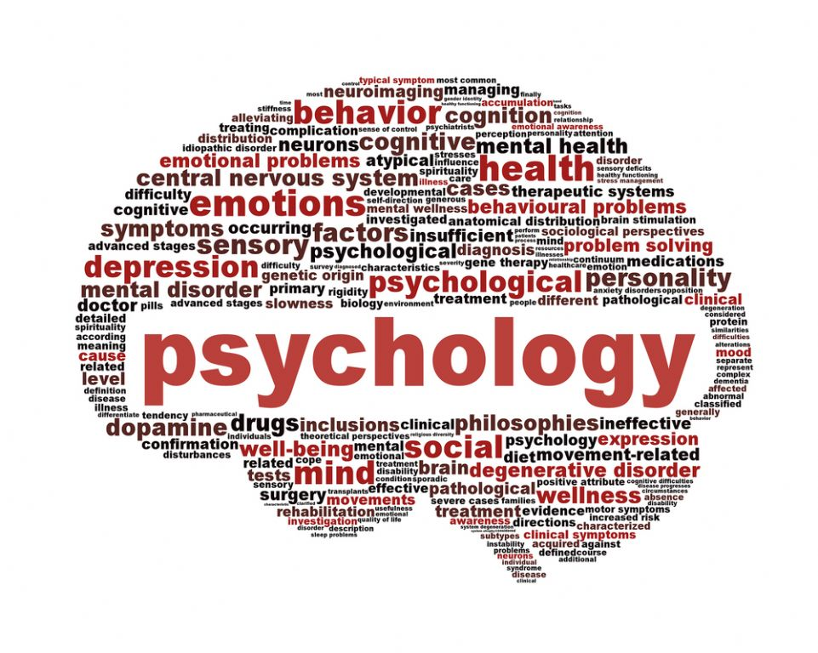
Bridging Course - Week 4

St Mary’s Catholic School
A-level Psychology Bridging Course

The following work requires you to explore psychopathology. You will then begin the process of learning to link the approaches, issues and debates to this topic. The final task involves submitting a report to demonstrate your ability to do this. Remember to take regular breaks, go back to the tasks after some time away, and try your best. Your Psychology teacher will go over the concepts with you in lessons, early in Year 12 to check your understanding.

Task 1: Recap

Over the past three weeks you have investigated the key approaches which psychologists use to explain behaviour, the way these approaches suggest behaviour can be changed, and the issues and debates which psychologists face trying to understand behaviour. Before we move on to explore these in relation to psychopathology, complete the questions below to see what you can remember. You do not need to write the questions out. Write your answers on paper under the title ‘Task 1: Recap Questions Week 4.’

- According to the biological approach, what should be considered when investigating behaviour?
- Which approaches would support the use of therapy to change behaviour? Explain your choices.
- In relation to the nature-nurture debate, which two approaches sit on opposite sides of this debate? Explain your choices.
- Two approaches suggest we should focus on thoughts when trying to understand behaviour, however one suggests we focus on conscious thoughts and the other on unconscious thoughts. Which two approaches are being referred to here?
- Which approach would argue that treatment for behaviour should be no different than it is for physical illnesses? Explain your answer.

If you are unsure of the answers to any of these questions, look over your notes from previous weeks to refresh your memory.

Extension: For each approach (biological/behavioural/cognitive/psychodynamic/humanistic) brainstorm potential ways of explaining and treating behaviours such as criminal behaviour, aggression or mental health disorders. Entitle each brainstorm “Extension Task 1, Week 4 (insert approach).”File this with your answers to Task 1 from this week.

Task 2: What is psychopathology?
Psychopathology is one of the first topics you will explore in detail when you start year 12. It is a topic which is assessed on Paper 1, but it also links to many of the topics assessed in Paper 3. When we study psychopathology we will focus on how we define abnormality and three clinical disorders (OCD, depression and phobias). This bridging work will give you some grounding in this topic. On the next three pages is some reading to complete to introduce you to this topic. As you complete the reading consider the questions below. You do not need to write notes in relation to these questions but you can if you wish. If you do write notes file them with your answers to Task 1 from this week under the title “Task 2, Week 4: Introductory Notes”.

Questions
Which approaches do you think are going to be important in this topic?
Which treatments do you think are going to be important in this topic?
Which issues and debates could be relevant to this topic?

Reading: Psychopathology Factsheet
Psychopathology is a term which refers to either the study of mental illness or mental distress or the manifestation of behaviours and experiences which may be indicative of mental illness or psychological impairment. There are many different professions involved in studying mental illness or distress. Most notably, psychiatrists and clinical psychologists are particularly interested in this area and may either be involved in clinical treatment of mental illness, or research into the origin, development and manifestations of such states, or often, both. More widely, many different specialties may be involved in the study of psychopathology. For example, a neuroscientist may focus on brain changes related to mental illness. Therefore, someone who is referred to as a psychopathologist, may be one of any number of professions who have specialised in studying this area. Psychiatrists in particular are interested in descriptive psychopathology, which has the aim of describing the symptoms and syndromes of mental illness. This is both for the diagnosis of individual patients (to see whether the patient's experience fits any pre-existing classification), or for the creation of diagnostic systems (such as the Diagnostic and Statistical Manual of Mental Disorders; the DSM) which define exactly which signs and symptoms should make up a diagnosis, and how experiences and behaviours should be grouped in particular diagnoses (e.g. clinical depression, schizophrenia). Psychopathology is not the same as psychopathy, which has to do with antisocial personality disorders and criminality.

Psychopathology is the study of abnormal cognitions, behaviour and experiences. It can be broadly separated into descriptive and explanatory. Descriptive psychopathology involves categorizing, defining and understanding symptoms as reported by people and observed through their behaviour. Explanatory psychopathology looks to find explanations for certain kinds of symptoms according to theoretical models such as psychodynamics or cognitive behavioural therapy. A practitioner in a clinical or academic field is referred to as a psychopathologist. Biological psychopathology is the study of the biological etiology of abnormal cognitions, behaviour and experiences. Child psychopathology is a specialization applied to children and adolescents. Animal psychopathology is a specialization applied to non-human animals.

Early explanations for mental illnesses were influenced by religious belief and superstition. Psychological conditions that are now classified as mental disorders were initially attributed to possessions by evil spirits, demons, and the devil. This idea was widely accepted up until the sixteenth and seventeenth centuries. Individuals who suffered from these so-called "possessions" were tortured as treatment. Doctors used this technique in hoping to bring their patients back to sanity. Those who failed to return to sanity after torture were executed.

The Greek physician Hippocrates was one of the first to reject the idea that mental disorders were caused by possession of demons or the devil. He firmly believed the symptoms of mental disorders were due to diseases originating in the brain. Hippocrates suspected that these states of insanity were due to imbalances of fluids in the body. He identified these fluids to be four in particular: blood, black bile, yellow bile, and phlegm. Furthermore, not far from Hippocrates, the philosopher Plato would come to argue the mind, body, and spirit worked as a unit. Any imbalance brought to these compositions of the individual could bring distress or lack of harmony within the individual. This philosophical idea would remain in perspective until the seventeenth century.

In the eighteenth century's Romantic Movement, the idea that healthy parent-child relationships provided sanity became a prominent idea. Philosopher Jean-Jacques Rousseau introduced the notion that trauma in childhood could have negative implications later in adulthood. In the nineteenth century, greatly influenced by Rousseau's ideas and philosophy, Austrian psychoanalyst Sigmund Freud would bring about psychotherapy and become the father of psychoanalysis, a clinical method for treating psychopathology through dialogue between a patient and a psychoanalyst. Talking therapy would originate from his ideas on the individual's experiences and the natural human efforts to make sense of the world and life.

The scientific discipline of psychopathology was founded by Karl Jaspers in 1913. It was referred to as "static understanding" and its purpose was to graphically recreate the "mental phenomenon" experienced by the client. The study of psychopathology is interdisciplinary, with contributions from clinical, social and developmental psychology as well as neuroscience, psychiatry and many more disciplines.

How do scientists (and people in general) distinguish between unusual or odd behaviour on one hand, and a mental disorder on the other? One strategy is to assess a person along four dimensions: deviance, distress, dysfunction and danger, known collectively as the four Ds. These are outlined below.

Deviance: this term describes the idea that specific thoughts, behaviours and emotions are considered deviant when they are unacceptable or not common in society. Clinicians must, however, remember that minority groups are not always deemed deviant just because they may not have anything in common with other groups. Therefore, we define an individual's actions as deviant or abnormal when their behaviour is deemed unacceptable by the culture they belong to.

Distress: this term accounts for negative feelings by the individual with the disorder. They may feel deeply troubled and affected by their illness. Behaviours and feelings that cause distress to the individual or to others around him or her are considered abnormal, if the condition is upsetting to the person experiencing it.

Dysfunction: this term involves maladaptive behaviour that impairs the individual's ability to perform normal daily functions, such as getting ready for work in the morning, or driving a car. This maladaptive behaviour has to be a problem large enough to be considered a diagnosis. Such maladaptive behaviours prevent the individual from living a normal, healthy lifestyle. However, dysfunctional behaviour is not always caused by a disorder; it may be voluntary, such as engaging in a hunger strike.

Danger: this term involves dangerous or violent behaviour directed at the individual, or others in the environment. The two important characteristics of danger is, danger to self and danger to others. An example of dangerous behaviour that may suggest a psychological disorder is engaging in suicidal activity. Behaviours and feelings that are potentially harmful to an individual or the individuals around them are seen as abnormal.
The term psychopathology may also be used to denote behaviours or experiences which are indicative of mental illness, even if they do not constitute a formal diagnosis. For example, the presence of a hallucination may be considered as a psychopathological sign, even if there are not enough symptoms present to fulfil the criteria for one of the disorders listed in the DSM. In a more general sense, any behaviour or experience which causes impairment, distress or disability, particularly if it is thought to arise from a functional breakdown in either the cognitive or neurocognitive systems in the brain, may be classified as psychopathology. It remains unclear how strong the distinction between maladaptive traits and mental disorders actually is, e.g. neuroticism is often described as the personal level of minor psychiatric symptoms.
The Diagnostic and Statistical Manual of Mental Disorders (DSM) is a guideline for the diagnosis and understanding of mental disorders. It serves as reference for a range of professionals in medicine and mental health in the United States particularly. These professionals include psychologists, counsellors, physicians, social workers, psychiatric nurses and nurse practitioners, marriage and family therapists, and more.

Examples of mental disorders classified within the DSM include:
Major depressive disorder is a mood disorder defined by symptoms of loss of motivation, decreased mood, and lack of energy and thoughts of suicide.
Bipolar disorders are mood disorders characterized by depressive and manic episodes of varying lengths and degrees.
Dysthymia is a mood disorder similar to depression. Characterized by a persistent low mood, dysthymia is a less debilitating form of depression with no break in ordinary functioning.
Schizophrenia is characterized by altered perception of reality, including delusional thoughts, hallucinations, and disorganized speech and behaviour. Most cases arise in patients in their late teens or early adulthood, but can also appear later on in life.
Borderline personality disorder occurs in early adulthood for most patients; specific symptoms include patterns of unstable and intense relationships, chronic feelings of emptiness, emotional instability, paranoid thoughts, intense episodes of anger, and suicidal behaviour.
Bulimia nervosa is an eating disorder specified as reoccurring episodes of uncontrollable binge eating followed by a need to vomit, take laxatives, or exercise excessively. It usually begins occurring at adolescence but most individuals do not seek help until later in life when it can be harder to change their eating habits.
Phobias, found in people of all ages, are characterized by an abnormal response to fear or danger. People diagnosed with phobias suffer from feelings of terror and uncontrollable fear, exaggerated reactions to danger that in reality is not life-threatening, and is usually accompanied by physical reactions related to extreme fear: panic, rapid heartbeat, and/or shortened breathing.
Pyromania is indicated by fascination, curiosity, or attraction to purposely setting things on fire. Pyromaniacs find pleasure and/or relief by watching things burn. This can occur due to delusional thinking, impaired judgement due to other mental disorders, or simply as aggressive behaviour to express anger.
Extension: use this information to create your own, more concise 1 page factsheet of psychopathology. Entitle this “Task 2, Week 4 Extension Task.” File this with your answers to Task 1 from this week.

Task 3: Researching the Disorders
Now that you have an understanding of what psychopathology is, we are going to focus on the three disorders within this topic which are relevant to the topic at A level. These disorders are OCD, depression and phobias. To learn more about these disorders, click on the links below and watch the documentaries. Then, complete the supplementary reading using the other links provided. Whilst watching and reading reflect on the questions below. You do not need to write notes in relation to these questions but you can if you wish. If you do write notes file them with your answers to Task 1 from this week under the title “Task 3, Week 4: Disorder Notes”.

Questions
What seems to be the symptoms of this disorder?
What seems to be cause of the disorder?
How can the disorder be addressed?
Are there any issues and debates to consider?

Documentaries
OCD:
Debunking the myths of OCD:
https://ed.ted.com/lessons/debunking-the-myths-of-ocd-natascha-m-santos
Understanding the OCD Brain part 1: OCD and me:
https://www.youtube.com/watch?v=YpCOAqxbfpA
Understanding the OCD Brain part 2: Animal research at Cambridge:
https://www.youtube.com/watch?v=A2zY12k1m2E
Understanding the OCD Brain part 3: Inside a patient’s head:
https://www.youtube.com/watch?v=txvVZxScCL8
Depression:
What is Depression?:
https://ed.ted.com/lessons/what-is-depression-helen-m-farrell
Phobias:
The Little Albert Study:
https://www.youtube.com/watch?v=9hBfnXACsOI
Primal Fear Clips:
https://www.youtube.com/watch?v=BzNSYw7xwpU
https://www.youtube.com/watch?v=A4vh5ZGJTHg&t=40s
https://www.youtube.com/watch?v=lMZ5o2uruXY

Supplementary Reading
OCD:
https://www.tutor2u.net/psychology/reference/obsessive-compulsive-disorder
https://www.tutor2u.net/psychology/reference/ocd-explained
https://www.tutor2u.net/psychology/reference/treating-ocd
Depression:
https://www.tutor2u.net/psychology/reference/depression
https://www.tutor2u.net/psychology/reference/explaining-depression-becks-cognitive-triad
https://www.tutor2u.net/psychology/reference/explaining-depression-ellis-abc-model
https://www.tutor2u.net/psychology/reference/treating-depression-cognitive-behavioural-therapy-cbt
Phobias:
https://www.tutor2u.net/psychology/reference/phobias-introduction
https://www.tutor2u.net/psychology/reference/characteristics-of-phobias
https://www.tutor2u.net/psychology/reference/explaining-phobias-the-two-process-model
https://www.tutor2u.net/psychology/reference/treating-phobias-systematic-desensitisation
https://www.tutor2u.net/psychology/reference/treating-phobias-flooding
Overview of topic:
https://pmt.physicsandmathstutor.com/download/Psychology/A-level/Notes/AQA/4-Psychopathology/Psychopathology%20Notes%20-%20AQA%20Psychology%20A-level.pdf

Extension: Read these pieces of research (see links below) and consider which approaches/treatments they could be used to support in relation to the disorders discussed:
OCD: https://www.ncbi.nlm.nih.gov/pmc/articles/PMC3782190/
Depression: https://www.ncbi.nlm.nih.gov/pmc/articles/PMC2395346/
Phobias: https://www.ncbi.nlm.nih.gov/pmc/articles/PMC5580526/

You do not need to write notes in relation to these considerations but you can if you wish. If you do write notes file them with your answers to Task 1 from this week under the title “Task 3, Week 4: Extension Task Notes”.

Task 4: Report

Now that you have been introduced to the three disorders you need to select one of them to focus on. Pick the one you found the most interesting or easiest to understand. Write a short report entitled Task 4, Week 4: A Report Describing, Explaining and Treating (insert disorder).” Below is some guidance of how to complete this. You may need to conduct some further research into your chosen disorder using https://www.simplypsychology.org/a-level-psychopathology.html and your own research.

Guidance
Length: your report should be no less than two sides but no more than four sides of A4 (font size 12, single spacing)

Style: this is a formal report which should use appropriate, scientific terminology. However, it should be written in a way that a non-specialist can understand and therefore this means key terms must be well explained.

Format: you can either type (preferred) or handwrite your report. It must be paragraphed and include the subheadings (they are in bold) used in the plan below.

Plan:
Introduction: explain what your disorder is; provide a clear definition/description which includes cognitive, behavioural and emotional characteristics. Use examples to show your knowledge of these characteristics. This can be done in one paragraph.

Explanations: this requires you to pick AT LEAST two approaches and explain how each approach attempts to explain the disorder. Each approach should have its own paragraph.

Treatments: this requires you to pick AT LEAST two treatments and explain how each treatment attempts to help those who suffer from the disorder. You must also state which approach these treatments are based on. Each treatment should have its own paragraph.

Conclusion: this requires you to pick AT LEAST one issue or debate to discuss in relation to your disorder. This is likely to be the most challenging part of the report. The purpose is to bring your report together by discussing for example, the problems of separating nature and nurture in relation to explaining or treating your disorder or the problems of suggesting the disorder is biologically determined for example. You should consider the implications of the issue/debate on the sufferer, their families and the NHS.

Extension: pick an approach which you did not discuss in your essay and suggest how that approach would explain and treat your disorder. Then discuss whether this is more practical or ethical than the previous approaches you discussed. Add this to your report under the subheading “Report Extension.”

