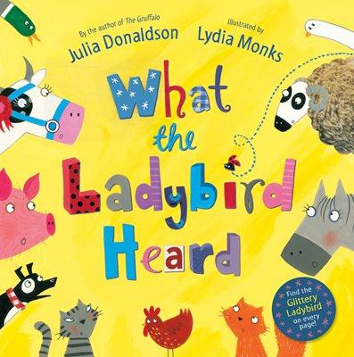 | Hello Everyone,  This week I have uploaded a few stories for you to listen to about a very clever ladybird. As with each week please do visit the sites daily such as https://www.thenational.academy/and https://whiterosemaths.com/  as they have daily lessons for Reception. I’d love to see all of your work so don’t forget to email me at mtrotter@dunnstreet.s-tyneside.sch.uk
Personal, Social and Emotional Development | - The ladybird is very small but that doesn’t stop her saving all of her friends. Have you ever rescued something before? Have you ever helped someone? What did you do? How did it make you feel?  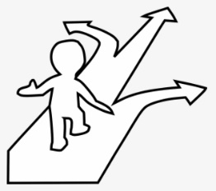  - Can you draw a picture of all of the ladybirds friends? Can you draw a picture of all of your friends and label it?  - Lanky Len and Hefty Hugh were always in trouble why? Did they make the right choices? What could they have done instead?
Communication, Language and Literacy | - Listen to the stories and talk to your grown-ups about what happened in each of them. Which story was your favourite? Why? Do you like Hefty Hugh and Lanky Len?  - Can you remember the repeated refrain in every story ‘ and the ladybird said ……….?  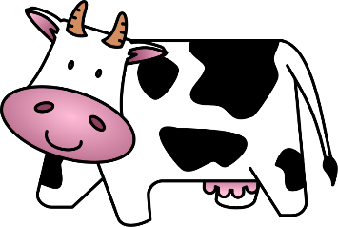  - All of the animals in the story make noises. Can you make the noises of each animal and pretend to be them? Which one was the most fun to be? I like pretending to be the crocodile and snapping my hands together to make the jaws
Physical | - How long can you hop on one foot for?  - How long can you jump for?  - How many star jumps can you do in 1 minute?  - How many spotty dogs can you do in one minute?  - Can you challenge your grown up?  - With a grown up can you practise making snips in paper with scissors? What fingers do you need? Ask your grown-ups to draw you some items to cut out. Maybe a ladybird?
Literacy | - Can you make a list of all of the animals in the first and second story? What about the third? Fourth? Were they the same in each? Which animals were your favourite and why?  - Hefty Hugh and Lanky Len start with the same sound - this is called alliteration. Can you think of a word starting with the same sound as your name? What about Shy Shaun, Perfect Peter? Marvellous Matilda  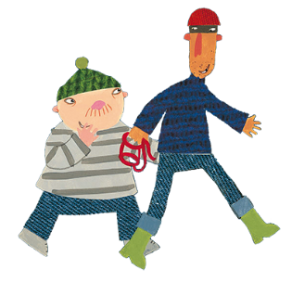  - I’d like you to write some sentences about your favourite ladybird story, it might start with ‘I liked the story of the ladybird going on holiday because she went to the zoo’. Remember capital letters, finger spaces and full stops!  - Read a new book every day
Mathematics | - Count forwards and backwards to 20 and beyond  - Count in twos to 20  - Ladybird wings are symmetrical which means they are the same on both sides. Can you make a ladybird and put 5 spots on one wing? If it is symmetrical you have to put the same number of spots again on the other wing facing each other  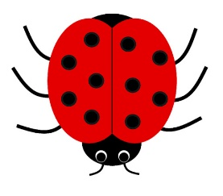  - Can you make lots of symmetrical ladybirds? Making sure that you put the same number of spots on each wing? Can you add up how many spots you have altogether? Can you record it in a number sentence such as 5 + 5=10 What do you notice about your number sentences? That’s right - they will be doubles if you’ve put the correct amount of spots on each wing.
Understanding the World | - Can you find out some facts about ladybirds? What do they eat? Where do they live? How many legs do they have? Put your facts into a little book. Go on a ladybird hunt and if you find one take a photograph of it.  - The ladybird goes on holiday. If you were going on holiday what would you need to take with you? If it was a cold place what would you take? What if it was a wet place? A hot place? Make a list of the items you would take. Would they fit in a suitcase?
Expressive Arts and Design | - Can you draw, paint or collage a ladybird?  - Listen to this song by Julia Donaldson: https://www.youtube.com/watch?v=7NbyiDpY6Ww listen to it a few times and see if you can join in  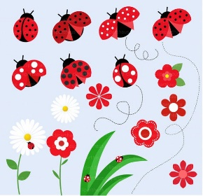  - Pretend that you are a character from the story. Act out the part and see if your grownups can guess who you are? Will you need to make a noise? Will you need to use actions? Will you have to move quickly?
Useful websites to use everyday
https://www.oxfordowl.co.uk/
https://www.thenational.academy/
https://www.bbc.co.uk/cbeebies
https://www.oliverjeffers.com/abookaday
https://www.tentown.co.uk/
https://www.ruthmiskin.com/en/find-out-more/parents/
https://whiterosemaths.com/

