MC900233681[1]MC900383802[1]MC900287195[1]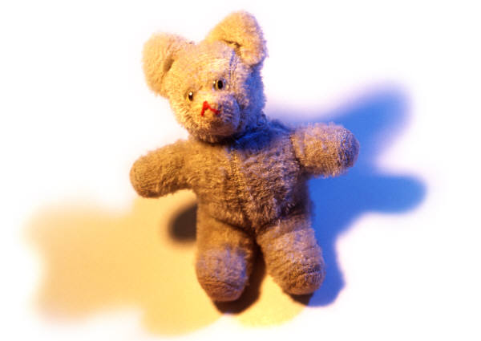

Try adding sound effects to a favourite story. Go around the house to find things that you can use together to make the sounds for the story. The Bear Hunt is a really good one for. Trying to find something in the house that makes a ‘squelch’ sound should be good fun. Try it and put the story together with your child making the sounds.

Sound Effects