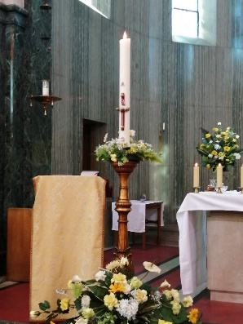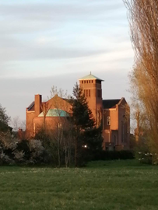

**[The Roman Catholic Church of The Precious Blood and All Souls.](http://allsoulscoventry.org.uk/" \o "The Roman Catholic Church of The Precious Blood and All Souls.  )**

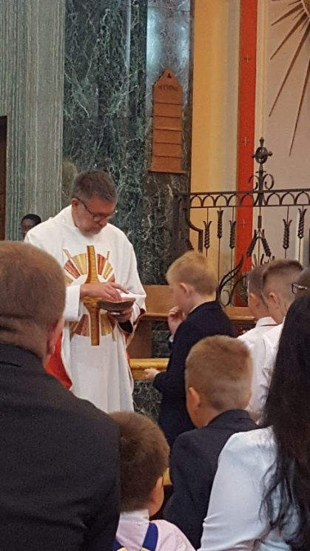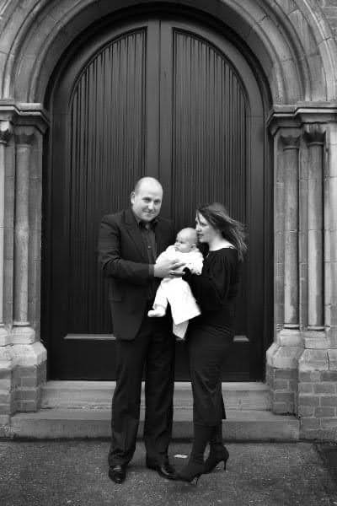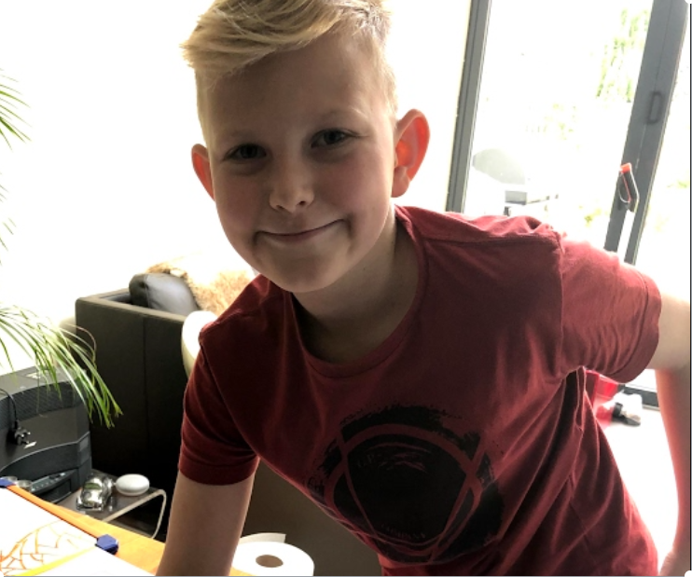

I started my journey when my parent made the decision to have me baptised at The Roman Catholic Church of The Precious Blood and All Souls. All Souls’ has been part of my life ever since. I have taken part in Christmas eve services over the years as well as attending mass and Sunday school when I was younger. In more recent years I was lucky to have received my First Holy Communion when I was in year 3 at All Souls Primary school, recently I attended the learning classes in readiness for my Confirmation which I am hoping will happen in the near future.

The Church and the Parish are special to me, the Church is a place where I can go to think and reflect about many things and give thanks to God spfor the good things in life. The Church offers me a place to meet with family, friends, and people out of School.



**Ethan Krol**

**Age 10**

**Year 6**

