Mon | Maths – Follow the WhiteRose maths lessons for Summer 1 Week (week beginning 11th May as we are a week behind). Worksheets and answer sheets are attached.  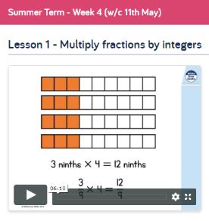 | English - Chapter 8 – What do we find out about Patricia? What kind of person is she? What is she planning on doing? Why is Mum allowing her in the house?  Write a diary entry in character as Patricia, Try to get her personality across! | Art:  Use BBC Bitesize to find out about artist Paula Rego  https://www.bbc.co.uk/bitesize/articles/z47fvk7
Tue | Maths – Follow the WhiteRose maths lessons for Summer 1 Week (week beginning 11th May as we are a week behind). Worksheets and answer sheets are attached.  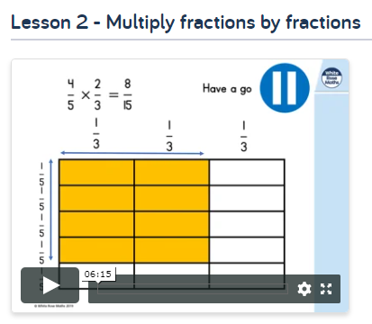 | English – Read Chapter 9 and then answer Tuesday’s comprehension questions. | Art:  Can you produce your own work in the style of Paula Rego?
Wed | Maths – Follow the WhiteRose maths lessons for Summer 1 Week (week beginning 11th May as we are a week behind). Worksheets and answer sheets are attached.  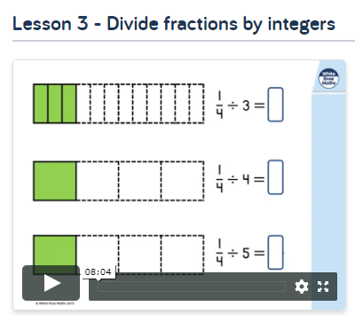 | English – Read Chapter 10. As you read, make a note of any new characters we are introduced to. Jot down what you find out about them, using Wednesday’s sheet. You could research the gods online to find any more information about them! | History – Use the Powerpoint o find out about The Battle of Marathon, then complete the Athens vs Sparta Activity Sheet
Thur | Maths – Follow the WhiteRose maths lessons for Summer 1 Week (week beginning 11th May as we are a week behind). Worksheets and answer sheets are attached.  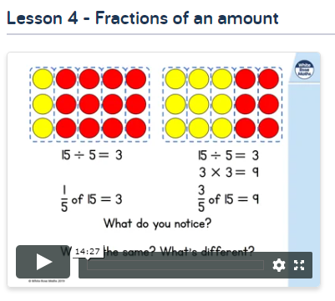 | English –  Use Thursday’s sheet to research two new gods – Tantalus and Sisyphus. Do this before you read Chapter 11! | Geography – Use the internet to find out about Greece. Can you make an advert for a holiday there?
Fri | Maths – Follow the WhiteRose maths lessons for Summer 1 Week (week beginning 11th May as we are a week behind). Worksheets and answer sheets are attached.  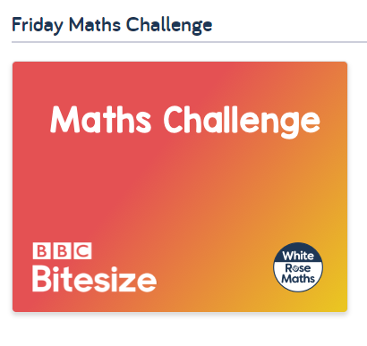 | English – Choose one of the gods that we have been introduced to. Write a report/fact file about them. | PE: Watch the street dance videos and try to join in! Can you perfect your moves?!  https://www.bbc.co.uk/teach/class-clips-video/street-dance-masterclass/zh2vpg8

