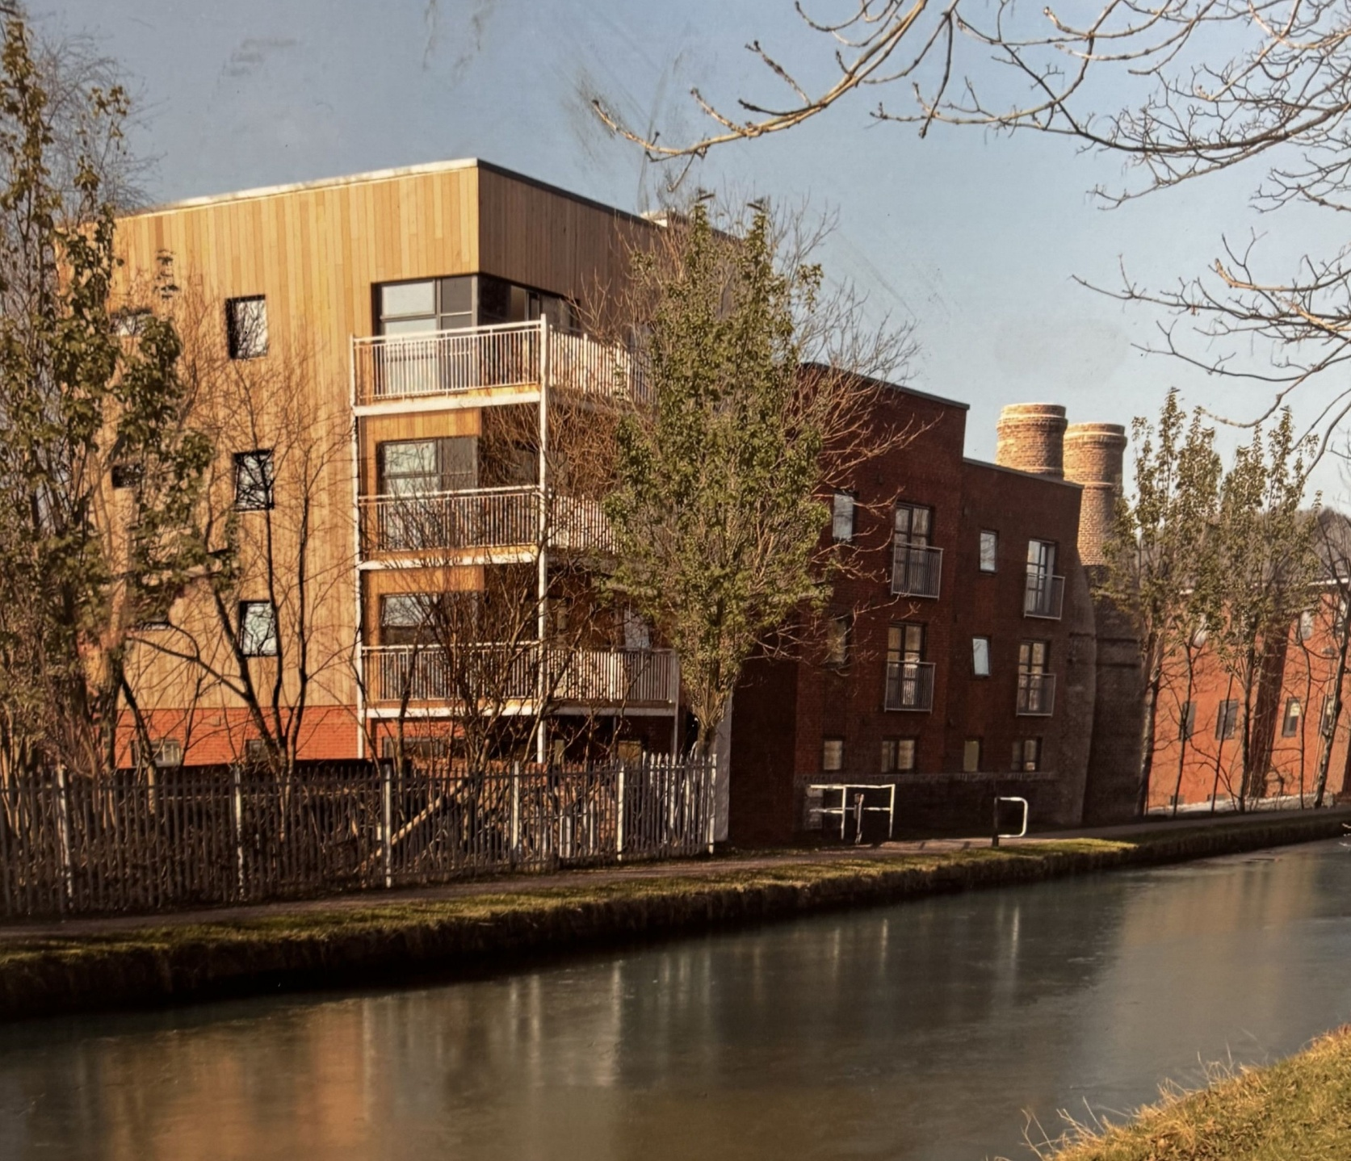

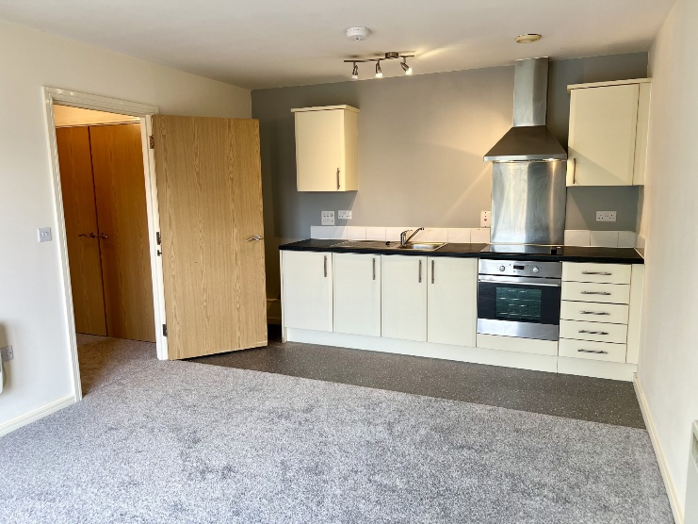
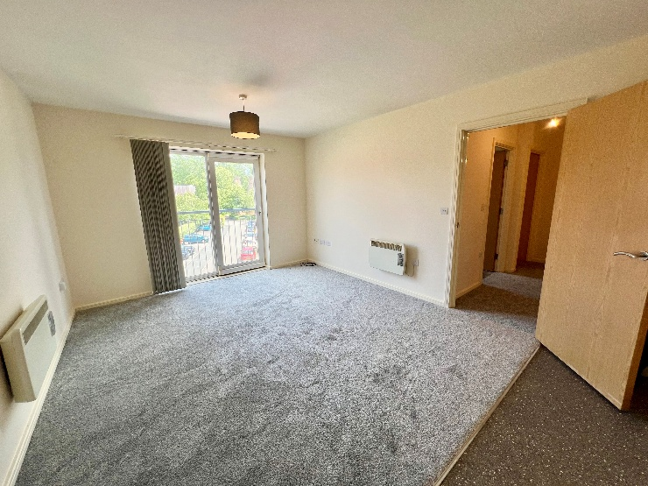


- Well Presented second floor Apartment, Featuring, a spacious lounge/ kitchen, bathroom and one bedroom
- Situated on an Idyllic Quiet Spot in Cliff Vale, close to local amenities and trains station and main transport links
- EPC rating D

to let
£675 PCM

Penstock drive, Cliff vale, STOKE-ON-TRENT,
st4 7GF

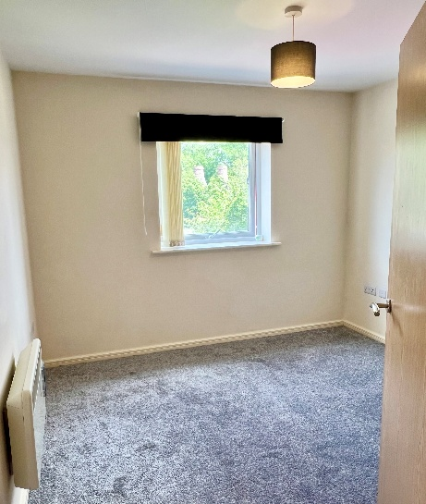
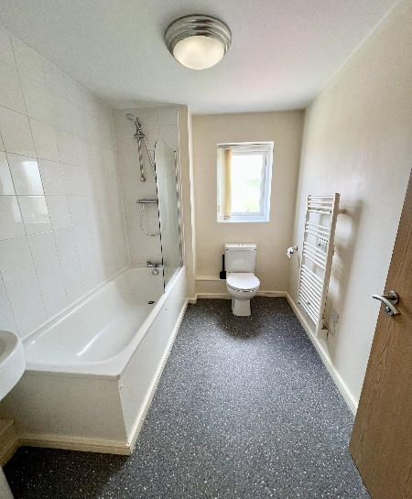
Penstock Drive
CLIFF VALE
ST4 7GF

Agents Note: Whilst every care has been taken to prepare these particulars, they are for guidance purposes only. All measurements are approximate and are for general guidance purposes only and whilst every care has been taken to ensure their accuracy, they should not be relied upon and potential buyers/tenants are advised to recheck the measurements

GENERAL DESCRIPTION
A well-presented second floor apartment located on the highly sought-after Penstock Drive Development in Cliffe Vale.

Ideally positioned for convenience, the property offers excellent access to major transport links, local amenities and public transport routes, making it perfect for commuters and those seeking easy day-to-day living.

The apartment itself is light, spacious and thoughtfully laid out. It features a generous lounge area, an ideal fitted kitchen complete with appliances, a bright and airy bathroom and one spacious bedroom.

Externally, the property offers ample parking for residents only.

This well maintained, recently re-decorated and re-carpeted, 1-bedroom apartment is situated in a highly desirable location, offering the perfect blend of style and convenience. Featuring an Open Plan Kitchen & Lounge: Spacious, modern living area ideal for relaxing or entertaining, Bright Bathroom, and 1 Bedroom: Comfortable and well-sized rooms, perfect for individuals or small families. Complete with an allocated parking bay and visitors parking. The apartment is perfect for professionals, couples, or anyone looking for a modern, easy-to-maintain living space in a prime location.

LOCATION
Situated on the popular lock 38 Development in Stoke-on-Trent, Staffordshire ST4 7GF, conveniently positioned for local amenities and transport links.

EPC
Band D

COUNCIL TAX
Band A

SERVICES
All mains including electricity and water are connected. Please note that the bills are not inclusive within the rent.

VAT
The rent will not be subject to VAT

ACCOMMODATION
Lounge/Kitchen | 17.04’ X 11.62’
Bedroom | 12.81’ X 8.96’
Bathroom | 8.91 X 6.53’
Total | 484 sq. ft

101B DARTMOUTH STREET
BURSLEM
ST6 1HF

Agents Note: Whilst every care has been taken to prepare these particulars, they are for guidance purposes only. All measurements are approximate and are for general guidance purposes only and whilst every care has been taken to ensure their accuracy, they should not be relied upon and potential buyers/tenants are advised to recheck the measurements

