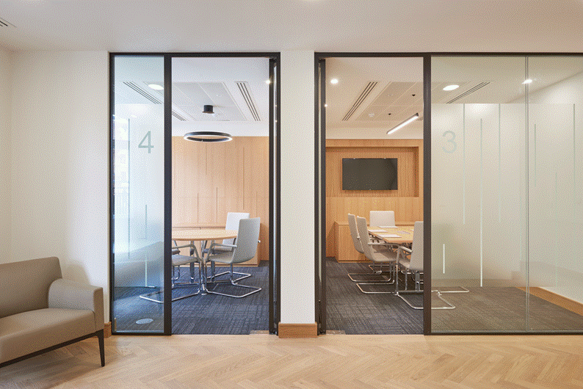

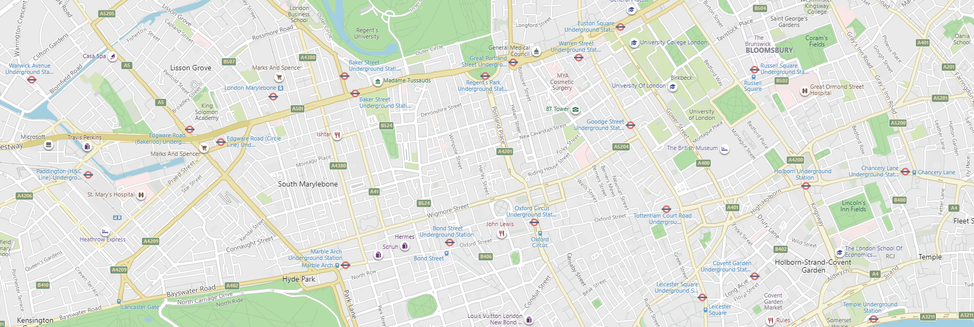

|  |  |  |  |  |  |
| --- | --- | --- | --- | --- | --- |
| Manned  reception | Furnished workspace | Fitted  reception | Board & meeting rooms | Open plan dedicated desking | Fitted kitchenette |
| Air conditioning | Good natural light | Efficient floor plate | 6 Person passenger lift | Demised  WC’s | 24 Hr Access |

**FULLY FURNISHED, HIGH QUALITY EXECUTIVE OFFICE…**  
  
11-15 Wigmore Street, is a high-quality office building in a prominent and well-located position. Access is through a manned reception. The first-floor accommodation benefits from a high-quality fit-out, with exemplary board and meeting room suites to the front of the floor. To the rear there is efficient open plan desking for staff, with access to a kitchenette and WC’s.

|  |  |  |  |  |  |
| --- | --- | --- | --- | --- | --- |
| **FLOOR** | **SIZE (SQ FT)** | **Rent (pSF)** | **Rates (pSF)** | **SC (pSF)** | **TOTAL COST** |
| 1st | 2,886 | £55.00 | £36.00 | £18.00 | c.£109.00 |
| **Total** | **2,886 sq ft** | **c.£160,000** | **c.£104,000** | **c.£52,000** | **c.£315,000** |

|  |  |  |
| --- | --- | --- |
| **VIEWING** Strictly by appointment through landlord’s joint sole agents: | | |
| Edward Charles & Partners  020 7009 2300 | Ian Bradshaw  [ibradshaw@edwardcharles.co.uk](mailto:ibradshaw@edwardcharles.co.uk) | Tony Parrack  [tparrack@edwardcharles.co.uk](mailto:tparrack@edwardcharles.co.uk) |
| White Druce & Brown  020 7467 5997 | Ian Franklin  [ianfranklin@whitedrucebrown.com](mailto:ianfranklin@whitedrucebrown.com) |  |

**EPC** Available on request

**OTHER** Available on completion of legal’ s.

**Tenure** Leasehold

**Lease** Available by way of a new flexible lease direct from the LL for a term by arrangement

**TRANSPORT**

Bond Street (4 min walk) Central & Jubilee Lines

(The Elizabeth Line is due to open soon, providing Crossrail routes and easy access to Heathrow and outer lying areas)

Oxford Circus (7 min walk) Central, Victoria & Bakerloo lines.

Various bus routes available along Oxford Street.

**LOCATION**

The property is located on the south side of Wigmore Street, close to its junction with Cavendish Square.

Wigmore Street is in the Marylebone Village area, with good access to retail along Oxford Street and the boutique food & beverage offering of Marylebone High Street & St Christopher’s Place.