Title Structure Summary – Meridian House, 202-204 Finchley Road, London NW3 6BX
The Meridian House site consists of four separate titles, as shown on the indicative plan below. These titles are a mixture of freehold and leasehold.
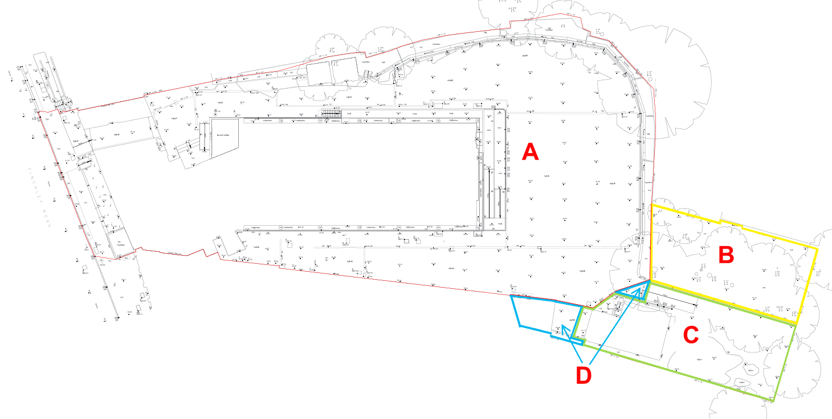
For the purpose of identification only
Key No. | Title Number | Tenure | Class of Title | Registered Address
A | NGL778211 | Leasehold | Absolute | Meridian House, 202-204 Finchley Road, London NW3 6BX
B | NGL853430 | Freehold | Absolute | Land at the back of 21 Frognal, London NW3 6AR
C | NGL793605 | Freehold | Absolute | The Bungalow, Meridian House, 202-204 Finchley Road, London NW3 6BX
D | NGL62471 | Freehold | Absolute | 19 Frognal, Hampstead

Leasehold Title Structure  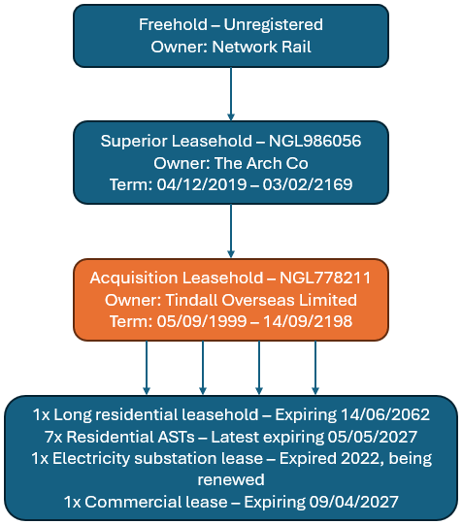 | Summary - Key Terms of Acquisition Lease
  Date: | 15/09/1999
  Parties: | - Railtrack PLC (as Landlord)  - Tindall Overseas Limited (as Tenant)
  Term: | 199 years from 15/09/1999
  1954 Act Protected: | Yes – the lease has security of tenure (right to renew)
  Original Rent: | £24,000 plus VAT p.a.
  Current Rent: | £76,000 plus VAT p.a. (effective 14/02/2020)
  Rent Reviews: | Frequency: Every 21 years  Type: New rent to be agreed by the parties. If not agreed, new rent to be higher of passing rent or amount determined by arbitrator (capped at 20% of open market value)
  Break Rights: | None

