

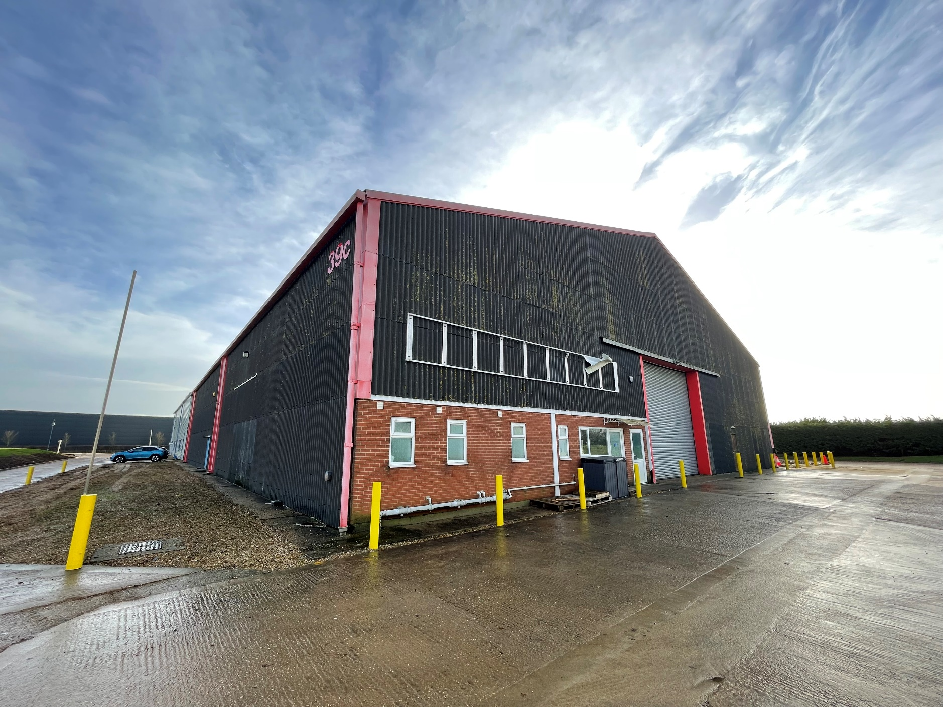
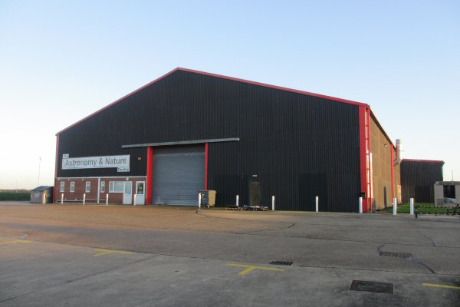

TO LET:
WAREHOUSE
Unit 39c
Lancaster Way Business Park
Ely
Cambridgeshire
CB6 3NW
663.58 sq m (7,143 sq ft)

- Available on a new lease
- Good access to Ely via A142 and Cambridge via A10
- Established business park location with amenities onsite
- Internal office accommodation
- Fibre Optic broadband available

Uniform Business Rates
The property was removed from the 2023 VOA Ratings List. Therefore, the property will need to be re-assessed once a new tenant is in occupation. The previous rateable value was £19,750. A rateable value of this level would result in an approximate rates payable of £9,855 per annum.

Service Charge
There is a service charge payable towards upkeep and maintenance of the common parts of the estate. More information is available on request.

EPC
The property has an EPC rating of D – 81.

Terms
The property is available by way of a new lease.

For the quoting rent or to arrange a viewing, please contact the agent.

Legal Costs
Each party to bear its own legal costs in association with this transaction.

Viewing and Further Information
Strictly through the sole agent, Cheffins.

Alexander Smith
Tel: 01223 271 970
Email: alexander.smith@cheffins.co.uk

Luke Davenport
Tel: 01223 271 974
Email: luke.davenport@cheffins.co.uk

Location
Ely is an expanding city with a population of approximately 20,000. The East Cambridgeshire District, to which Ely is central, is one of the fastest growing districts in England.

Lancaster Way Business Park is located around 1½ miles from Ely City centre, adjacent to the A142, providing access to the A10 (within around ½ mile) and thereafter to the A14 approximately 12 miles distant. Cambridge is located around 15 miles to the south and the mainline railway station runs a regular service to London Kings Cross with a journey time of 67 minutes.

Description
The property comprises approximately one third of a steel portal frame industrial building with brick and fibre cement sheet elevations and roof. The premises benefit from a power-floated concrete floor, roller shutter loading door and ancillary office accommodation, with mezzanine storage above.
Accommodation
The property comprises the following approximate gross internal areas:

 | Sq M | Sq Ft
Ground Floor | 551.65 | 5,938
First Floor | 111.95 | 1,205
Total | 663.58 | 7,143

Planning
The building has previously been used for warehousing and light industrial purpose, in compliance with Use Class E (g)(iii) and B8.

Interested parties should make their own enquiries by contacting East Cambridgeshire District Councils Planning department on 01353 665555.

The Code for Leasing Business Premises in England and Wales recommends you seek professional advice before agreeing a business tenancy. The Code is available through professional institutions and trade associations or through the website www.leasingbusinesspremises.co.uk. These particulars are intended to give a fair description of the property but their strict accuracy is not guaranteed neither do they constitute part or an offer/contract. Applicants must satisfy themselves as to the correctness of the information contained herein before entering into a binding contract. All prices and rentals quoted are exclusive of VAT (if chargeable). The services, fixtures, fittings, appliances and other items of equipment referred to herein have not been tested by this firm. Therefore no warranty can be given as to their condition and applicants must satisfy themselves in this respect.
