

NK/TM (Paddy the Farmers Editorial Text) agency word

Prime Suburban Hospitality & Residential Investment Opportunity

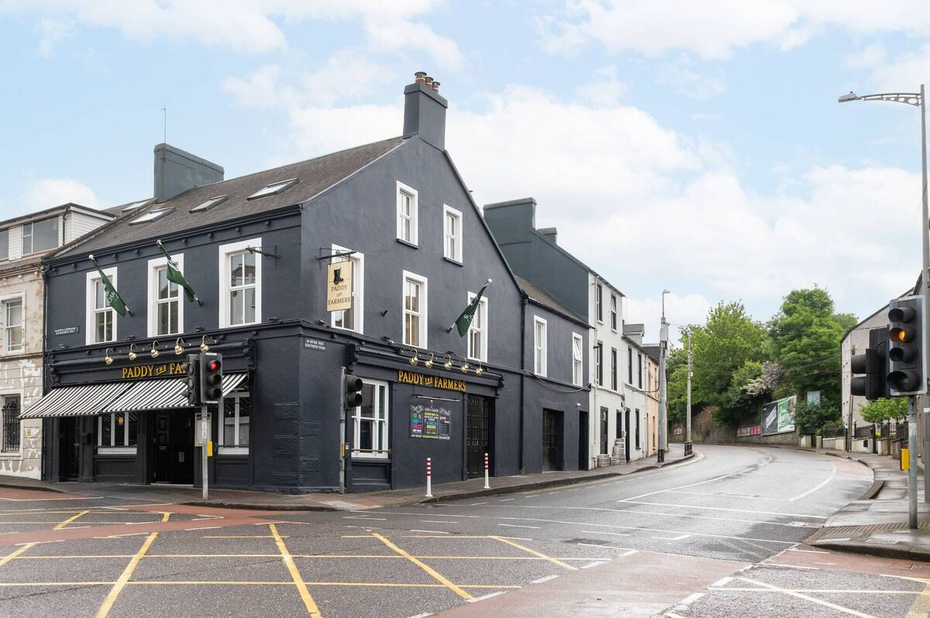

Lisney CRE have brought Paddy the Farmers, Blackrock, Cork, to the market for sale by private treaty, guiding in excess of €1,900,000 The property is being offered in one or more lots, comprising the licensed premises (Lot 1), the nine overhead residential apartments (Lot 2), or the entire (Lot 3).

Paddy The Farmers is a long-established and highly regarded licensed premises situated in the heart of Blackrock Village, Cork, one of the city’s most established and desirable suburban locations. The property occupies a prominent position within the village, benefiting from strong local footfall and proximity to surrounding residential neighbourhoods and the City.

The ground floor comprises a traditional public house with the upper floors comprising nine self-contained residential apartments, providing a valuable and diversified income stream. The combination of an established hospitality business with substantial residential accommodation offers a compelling mixed-use investment opportunity in one of Corks most affluent suburbs.

The flexible lotting structure allows purchasers to acquire either the trading licensed premises, the residential investment element, or the entire mixed-use asset, depending on their investment or operational requirements.

According to Tony Morrissey and Gerard O’ Callaghan of Lisney, who are handling the sale, Paddy the Farmers represents a rare opportunity to acquire a landmark suburban pub with the added benefit of strong residential income in a high-demand Cork location.

Tony Morrissey comments: “Paddy the Farmers occupies a pivotal trading position in the centre of Blackrock Village. The licensed premises benefits from consistent repeat trade and a strong local following, while the nine overhead apartments provide secure residential income in one of Cork’s most sought-after suburbs. This is a unique opportunity to acquire a high-profile mixed-use asset with both operational and investment appeal.”

Further information and viewing arrangements are available through Tony Morrissey and Gerard O’ Callaghan at Lisney.

