CERTIFICATE OF AUTHENTICITY
n° 000066

As from D.L. 22 January 2004, n. 42, this document is to be considered for all purposes
Certificate of Photographic Authenticity for the work indicated

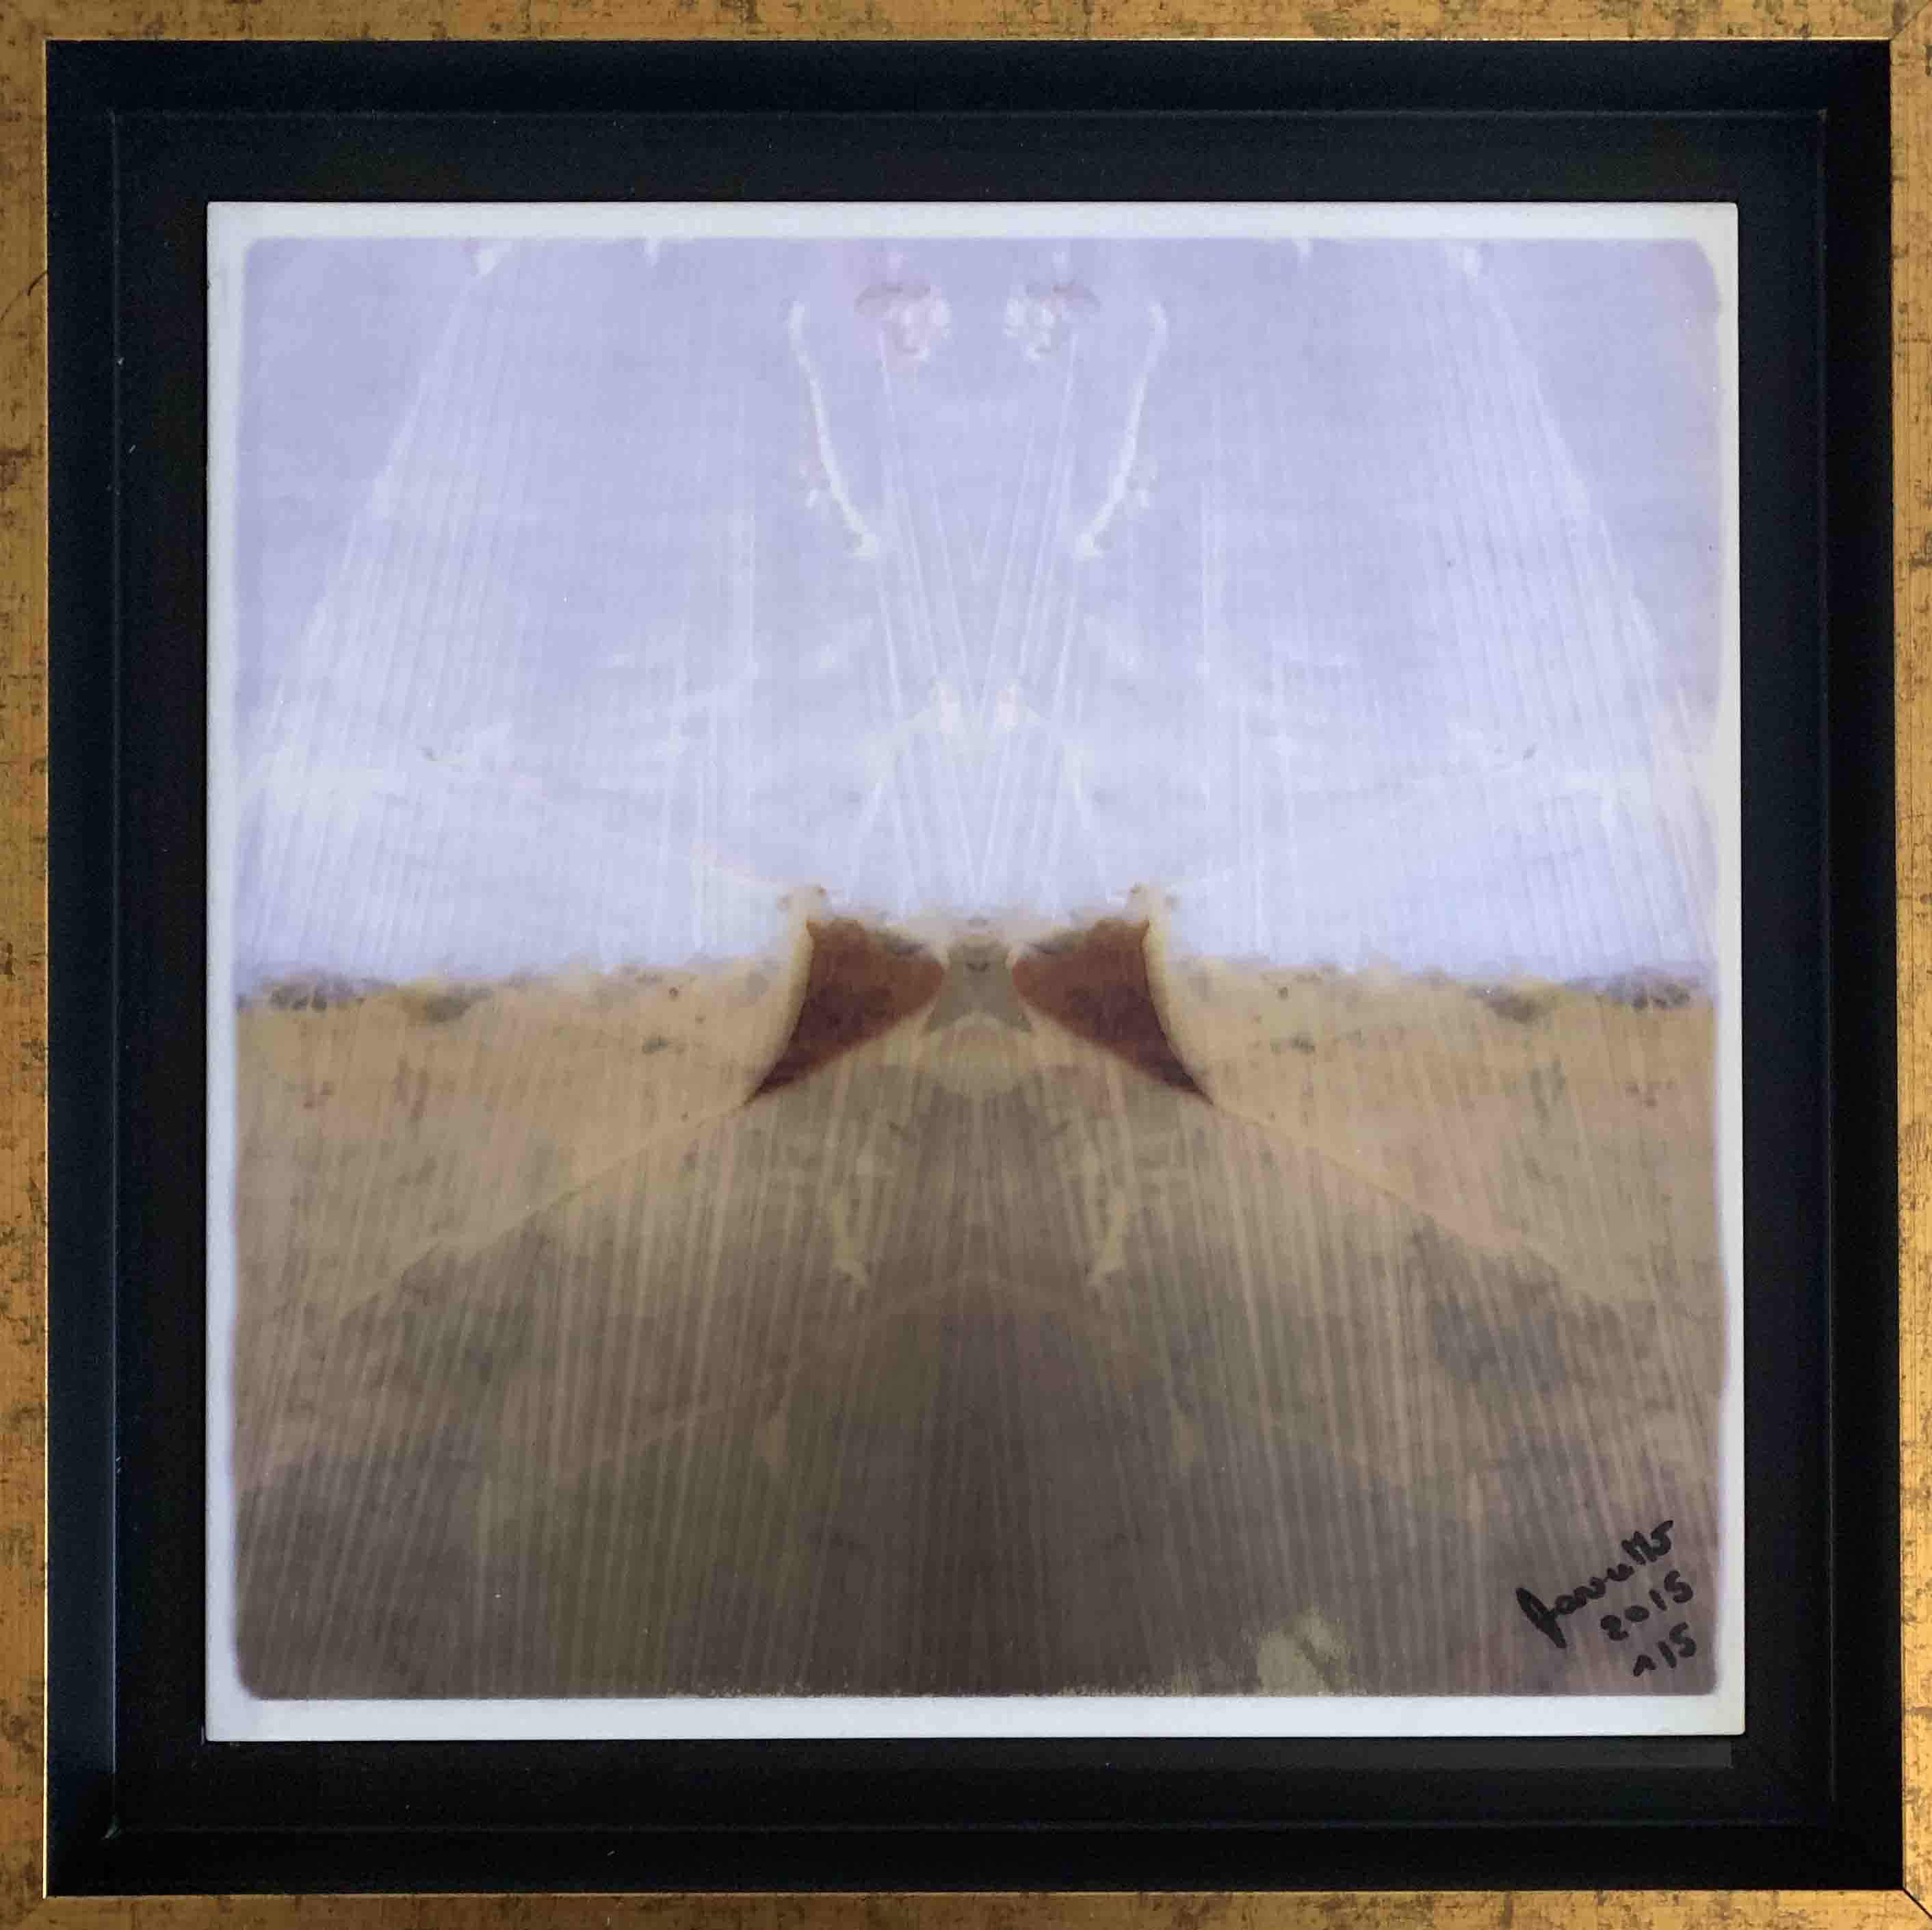

TITLE: The man with the bow tie – L’ uomo col papillon

SIZE CM: 30x30 cm

SUPPORT: Print on marble of Lasa – stampa su marmo di Lasa

YEAR: 2015

EDITION: Subject 1/5
Support 1/1

The undersigned Stefano Favaretto born in Merano on 10/27/1969
certifies and guarantees the authenticity and ownership of the work

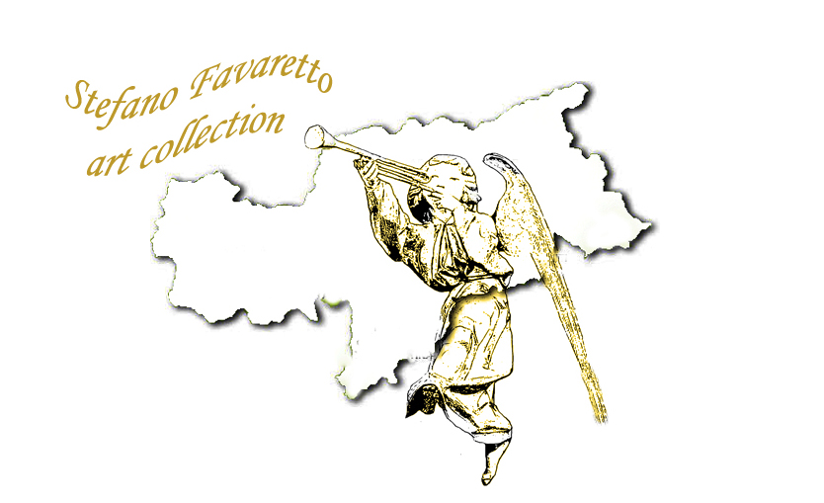
SIGNATURE:
