MILANO, 18 MAGGIO 2021
AUTHOR CERTIFICATION

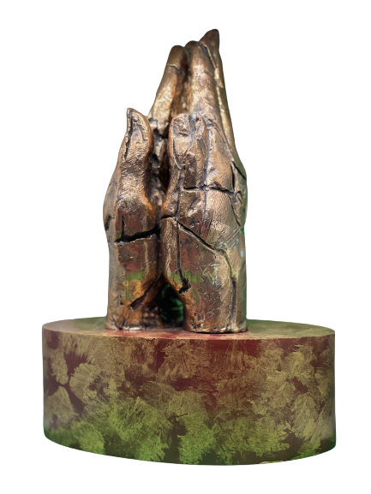

YEAR:
2017

TITLE: LE MANI IN PREGHIERA

TECHNIQUE:
BRONZE SCULPTURES BY LOST WAX

MEASURE:
CM H24 X W18 X 11D

CERTIFICO CHE QUESTA OPERA È STATA IDEATA E REALIZZATA DA ME MEDESIMA, GIANNA MOISE

I HAVE CERTIFIED THAT THIS WORK WAS IDEATED AND MADE BY ME, GIANNA MOISE

IN FEDE
FAITHFULLY

GIANNA MOISE
