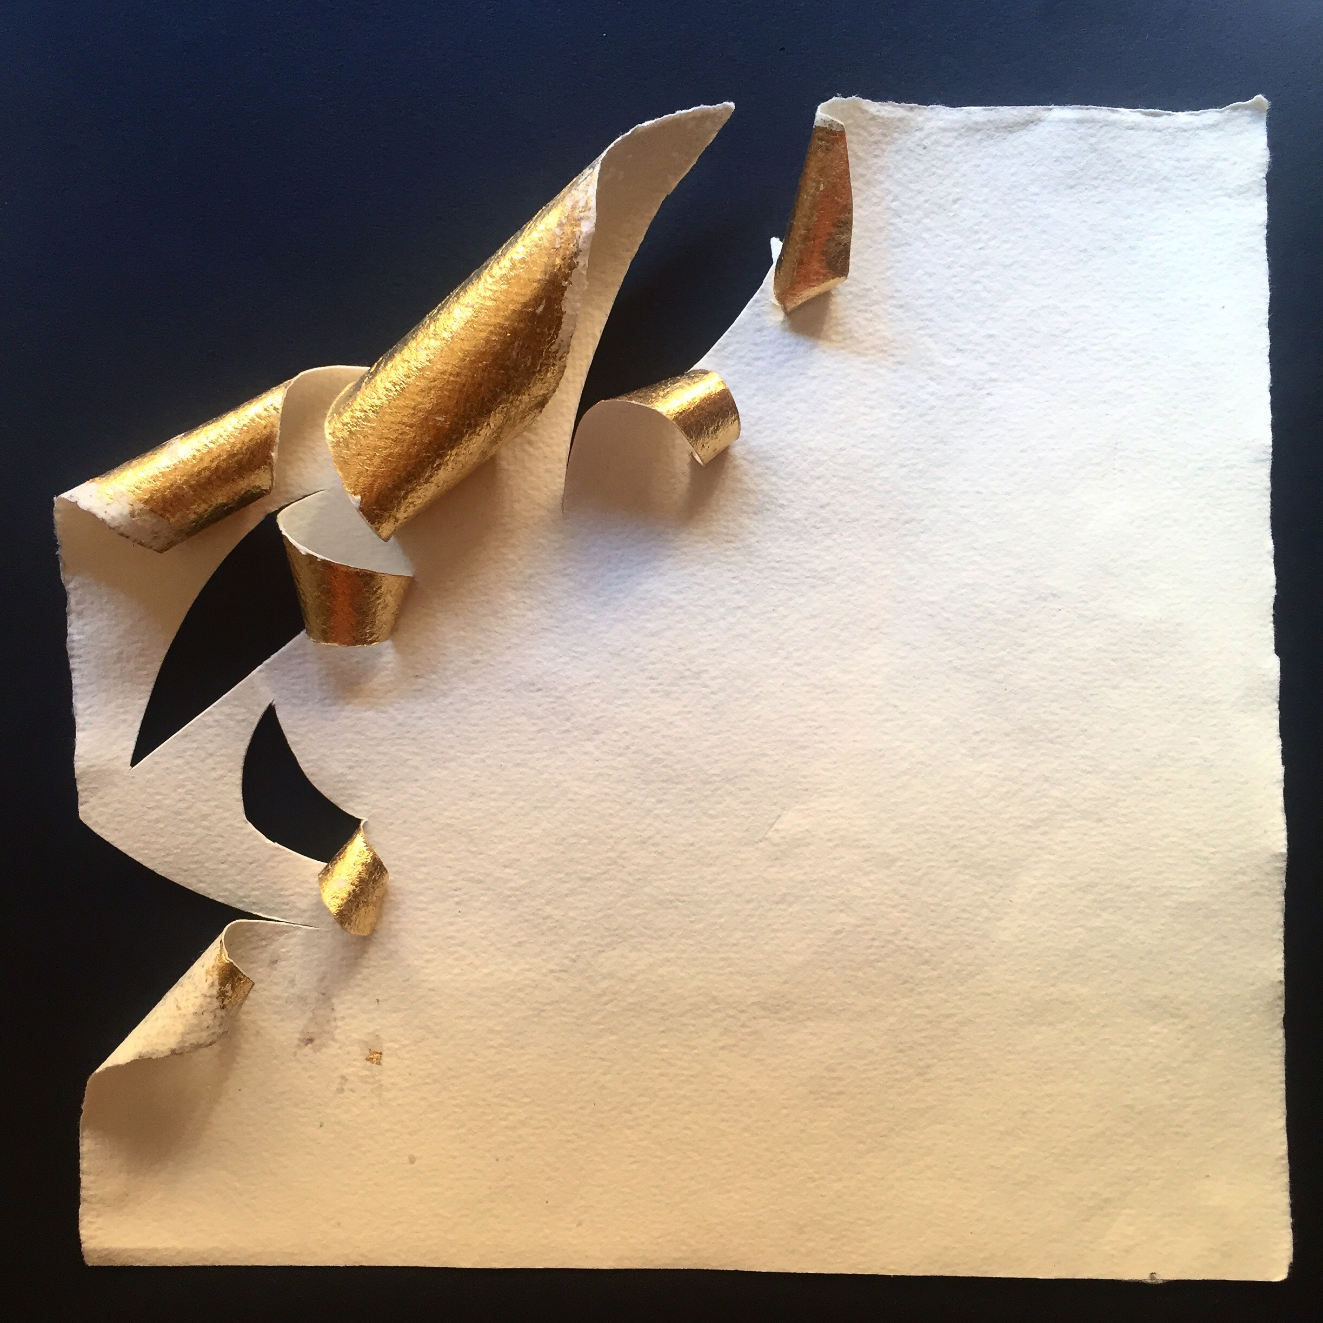

Title: | GOLDLINES
Author: | BEATRICE ZAGATO
Year: | 2017
Technique: | PAINTING:  GILDING ON PAPER
Dimensions: | 21,5X21,5X2

I, the undersigned and author, hereby certify this to be an original artwork.

Io, sottoscritto e autore, certifico che si tratta di un'opera d'arte originale.

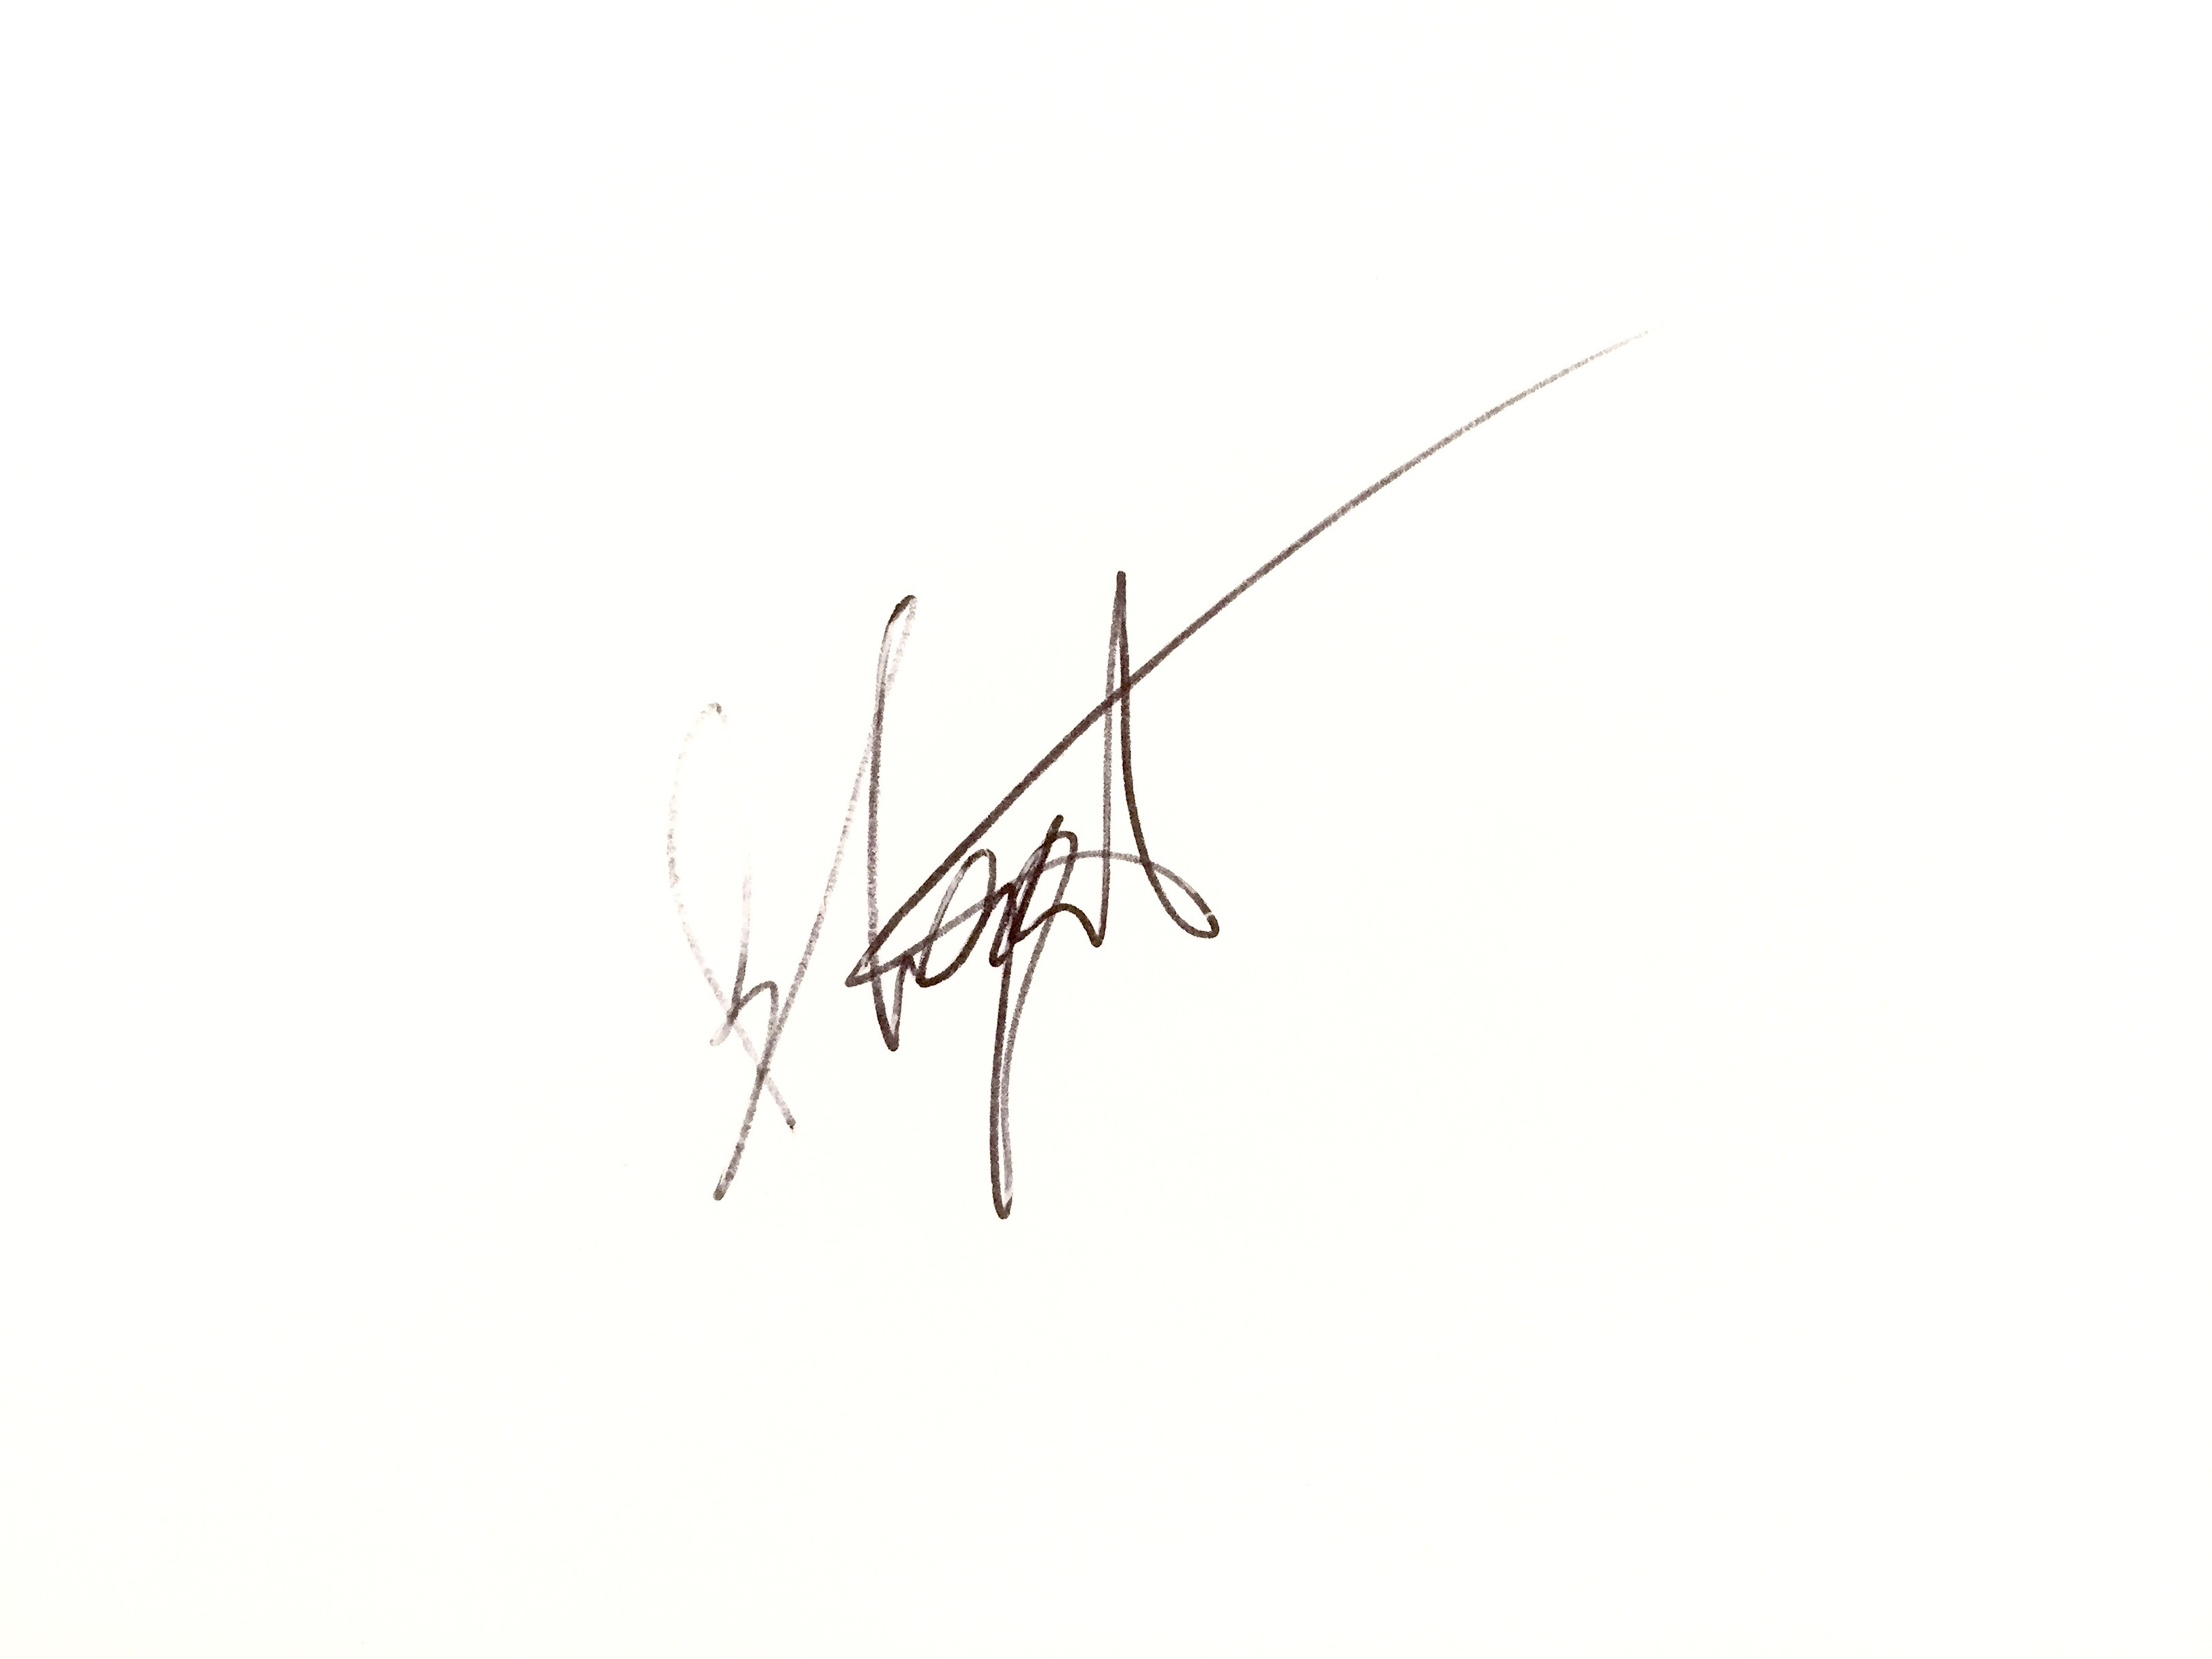

SIGNATURE  …………………………………………………………… | Date  13/10/2020

