MILANO, 3 DICEMBRE 2019
AUTHOR CERTIFICATION
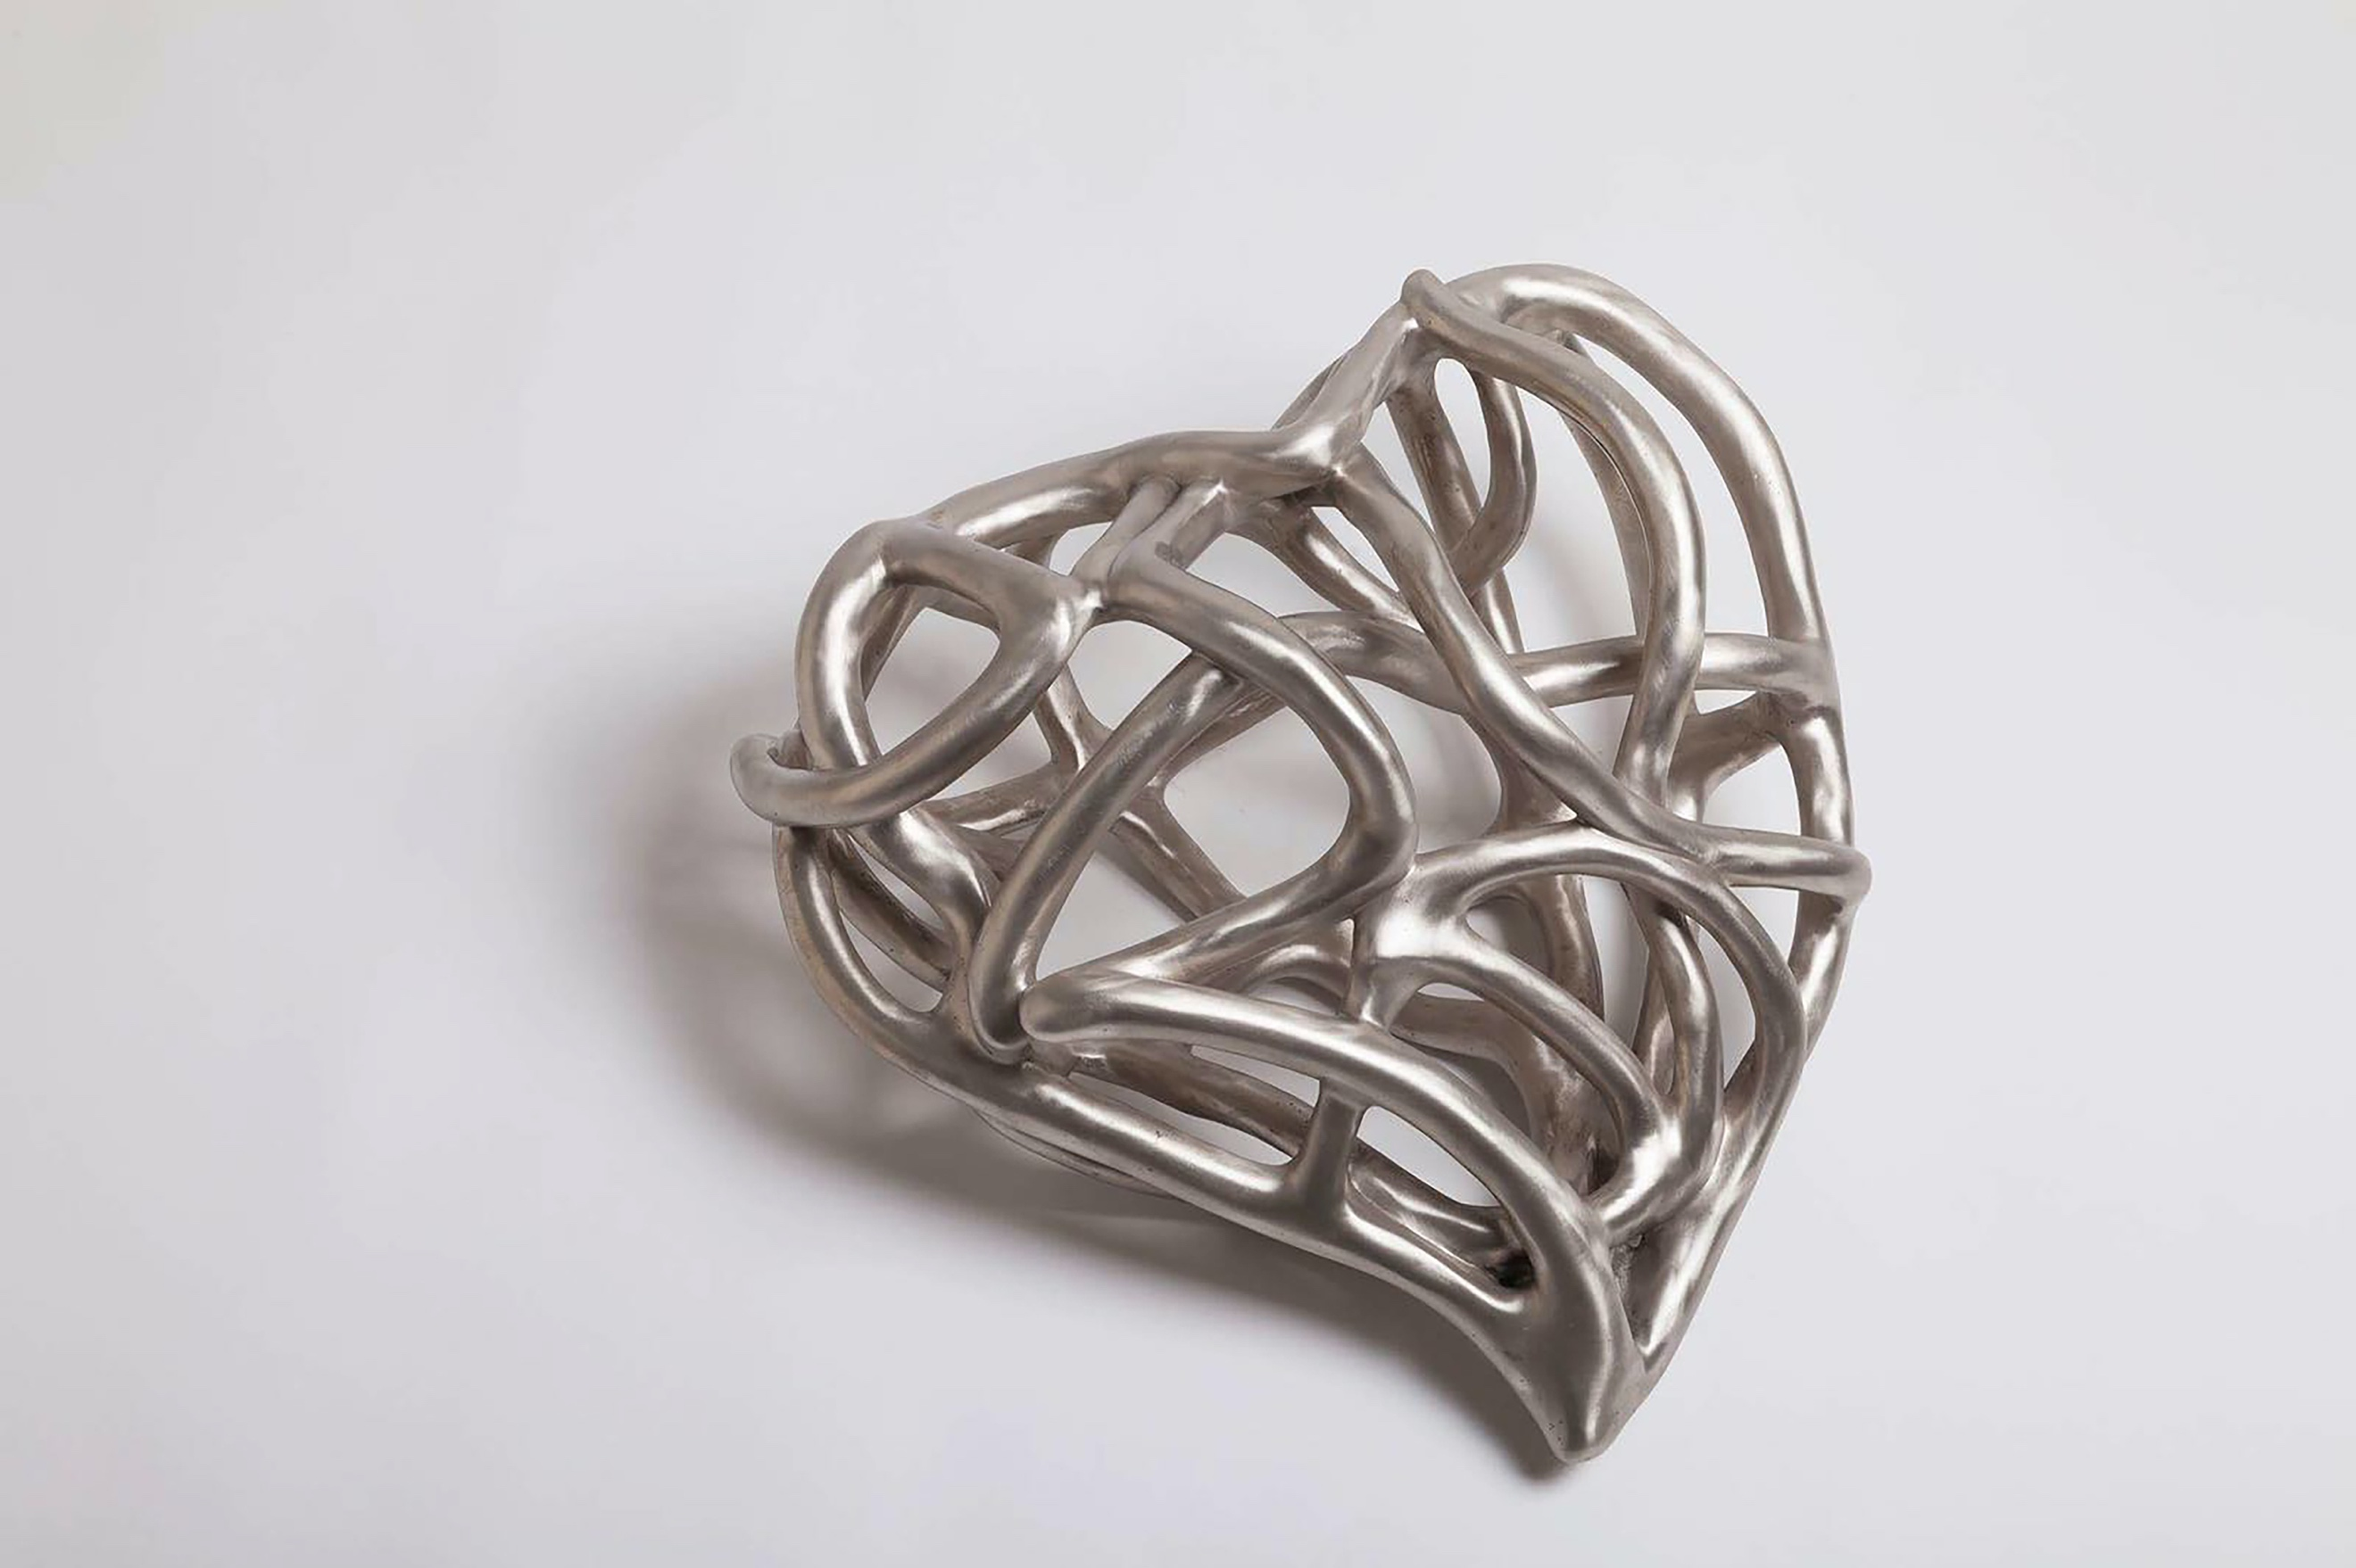

YEAR:
2017

TITLE: HEART TO HEART

TECHNIQUE:
BRONZE SCULPTURES BY LOST WAX

MEASURE:
CM H68 X W80 X 40D

CERTIFICO CHE QUESTA OPERA È STATA IDEATA E REALIZZATA DA ME MEDESIMA, GIANNA MOISE

I HAVE CERTIFIED THAT THIS WORK WAS IDEATED AND MADE BY ME, GIANNA MOISE

IN FEDE
FAITHFULLY

GIANNA MOISE
