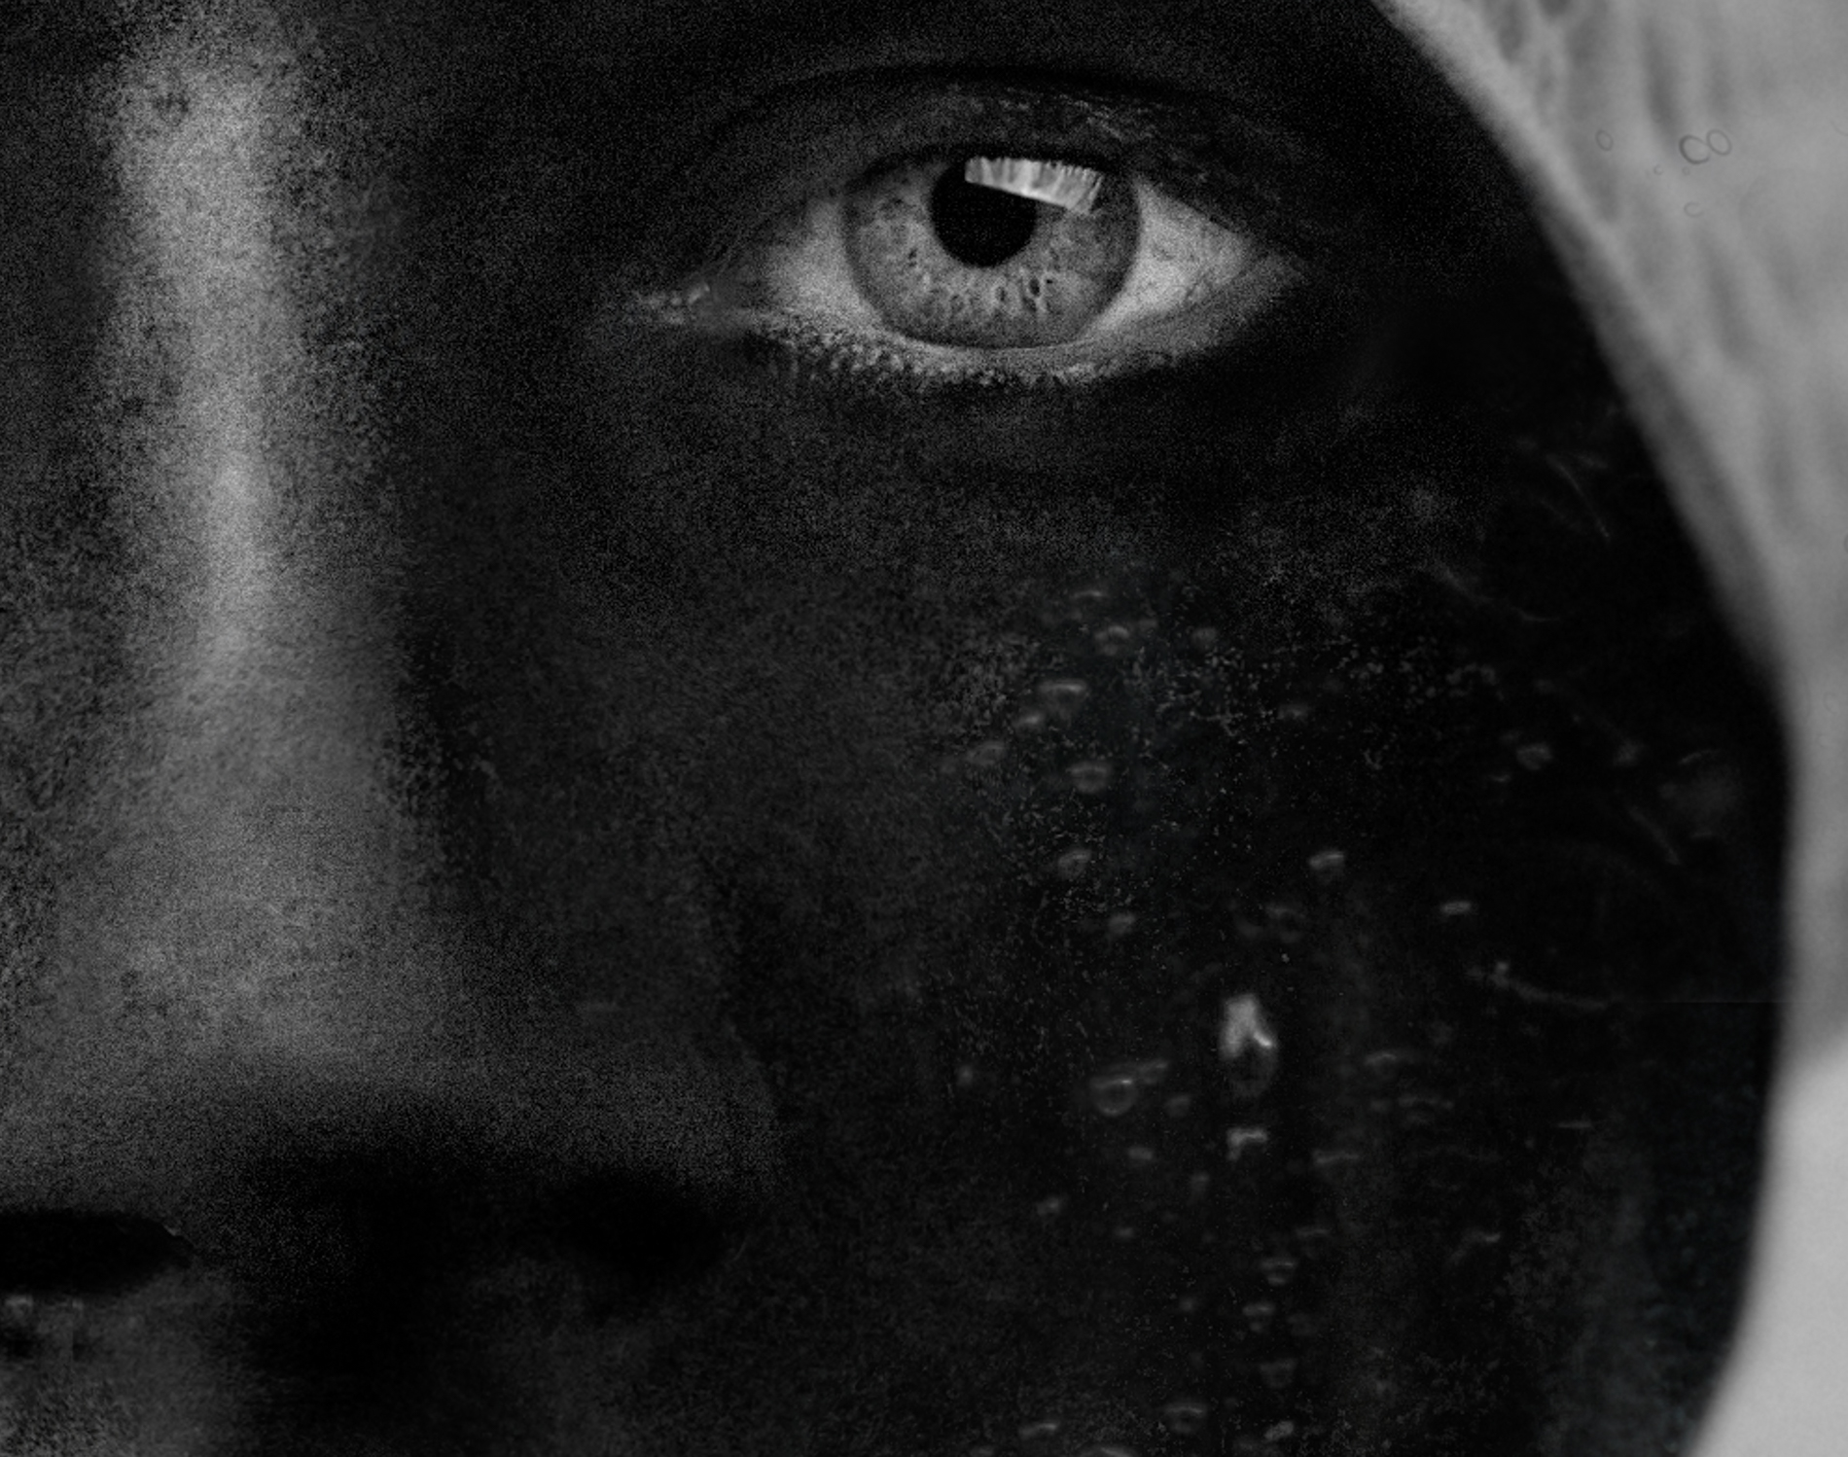

Title: | swimmer
Author: | René Dissel
Year: | 2020
Technique: | Portrait photography
Dimensions: | 120x80cm

I, the undersigned and author, hereby certify this to be an original artwork.

Io, sottoscritto e autore, certifico che si tratta di un'opera d'arte originale.

SIGNATURE  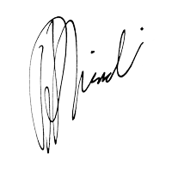  …………………………………………………………… | Date  21/07/2020

