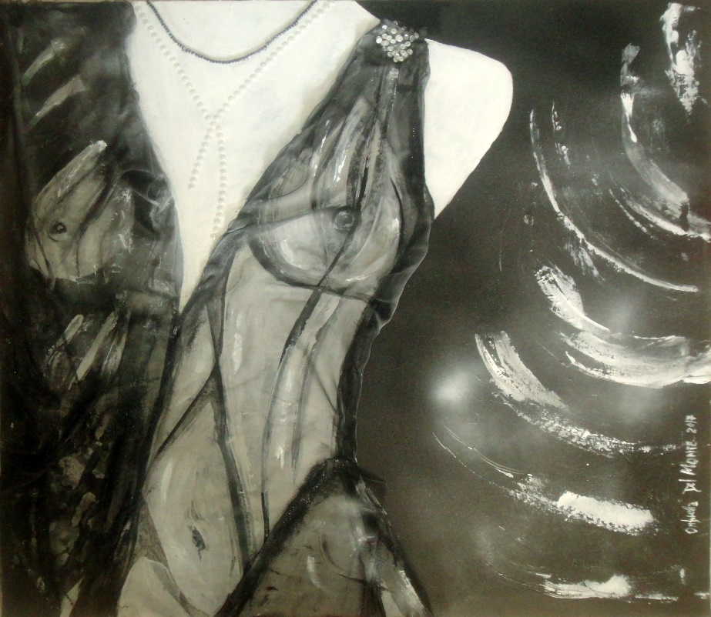

Title: | “Anima Chic!”
Author: | Ombretta Del Monte
Year: | 2017
Technique: | acrylic mixed tissue and application
Dimensions: | 80x80

I, the undersigned and author, hereby certify this to be an original artwork.

Io, sottoscritto e autore, certifico che si tratta di un'opera d'arte originale.

Signature date
29/07/2020

