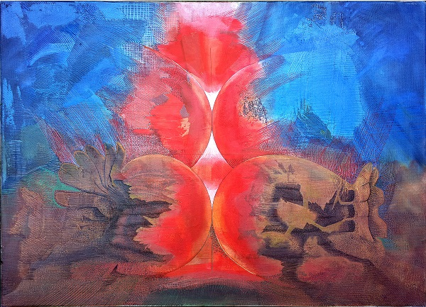

Title: | JT WAS
Author: | JERZY LESZEK STANECKI
Year: | 2014
Technique: | OIL + CANVAS
Dimensions: | 70 x 50 x 1,5

I, the undersigned and author, hereby certify this to be an original artwork.

Io, sottoscritto e autore, certifico che si tratta di un'opera d'arte originale.

SIGNATURE DATA

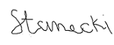 13-08- 2020

