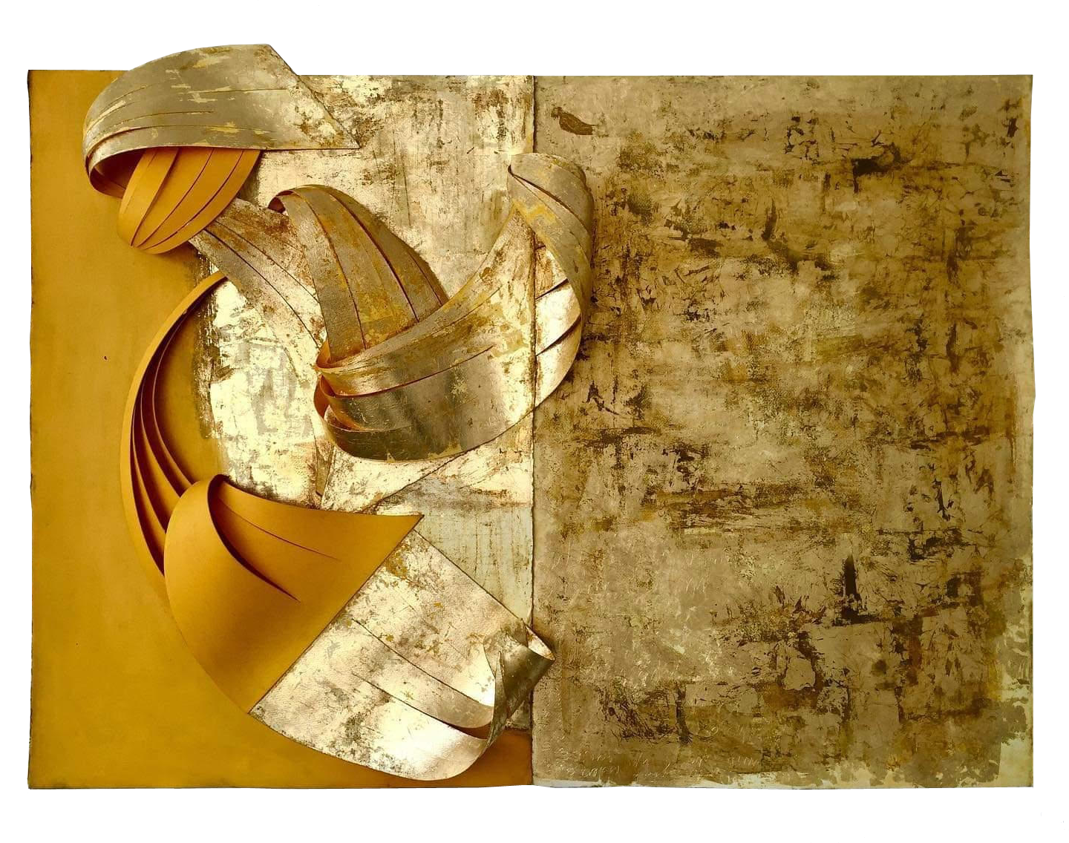

Title: | GOLD
Author: | BEATRICE ZAGATO
Year: | 2020
Technique: | PAINTING:  Acrylic on Paper  100X160X20
Dimensions:

I, the undersigned and author, hereby certify this to be an original artwork.

Io, sottoscritto e autore, certifico che si tratta di un'opera d'arte originale.

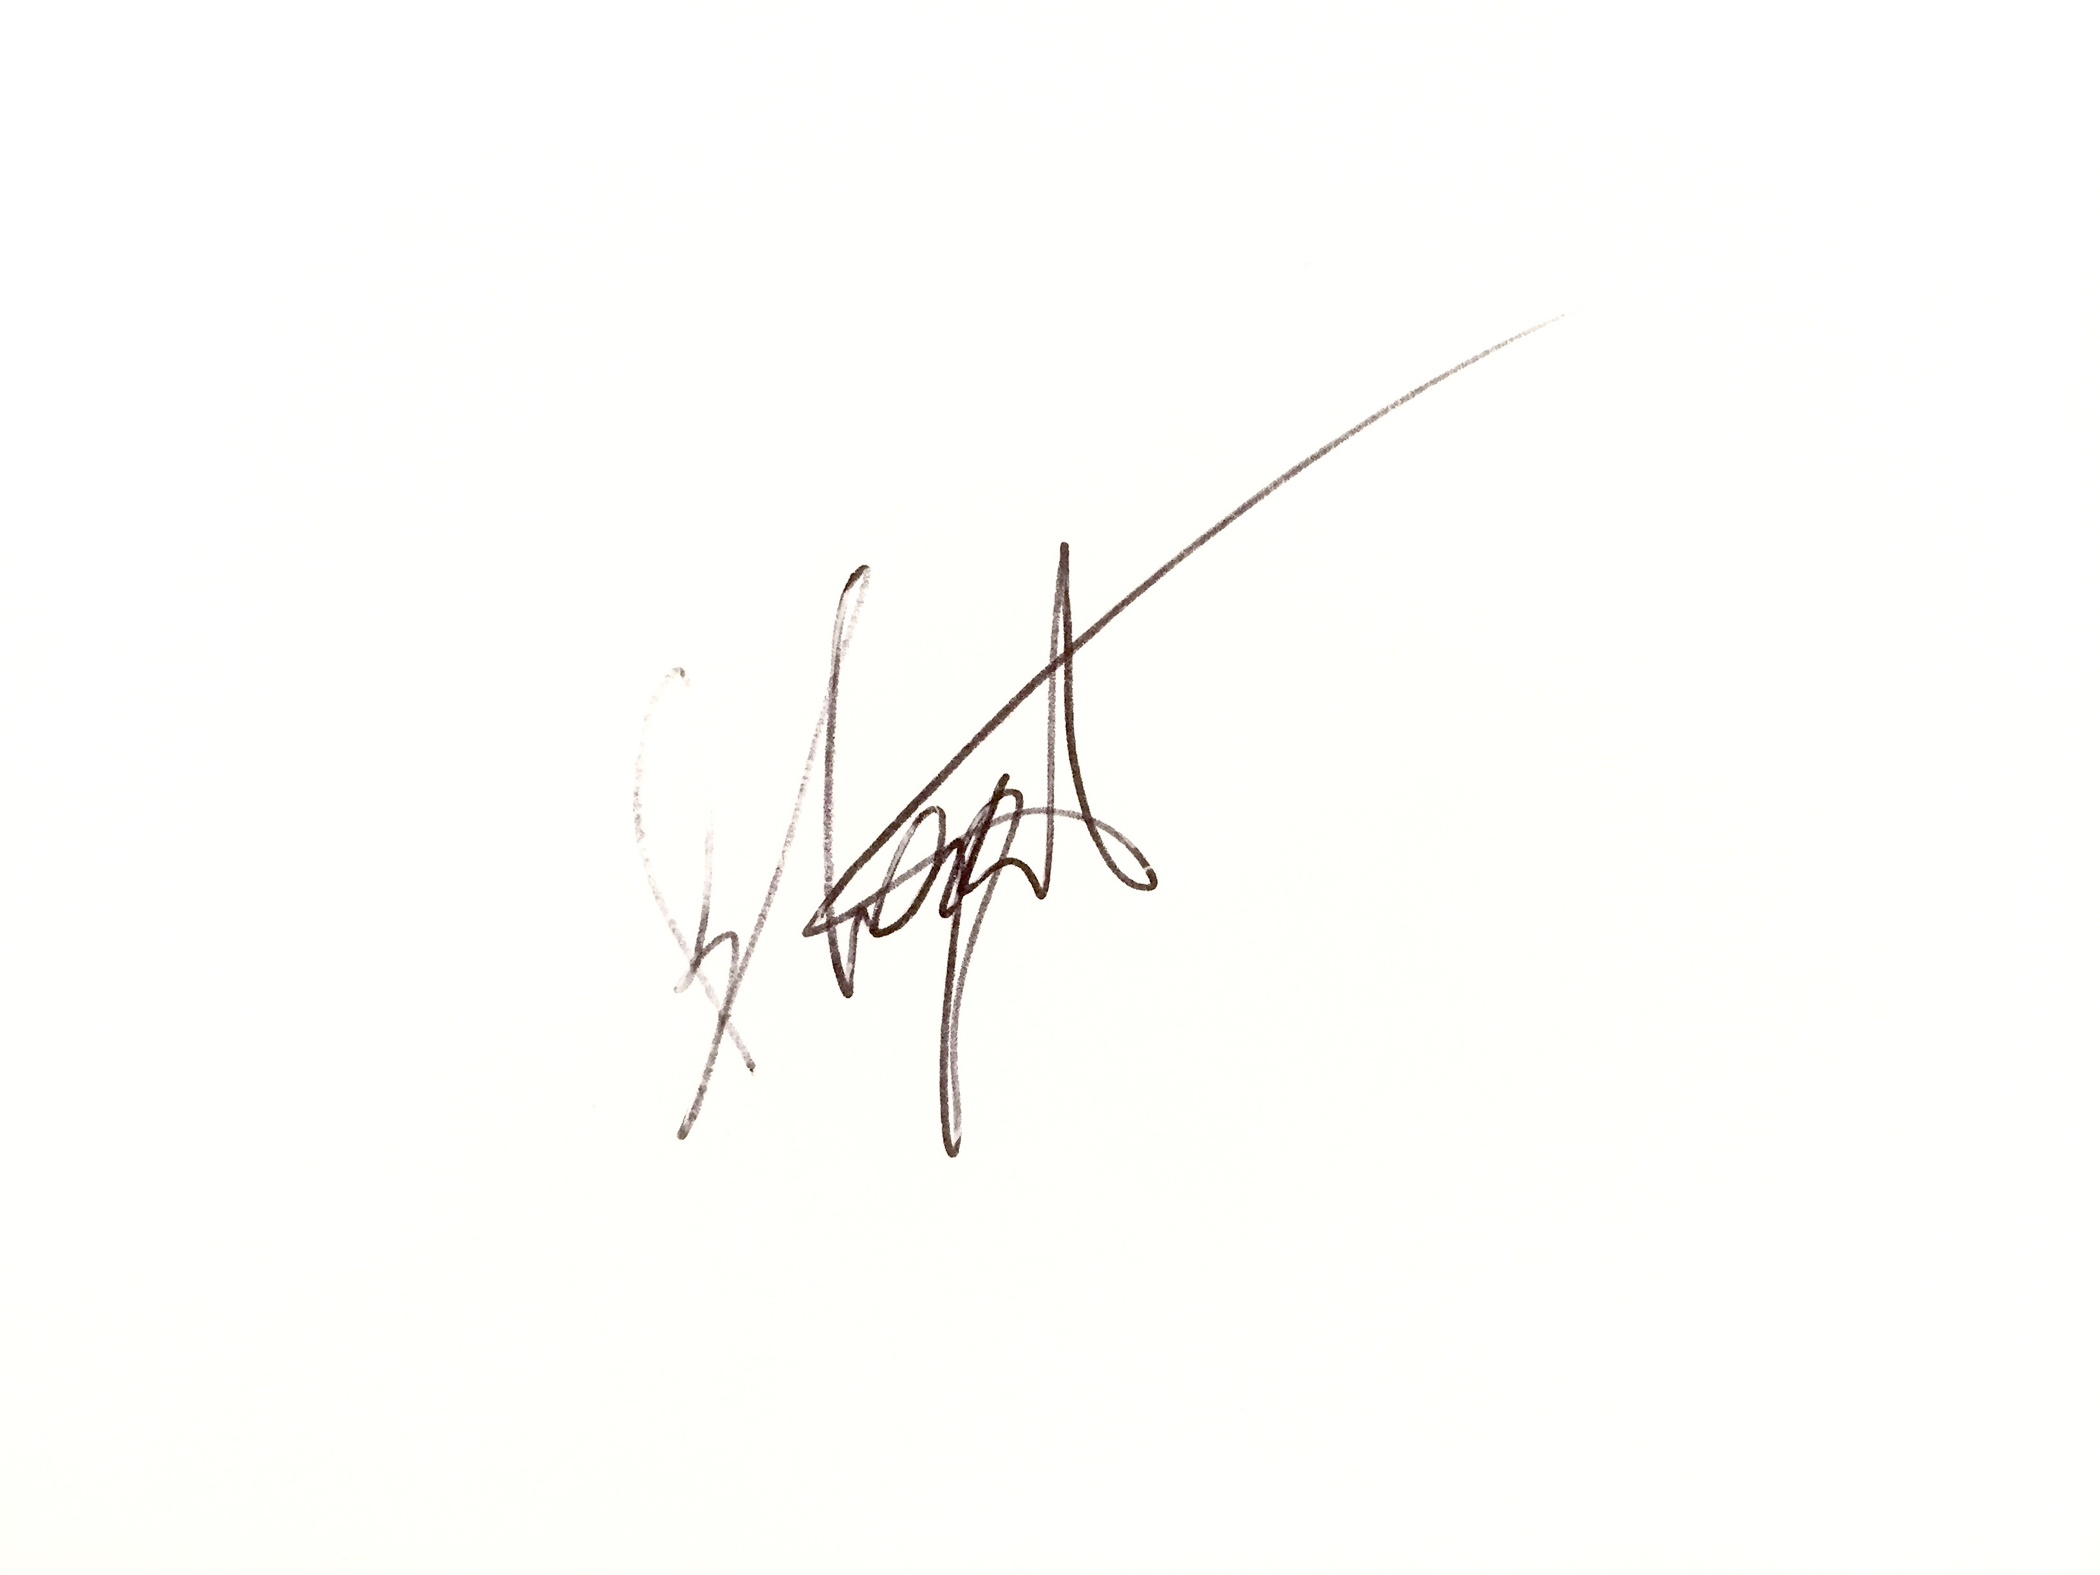

SIGNATURE  …………………………………………………………… | Date  /2020

