CERTIFICATE OF AUTHENTICITY
n° 000075

As from D.L. 22 January 2004, n. 42, this document is to be considered for all purposes
Certificate of Photographic Authenticity for the work indicated

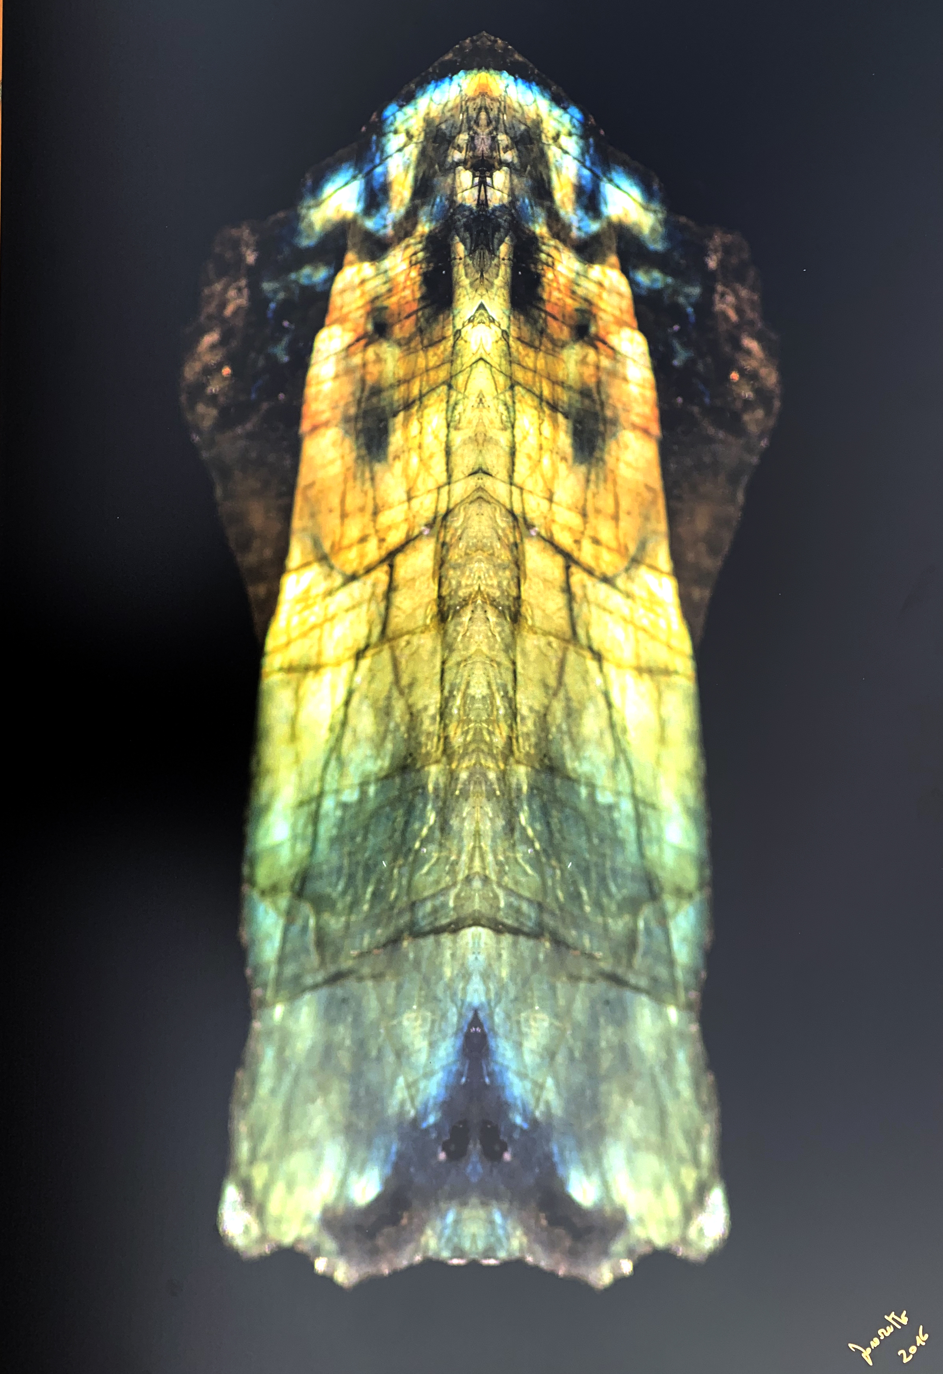

TITLE: The praying King

SIZE CM: 90x60 cm

SUPPORT: Direct print on Alu D-Bond

YEAR: 2016

EDITION: Subject 1/8 + 2 a.p.

The undersigned Stefano Favaretto born in Merano on 10/27/1969
certifies and guarantees the authenticity and ownership of the work

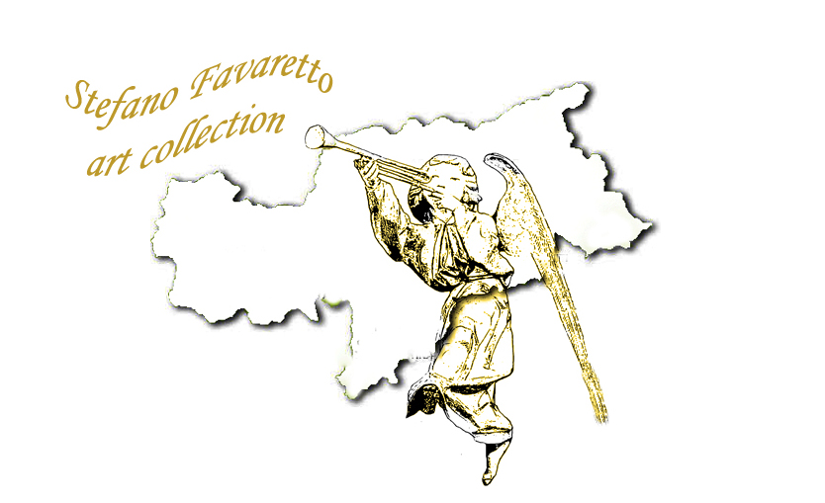
SIGNATURE:
