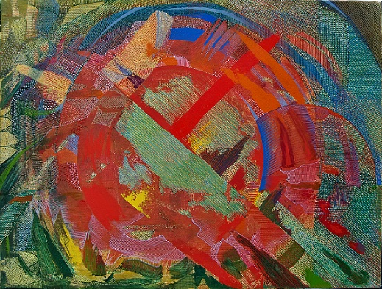

Title: | SOLAR
Author: | JERZY LESZEK STANECKI
Year: | 2010
Technique: | OIL + CANVAS
Dimensions: | 80 x 60 x 1,5

I, the undersigned and author, hereby certify this to be an original artwork.

Io, sottoscritto e autore, certifico che si tratta di un'opera d'arte originale.

SIGNATURE DATA

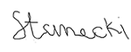 05-08- 2020

