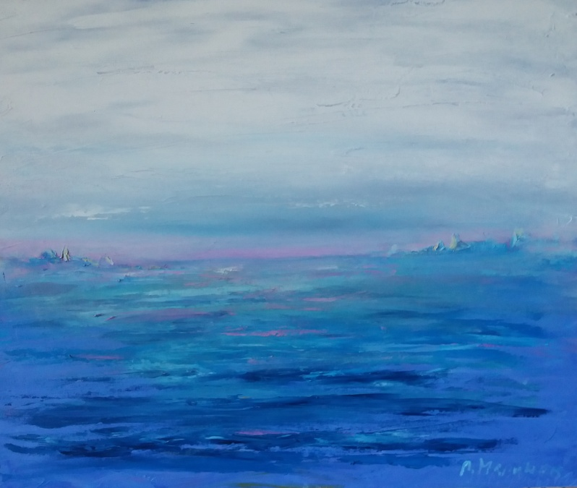
Title : Enlighnment
Author: Pavel Marinov
Year: 2018
Technique: Oil
Dimensions: 60/50/2
Аз, долуподписаният и автор, удостоверявам, че това е оригинално произведение на изкуството.
I, the undersigned and author, hereby certify this to be an original artwork.

Signature: 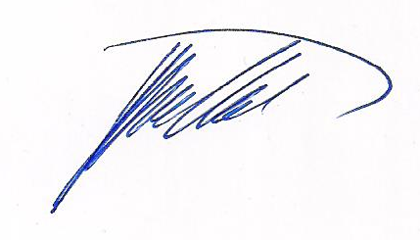 Date: 12.11.2020

