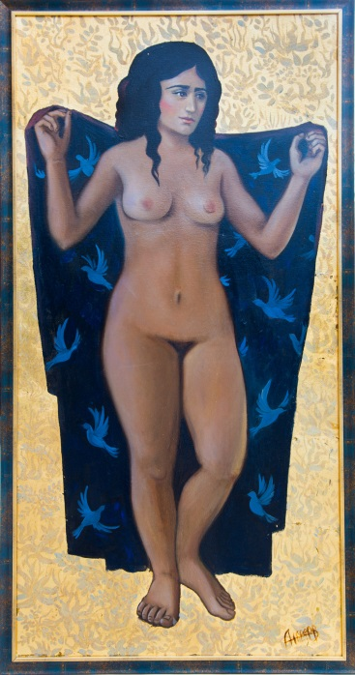

Title: | APHRODITE
Author: | ANFEROV MAXIM
Year: | 2020
Technique: | OIL CANVAS , gold leaf
Dimensions: | 100x50x2

I, the undersigned and author, hereby certify this to be an original artwork.

Io, sottoscritto e autore, certifico che si tratta di un'opera d'arte originale.

SIGNATUR  ………………………………………………………… | Date  11/19/2020
