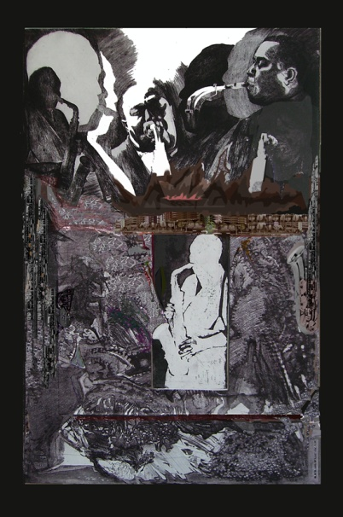

Title: | BIRD-CHERLIE PARKER
Author: | JERZY LESZEK STANECKI
Year: | 2005
Technique: | DIGITAL PRINT
Dimensions: | 90 x60 cm

I, the undersigned and author, hereby certify this to be an original artwork.

Io, sottoscritto e autore, certifico che si tratta di un'opera d'arte originale.

SIGNATURE DATA

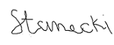 26-12- 2020

