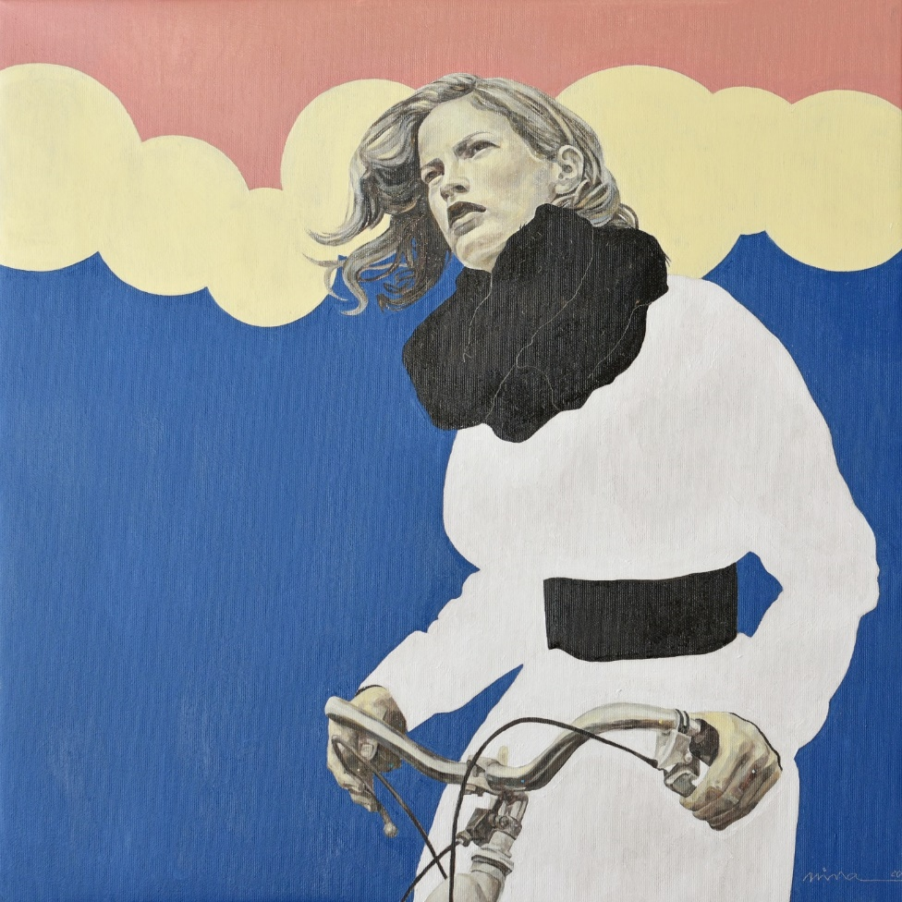

Title: | LATE FOR A MEETING
Author: | NINA PETROVA
Year: | 2020
Technique: | DRAWING, OIL ON CANVAS
Dimensions: | 50X50

I, the undersigned and author, hereby certify this to be an original artwork.

Io, sottoscritto e autore, certifico che si tratta di un'opera d'arte originale.

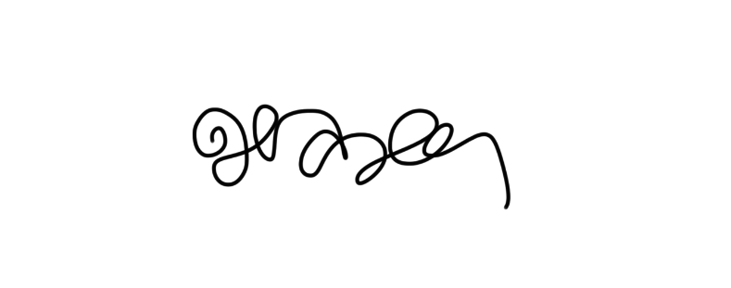  SIGNATURE  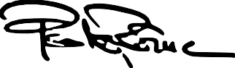  …………………………………………………………… | Date  03/10/2020

