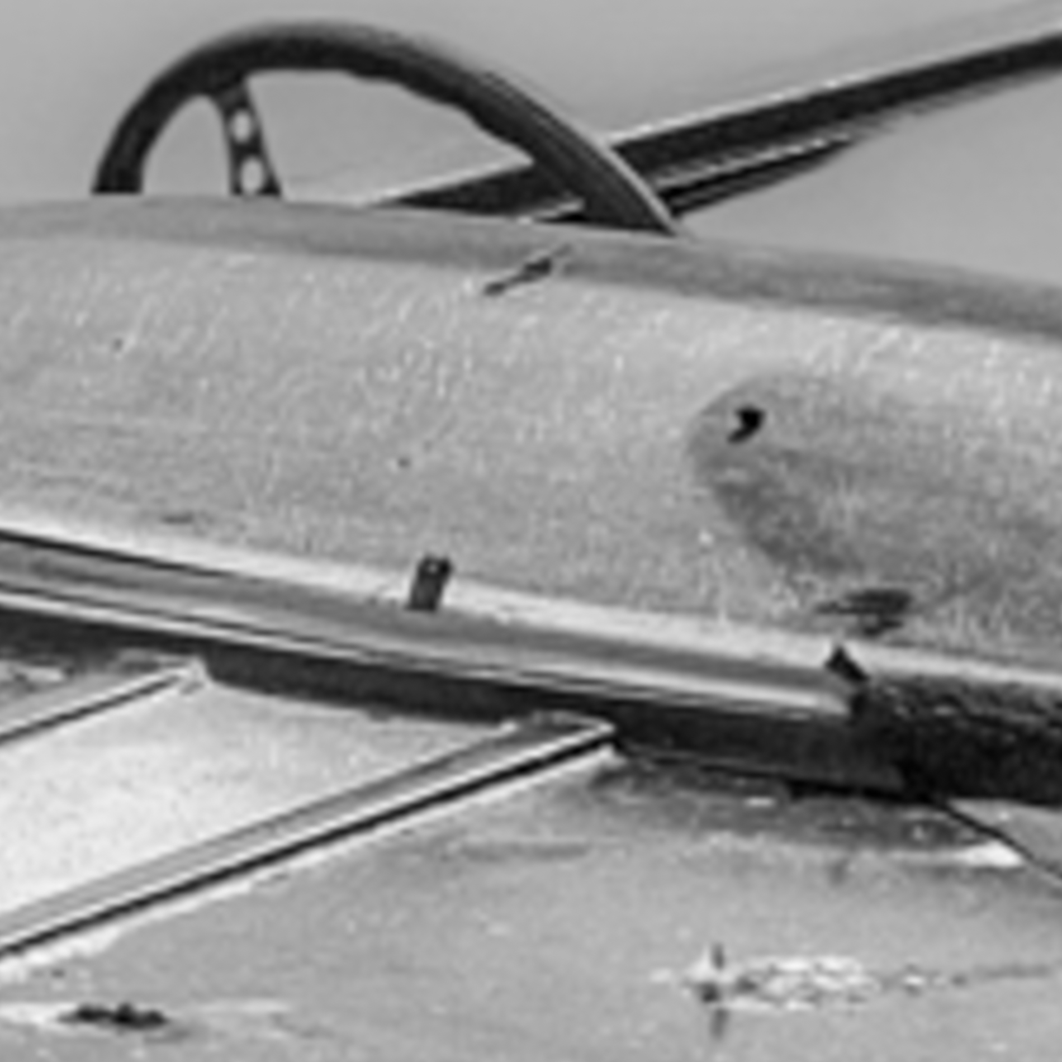

Title: | Time to slow down
Author: | René Dissel
Year: | 2020
Technique: | Fine art bnw photography
Dimensions: | 80x80cm

I, the undersigned and author, hereby certify this to be an original artwork.

Io, sottoscritto e autore, certifico che si tratta di un'opera d'arte originale.

SIGNATURE  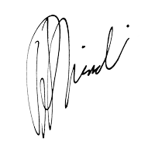  …………………………………………………………… | Date  21/07/2020

