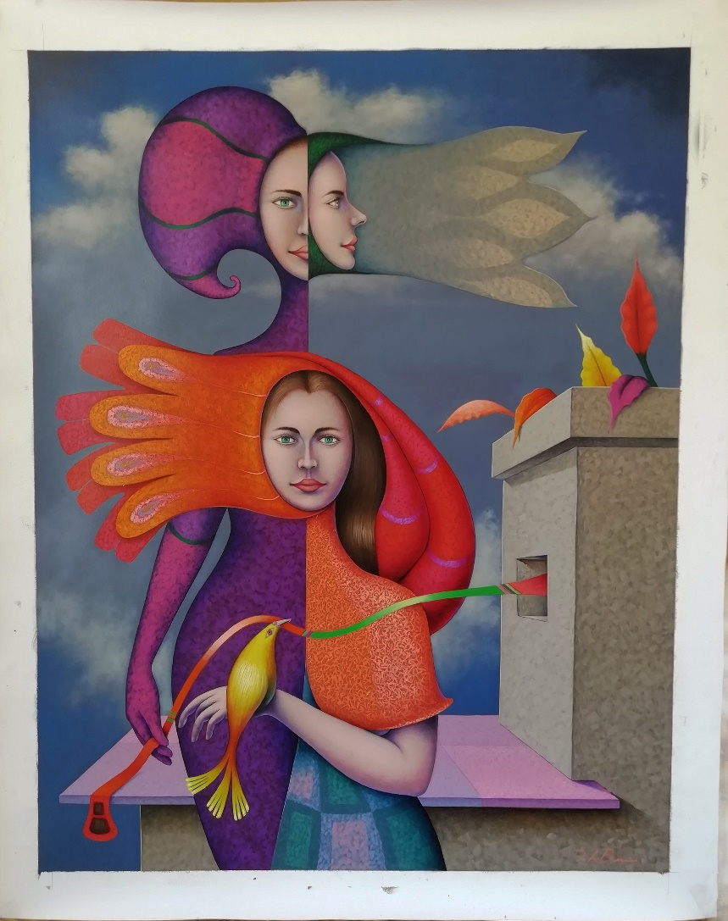

Title: “La cinta”.
Author: José De la Barra
Year: 2020
Técnica/dimensión: Oil on canvas/ 34” x 27” inches.

I, the undersigned and author, hereby certify this to be and original artwork.
In the signed certify that this artwork is original of my authorship.

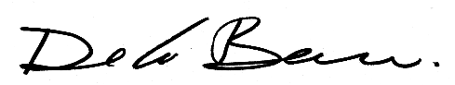
SIGNATURE : DATE : 03/05/2020

