CERTIFICATE OF AUTHENTICITY
n° 000047

As from D.L. 22 January 2004, n. 42, this document is to be considered for all purposes
Certificate of Photographic Authenticity for the work indicated

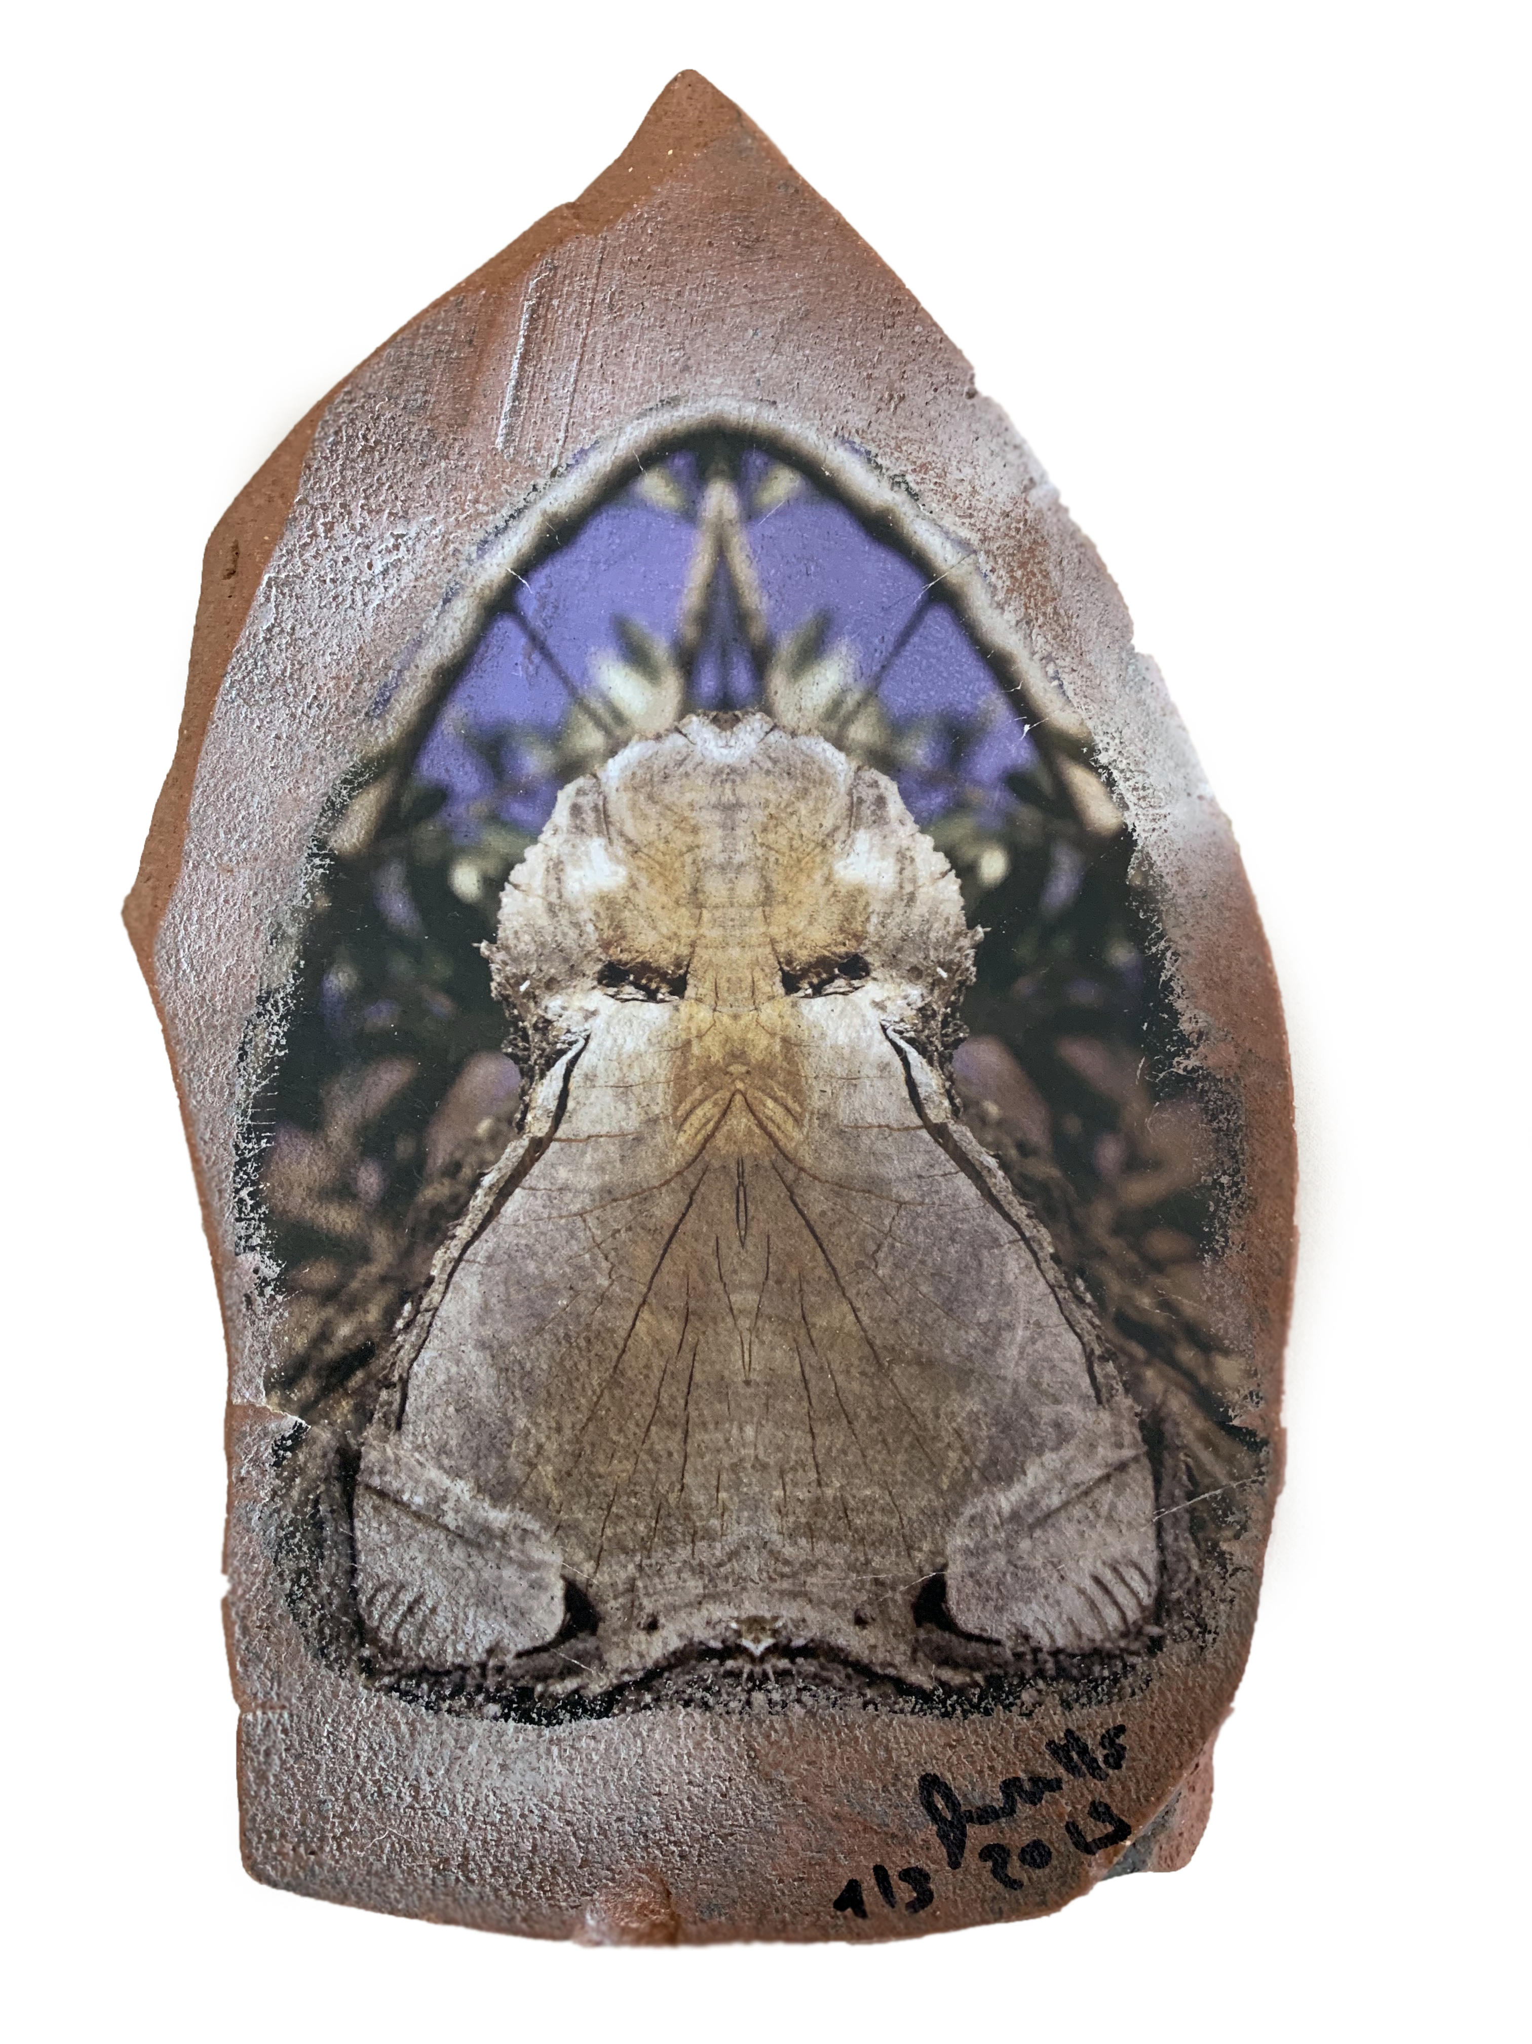

TITLE: The little owl of Antria

SIZE CM: 20 x 11 x 3 cm

SUPPORT: Print on jar

YEAR: 2019

EDITION: Subject 1/3
Support 1/1

The undersigned Stefano Favaretto born in Merano on 10/27/1969
certifies and guarantees the authenticity and ownership of the work

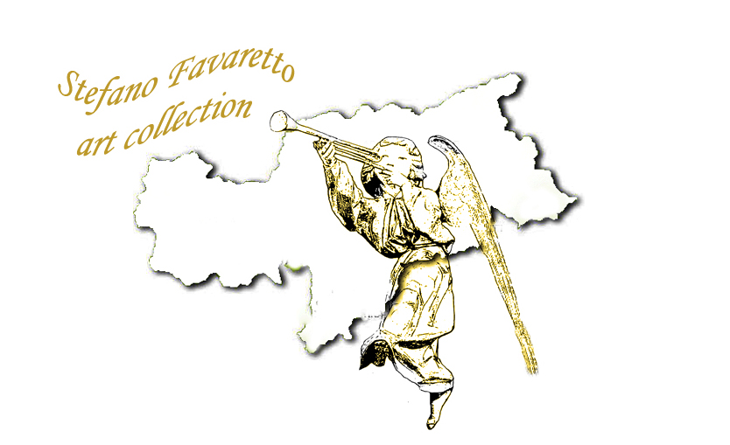
SIGNATURE:
