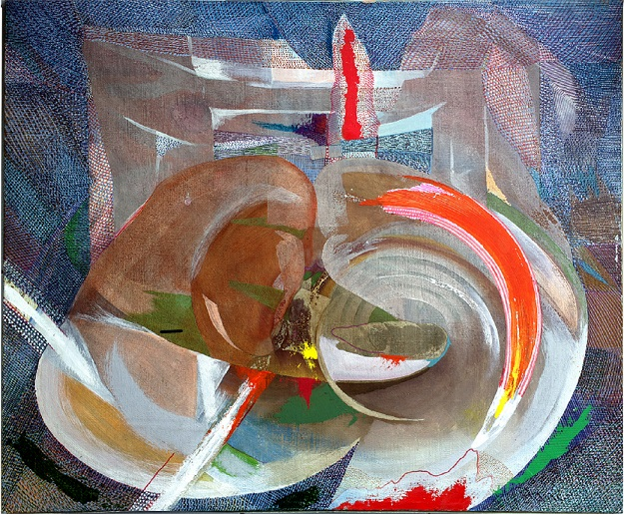

Title: | SUSHI
Author: | JERZY LESZEK STANECKI
Year: | 2005
Technique: | OIL + CANVAS
Dimensions: | 65 x 54 x 1,5

I, the undersigned and author, hereby certify this to be an original artwork.

Io, sottoscritto e autore, certifico che si tratta di un'opera d'arte originale.

SIGNATURE DATA

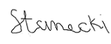 02-09- 2020

