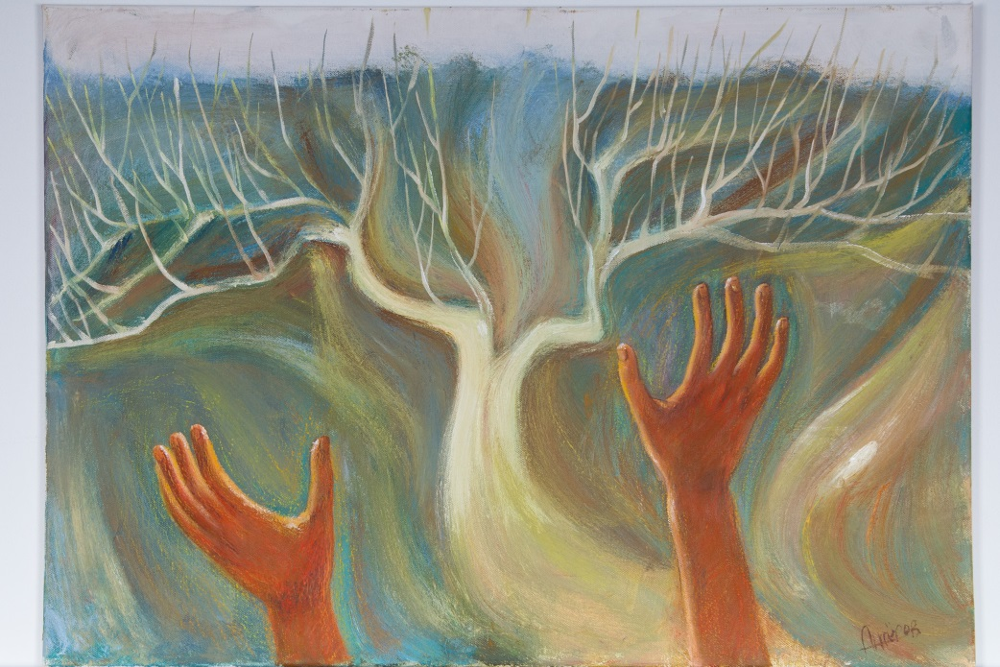

Title: | THE ENERGY OF LIFE
Author: | ANFEROV MAXIM
Year: | 2018
Technique: | OIL CANVAS ,OIL PASTEL
Dimensions: | 70x50x2

I, the undersigned and author, hereby certify this to be an original artwork.

Io, sottoscritto e autore, certifico che si tratta di un'opera d'arte originale.

SIGNATUR  ………………………………………………………… | Date  11/19/2020
