CERTIFICATE OF AUTHENTICITY
n° 000033

As from D.L. 22 January 2004, n. 42, this document is to be considered for all purposes
Certificate of Photographic Authenticity for the work indicated

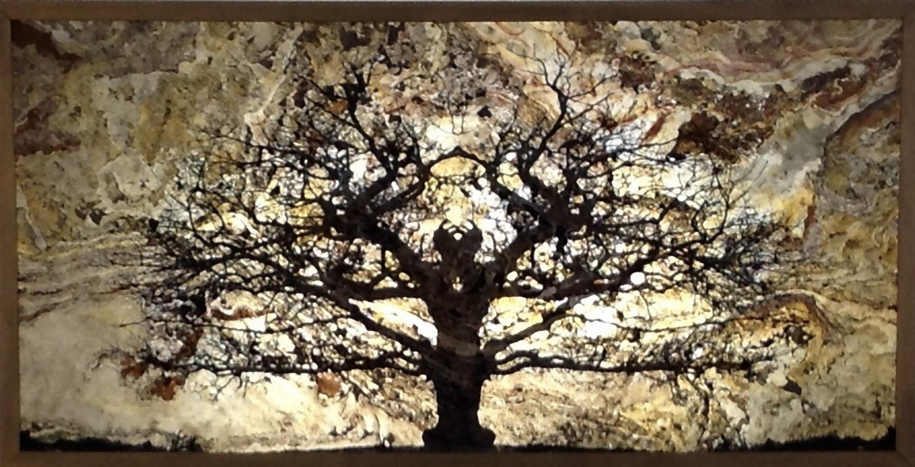

TITLE: The magic tree – L’ albero magico

SIZE CM: 210 x 105 cm

SUPPORT: direct print on real rock slate

YEAR: 2015

EDITION: Subject 2/8 + 2 A.P.
Support 1/1

The undersigned Stefano Favaretto born in Merano on 10/27/1969
certifies and guarantees the authenticity and ownership of the work

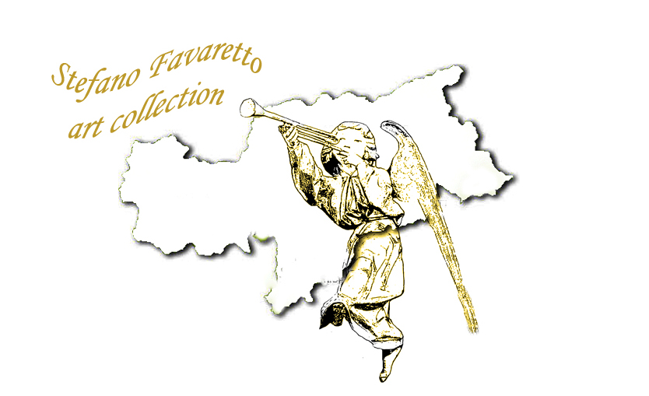
SIGNATURE:
