CERTIFICATE OF AUTHENTICITY

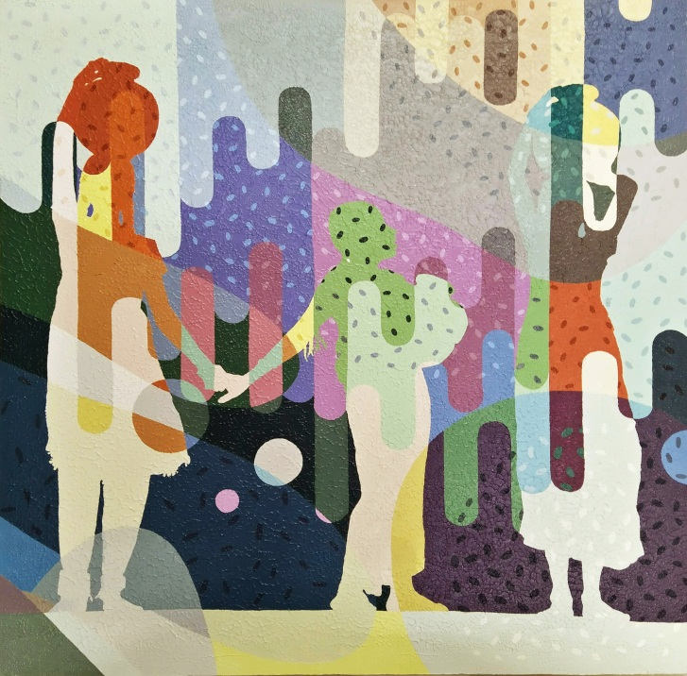

THIS IS TO CERTIFY THAT THIS PAINTING IS GENUINE AND AUTHENTIC

ARTIST NAME : BHARATHI SENTHILVELAN
MEDIUM : ACRYLIC ON CANVAS
SIZE : 36” x 36”
YEAR : 2020

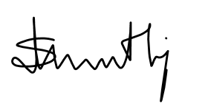
--------------------------------------------------------
BHARATHI SENTHILVELAN

