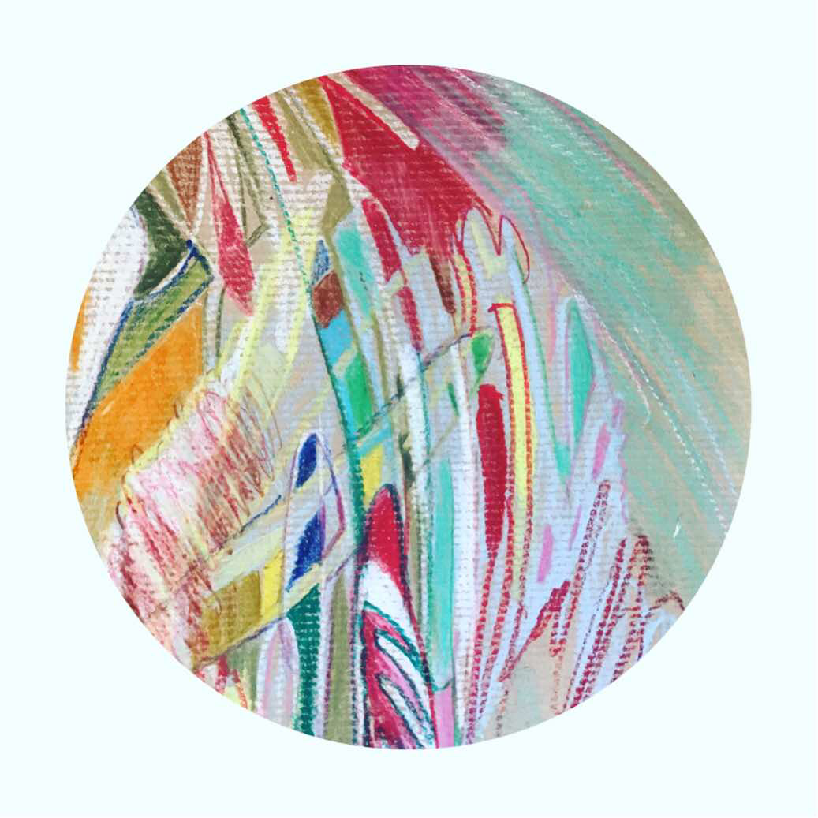

Title: | “de las esferas 6.”
Author: | Magali Reales
Year: | 2020
Technique: | Crayons aquarelle et pastel/kraft
Dimensions: | 20 centimeters in diameter

I, the undersigned and author, hereby certify this to be an original artwork.
Io, sottoscritto e autore, certifico che si tratta di un'opera d'arte originale.

SIGNATURE  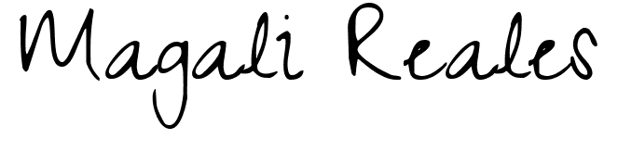  …………………………………………………………… | Date  9/8/2020

