CERTIFICATE OF AUTHENTICITY

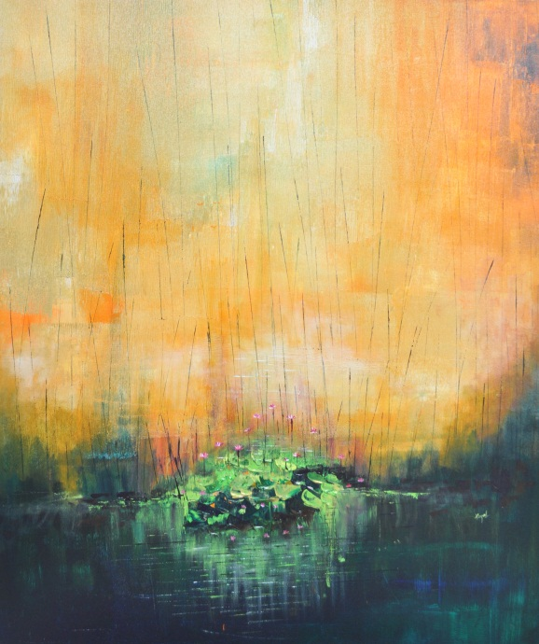

THIS IS TO CERTIFY THAT THIS PAINTING IS GENUINE AND AUTHENTIC

ARTIST NAME : KAYALVIZHI SETHUKARASU
MEDIUM : ACRYLIC ON CANVAS
SIZE : 91.4CM x 76.2CM”
YEAR : 2020

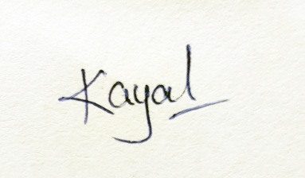
--------------------------------------------------------
KAYALVIZHI SETHUKARASU

