PRESS RELEASE
FOR PUBLICATION: 30th September 2019

Sustainable Marine Energy reveals plans for 9MW Pempa’q Tidal Energy Project at annual Ocean Energy Europe Conference in Dublin

Sustainable Marine Energy (SME) and Minas Tidal LP (MTLP) have agreed to co-develop their adjacent berths at the Fundy Ocean Research Center for Energy (FORCE) and will utilise SME’s PLAT-I floating in-stream tidal energy technology to deliver up to 9MW of tidal energy to the Nova Scotia grid.
The combined project is to be called the Pempa’q In-stream Tidal Energy Project and will be delivered in phases starting next year. For Phase 1 SME will deliver three next generation PLAT-I platforms, each producing up to 420kW, providing a combined capacity of 1.26MW.
Sustainable Marine Energy (Canada) was recently awarded a license by the Nova Scotia Department of Energy and Mines (NSDEM) which allows energy generated by the three tidal energy systems to be sold via a power purchase agreement (PPA) to Nova Scotia Power.
Project financing for the first phase through equity and debt is being provided by Hamburg-based reconcept Group. The asset manager specialising in renewable energy investments has been advising on the project and is establishing a capital fund specifically for this purpose. reconcept will also be supporting the financing of further phases of the project, to enable the delivery of the full 9MW of capacity provided by the two berths.
Karsten Reetz, Managing Partner of reconcept Group stated: “Tidal power has great potential, especially in the Bay of Fundy, and can help answer the challenges of the climate crisis. The major advantage of tidal power plants is their predictable and reliable output - this is very compelling from the investor's point of view. We expect attractive returns for our German co-investors.”
SME and the principals of MTLP have formed a joint-venture company; Spicer Marine Energy Inc. which will be responsible for deploying and operating the tidal energy systems for the duration of the project.
Jason Hayman, the Managing Director of SME commented: “Reaching this point has been a team effort and made possible by the strong support provided by key stakeholders in both Europe and Canada.
Over the past three years we have focused on developing and proving up our technical solution which has been strongly supported by our major shareholders; SCHOTTEL and Scottish Enterprise. This enabled SME to build and test the first PLAT-I demonstrator in Scotland, and since this time last year we have continued the testing in Nova Scotia, at Grand Passage, in preparation for our entry into FORCE.
The FORCE site is renowned for its incredible tidal resource, but this also makes it a very challenging environment in which to deploy equipment. The lessons learned from our deployments in Scotland and Nova Scotia have helped us to prepare for this project.
A supportive and stable market environment is required to enable the transition from R&D into an industry that can deliver commercially viable, abundant and predictable clean energy. We would like to thank the Government of Nova Scotia for remaining steadfast in their support of tidal energy. This enables us to continue our staged approach to delivering our objective; reducing the cost of tidal energy. “
The President of MTLP, Mark Savory, who has been appointed as President of the Spicer Marine Energy joint venture stated: “In conjunction with our partner Minas Energy, a founding berth holder at FORCE, we have evaluated a number of potential technologies for developing our project over the years.
SME have demonstrated an innovative and robust solution which offers unrivalled access to key components for maintenance which will help reduce lifecycle costs and is essential for de-risking early-stage projects. Combined with the demonstrated ease of installation when compared to other technologies, this provides us with a high degree of confidence. We have scrutinised SME’s next generation design; they have adapted their system to deal with the conditions present at FORCE and have increased the rated output by 50% with only a small increase in the size of the platform. This makes us very optimistic about the commercial potential of their approach.”
When questioned about the significance of the project’s name, Savory responded: “Here, in Nova Scotia, we are conducting our activities in an area that is home to the Mi’kmaq First Nation. In the Mi’kmaq language, pempa’q (pronounced bem·baahk) is the name for the rise of the tide, which we feel is especially representative of the environment we are working in. The Bay of Fundy is famous for its large tidal range, which creates the strong tidal streams through the Minas Passage that we are using to generate renewable energy. FORCE is located on the Parrsboro Shore, which in the 1800’s had very prosperous shipbuilding industry, that used the rise of the tide to launch their vessels. Now we are using the rise of the tide in the Bay of Fundy to launch a new, sustainable industry which will bring economic prosperity to the area in an environmentally responsible manner, that respects the values of Indigenous communities, many of whom are becoming more and more involved in the development of the renewable energy projects in Canada.”

-ENDS-

NOTES TO EDITORS
About Sustainable Marine Energy

Sustainable Marine Energy supplies, installs and operates turnkey tidal energy systems which have been tested extensively in Europe and Canada. The PLAT-I floating tidal power system has been proven to be easily maintainable and accessible all year-round in the Canadian climate. Its modular design enables assembly close to site, and it is deployed using local vessels, providing island and coastal communities with a source of reliable, predictable and clean power.

Sustainable Marine Energy (Canada) is responsible for delivering the Grand Passage demonstration project, where the 280kW PLAT-I is being used to prove up the technology, along with environmental monitoring systems and techniques. This testing is enabling a phased project at Fundy Ocean Research Centre (FORCE) utilising the next generation PLAT-I 6.40 platform, which will deliver up to 9MW of tidal energy into the Nova Scotia grid

About Minas Tidal LP
Minas Tidal Limited Partnership (MTLP) is a limited partnership formed to develop, own and operate tidal energy systems within the Berth “A” located within the FORCE area.

About reconcept
reconcept is an independent, owner-managed company and one of Germany’s pioneers in investments in renewable energy assets. With more than 20 years of expertise in this area, reconcept has access to high quality investment opportunities in attractive “green” assets and markets and translates these into clear investment offers tailored to the investment objectives of both private and institutional investors. Together with around 10,000 investors, reconcept has been able to realise more than 230 renewable energy plants - solar, wind and hydroelectric power plants in Germany and abroad with a total installed capacity of around 360 megawatts and an investment volume of around 510 million euros.

About FORCE
FORCE is Canada’s leading research centre for in-stream tidal energy, located in the Bay of Fundy, Nova Scotia. FORCE is made up of 5 berths in a Crown Lease Deployment Area in the Minas Passage near Parrsboro, with a total capacity of 22MW.

About SCHOTTEL
SCHOTTEL group is SME`s largest shareholder and is active in the areas of marine propulsion systems, gearbox technology, automation technology and renewable energies. SCHOTTEL is developing environmentally responsible marine technologies including tidal energy and electric propulsion systems, such as systems for fully electric ferries. SCHOTTEL has developed and manufactures the SIT 250 In-stream Turbine drivetrain, and also supplies power conversion and control system for SME’s tidal energy systems.
SCHOTTEL’s headquarters is located in Spay, Germany, but has a large global network of sales and service locations ensuring customer service worldwide.

PHOTOGRAPHS

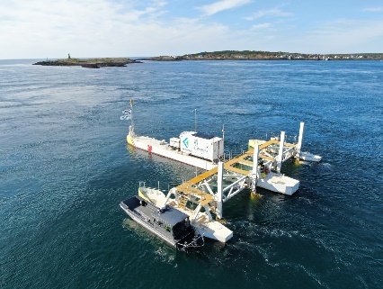  - SME_PLAT-I at Grand Passage.jpg | 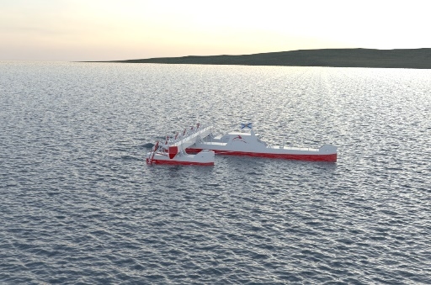  - SME_PLAT-I 6.40

For more information, or to arrange interviews please contact:
Angela MacPhail
Sustainable Marine Energy (Canada) Ltd
e-mail: angela.macphail@sustainablemarine.com
t: +1 (902) 832-3676

www.sustainablemarine.com

Tidal Licence Issued to Sustainable Marine Energy, https://novascotia.ca/news/release/?id=20190724003

