Bristol Old Vic

Early Career Writers Programme

2025 – 2026

Easy Read Application Guidance

How to apply for the Bristol Old Vic Early Career Writers Programme 2025 – 2026

This is inclusive and easy to read application guidance.

The document tells you everything you need to know about our awards including:

* Details about the programme (pages 3 – 4)
* Our key intentions (pages 5 – 6)
* How the programme will work (pages 7 – 9)
* Who can apply (pages 10 – 11)
* What we mean by ‘Early Career’ (pages 12 – 14)
* Key dates (page 15)
* Application form questions (pages 16 – 22)
* How to apply (page 23)

Please read all the information in this document.

If you want to ask a question or need more information, please send an email to

Lisa Gregan: [lisa.gregan@bristololdvic.org.uk](mailto:lisa.gregan@bristololdvic.org.uk)

About the programme

**What is this?**

Following a successful first year (2024 – 2025), the Bristol Old Vic Early Career Writers 2025 – 2026 Programme is open for applications.

It is a free initiative which exists to encourage and support a group of four ‘early career’ writers to take their next steps with their playwriting practice.

The programme will be delivered across several weeks between December 2025 and September 2026.



9 months

The programme will take place in-person at Bristol Old Vic – our theatre on King Street.

The programme will be led by a ‘lead writer’, who will be local playwright Ross Willis. His previous work includes ‘Wolfie’ and ‘Wonder Boy’.

**Who can apply?**

It is open to writers currently living in or originally from the South West of England.



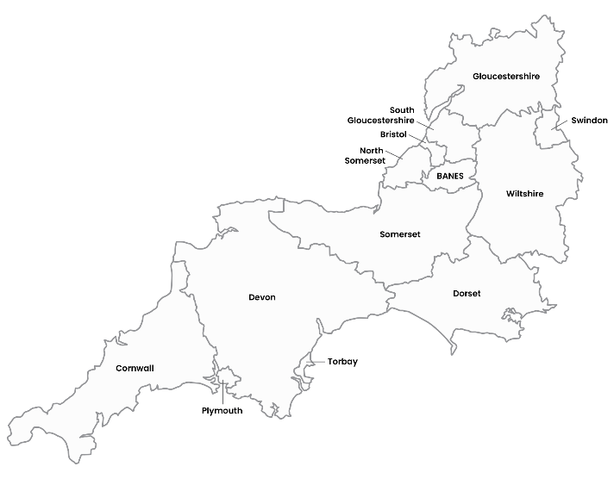

Our key intentions

Build relationships between Bristol Old Vic and our Early Career Writers and make you feel that you are a part of our community – not just visitors

Give space and time for Bristol Old Vic to be flexible to the needs of the Early Career Writers group

Allow our group of Early Career Writers to experience the joy of writing a play

Create a process of submitting work and receiving feedback from Bristol Old Vic. This is an example of how a writer may work professionally with a theatre’s Literary Team

Create opportunities for writers to watch plays and other forms of theatre as a way of seeing scripts and writing coming to life on stage

Create a joyful space where writers can connect with and support each other to create bold new work



How will it work?



We will be selecting four writers to take part in the 2025 – 2026 programme.

We will be selecting writers who are living in or originally from the South West. If you aren’t sure if that’s you, you can ask us for support to find out.

You will need to complete an online application form – more details about the questions below.



12

sessions

There will be around 12 sessions, led by local playwright Ross Willis, over a period of 9 months: December 2025 – September 2026.

The course is designed to fit around your existing work or other commitments.

In the programme’s early sessions, there will be a focus on writers training and developing their skills through writing workshops.

***

Writers will then have the opportunity to work on and share their writing with the group, Ross Willis and Bristol Old Vic’s Literary Team, and receive feedback.

Financial support will be available to any participants who are facing financial or access barriers to attending sessions.

Writers will also be able to access: free space to work in, invitations to press nights, free tickets to Bristol Old Vic shows, and discounts at our bar.

Who can apply?

Anyone living in or originally from the South West of England.

Anyone who writes!

Anyone who considers themselves to be ‘early career’ – more details about what we mean by this below.

Anyone of any age who is above the age of 18. There is no age limit.

You do not need to have any previous experience to apply.

You do not need to have any previous education to apply.

What does ‘early career’ mean?

You might never have shared your writing with anyone before, but you would like to take your first steps to do so.

You might be someone who has previously taken part in different writing opportunities, but this programme offers you a new experience.

You might be someone who writes a lot, but your work has only been performed at scratch nights (i.e. short extracts of plays which are in development) or within a short performance run (i.e. less than a week) at a theatre.

You might be an artist writing in another medium (e.g. music, poetry or prose) who would like the opportunity to learn and practise playwriting.

You might be someone who works in a different role in theatre but maybe you haven’t been in the role of a writer before.

You probably haven’t had a 4-week run of one of your plays at a major UK theatre.

We understand that you might unsure whether you qualify as an ‘early career’ writer and this definition can vary.

We have set out some examples above – you might be some or none of these things!

We want to hear from as many people as possible. If you are still not sure whether you are suitable for this opportunity or not, please feel free to get in touch with us and we will help you work that out.

You can send an email to

Lisa Gregan: [lisa.gregan@bristololdvic.org.uk](mailto:lisa.gregan@bristololdvic.org.uk)

We will be happy to respond to any questions and explain anything over email or a telephone call.

Key Dates

Applications are open Tuesday 12 August 2025.

Deadline for applications is 12pm on Wednesday 10 September 2025.

The programme will take place from December 2025 to September 2026.

Application Form Questions

1. **Tell us about you and your writing journey so far.**

How would you describe both yourself as a writer and what your current writing journey has been? You might write just for yourself, you might have written something that has already been performed, you might write in a different medium or art form etc.

No experience is necessary, it’s just useful for us to know how you currently approach writing as a practice.

We are using a “light touch” application process – this means that our questions are designed to allow you to express yourself as freely as possible without being limited to strict guidelines. We will ask you tell us a bit about yourself, your play idea and what inspires you, and share a bit of your writing (see guidance below for full details).

You will the option to submit written or recorded (video/audio) responses.

The Early Career Writers Programme application form asks the following 5 questions:

If you are providing a written response, please use no more than 150 words:

|  |
| --- |
|  |

If you are responding with a video or audio recording, please make sure that this is no longer than 2 minutes long. If it is a BSL video recording, please make sure that this is no longer than 3 minutes long.

**2. Tell us about an idea that you think could work as a play and that you want to write right now.**

There are no right or wrong answers and you don't need to have the whole idea worked out. We recommend focusing on describing the basic story you are thinking about, why it might interest you and what you imagine the feel of it to be.

If you are providing a written response, please use no more than 150 words:

|  |
| --- |
|  |

If you are responding with a video or audio recording, please make sure that this is no longer than 2 minutes long. If it is a BSL video recording, please make sure that this is no longer than 3 minutes long.

**3. Tell us about who or what creatively inspires you and your writing at the moment.**

We want to know a bit about what excites you creatively. This might be a playwright or a play but it could be work in a different medium (poetry, prose, television, film & music) or something else entirely. There are no right or wrong ways to answer this question. Try to be honest and brave; we are interested to know about what work and culture is influential for our Early Career Writers, to best support and encourage their artistic voice and vision.



If you are providing a written response, please use no more than 150 words:

|  |
| --- |
|  |

If you are responding with a video or audio recording, please make sure that this is no longer than 2 minutes long. If it is a BSL video recording, please make sure that this is no longer than 3 minutes long.

**4. Is there anything else you’d like to tell us about yourself?**

This isn't a compulsory question but an open opportunity for you to share anything else that you would like to about yourself.

If you are providing a written response, please use no more than 150 words:

|  |
| --- |
|  |

If you are responding with a video or audio recording, please make sure that this is no longer than 2 minutes long. If it is a BSL video recording, please make sure that this is no longer than 3 minutes long.

**5. We will also ask you to share a sample of your writing (maximum length is 10 pages).**

This writing sample does not need to be related to the play idea you shared with us earlier in the form, it can be anything you like. The only thing we ask is that it should be intentionally written for live performance (e.g. stage drama or performance poetry) as opposed to an extract from a short story, novel or screenplay.

**For written submissions, we strongly suggest preparing your answers in advance and copying and pasting them into the application form when you are ready.**

How do I apply?

Applications are submitted online via Typeform. Please note that the deadline for applications is **Wednesday 10 September 2025** at **12pm**.

For written applications, you can use the text boxes on this document above and then copy and paste them into the online form here: <https://form.typeform.com/to/PiDK35ye>

For audio or video applications, please record the answer to each question as a separate file and upload the files into the online form here: <https://form.typeform.com/to/PiDK35ye>

If you need to apply in a different format or if you need any help or support with the application process, please email

Lisa Gregan: [lisa.gregan@bristololdvic.org.uk](mailto:lisa.gregan@bristololdvic.org.uk)

**When will I hear back about my application?**

We will aim to respond to everyone **on or before Wednesday 8 October 2025**.