[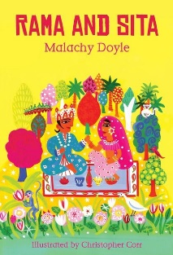](https://www.google.co.uk/url?sa=i&rct=j&q=&esrc=s&source=images&cd=&cad=rja&uact=8&ved=&url=https://www.bloomsbury.com/uk/rama-and-sita-the-story-of-diwali-9781408139509/&psig=AOvVaw1r_vSz5zleukI_d9ogqmik&ust=1542446434984570)[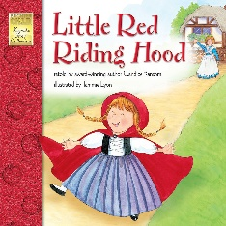](https://www.google.co.uk/url?sa=i&rct=j&q=&esrc=s&source=images&cd=&cad=rja&uact=8&ved=&url=https://www.amazon.in/Little-English-Spanish-Brighter-Keepsake-Stories/dp/1577681983&psig=AOvVaw0Gtf_VHPzW2sfnRpL61nwu&ust=1542446647054235)

**As communicators, we will:** Continue to develop our attention and listening skills in

a variety of situations.

Learn new vocabulary such as whoosh, whizz, crackle (bonfire night)

Plan a party for Polly (LF)

Talk about how we are different.

Take part in role play (UF –school, LF- home corner)

Take part in the Nursery Rhyme Challenge (LF)

Take part in circle time activities

Takepart in Helicopter Stories (UF)

**As healthy movers, we will:**

Handle tools in the classroom safely.

Make marks with different tools, write recognisable letters and write our name.

Use the climbing equipment to develop our gross motor skills.

Make Rangoli patterns to develop our fine motor skills.

Take part in yoga (UF)

Be involved in the sponsored ‘Gymercise’ activity (UF)

Eat healthy snacks

**As individuals and friends, we will:**

Continue to learn about right and wrong behaviours and the importance of our Golden Rules.

Learn to take turns and share resources.

Learn to work cooperatively.

Learn about mutual respect.

Talk about how to be a good friend.

Have a class target and individual targets (Investors in Pupils)

**As effective learners, we will:** enjoy and achieve what we set out to do. Be willing to have a go and be confident to share our own ideas.

**As mathematicians, we will**:

Continue to learn number rhymes.

Recognise numbers 1-10 (LF) 1-20 (UF)

Match numeral to quantity

Count objects.

Make a Christmas cake (LF)

**As readers and writers we will:**

Listen to the stories shown and many more (daily).

Read our reading books (UF).

Take part in daily phonics sessions.

Learn to hold books the correct way up and turn pages one at a time.

Write daily and give meaning to the marks we make/ write recognisable letters.

Write invitations, birthday cards, Christmas cards, party food lists, labels.

**As artists, actors and musicians we will:**

Listen to Indian music and use musical instruments that originate from India.

Make firework pictures.

Make Christmas decorations and cards.

Make Mendhi patterns.

Make a diwa lamp

Learn new songs (Christmas)

Perform a Christmas play.

Create movements to party music

Decorate Pudsey Bear

Role-play a Diwali party/ Christmas party/birthday party.

[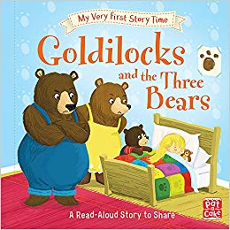](https://www.google.co.uk/url?sa=i&rct=j&q=&esrc=s&source=images&cd=&cad=rja&uact=8&ved=&url=https://www.amazon.in/Goldilocks-Three-Bears-glossary-activity/dp/1526380234&psig=AOvVaw25NIPnUXhHZByl9IDXANZp&ust=1542446778005126)[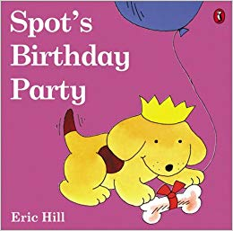](https://www.google.co.uk/url?sa=i&rct=j&q=&esrc=s&source=images&cd=&cad=rja&uact=8&ved=&url=https://www.amazon.com/Spots-Birthday-Party-color-Eric/dp/0142501255&psig=AOvVaw3674cBZga0mWggWzj-pDy-&ust=1542446518637177)[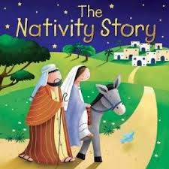](https://www.google.co.uk/url?sa=i&rct=j&q=&esrc=s&source=images&cd=&cad=rja&uact=8&ved=&url=https://www.eden.co.uk/the-nativity-story-board-book/&psig=AOvVaw3R5BlMk6MGLDUMLTPXOCCd&ust=1542446715794227)[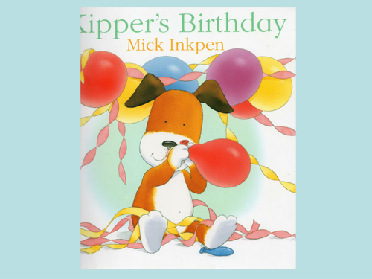](https://www.google.co.uk/url?sa=i&rct=j&q=&esrc=s&source=images&cd=&cad=rja&uact=8&ved=&url=https://www.tes.com/teaching-resource/kipper-s-birthday-powerpoint-6135941&psig=AOvVaw0byxhyLh9OP7EvgAdWD4Qu&ust=1542446561176770)

‘Let’s Celebrate’ we will cover Bonfire Night, Diwali, Birthdays and Christmas. Autumn 2 UF (Reception) & LF (Nursery)

This is our topic for this half term. Please use it to add your own research or bring things into school to support your child’s learning. Thank you

**As explores and investigators we will:**

Explore melting (LF)

Take part in a wellie walk (UF)

Learn about our own celebrations and celebration of others.

Explore colour and light.

Bake barfi, a birthday cake, a Christmas cake.(LF)

Make party food.

Explore the season autumn.

Plant and care for our winter plants.

.