[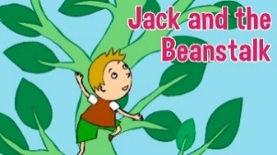](https://www.google.co.uk/url?sa=i&rct=j&q=&esrc=s&source=images&cd=&cad=rja&uact=8&ved=2ahUKEwiI2rnI-5XhAhUDAmMBHSaBDXsQjRx6BAgBEAU&url=https://www.youtube.com/watch?v%3DW5rxfLRgXRE&psig=AOvVaw0VMS6o7_NW_MBKGJVV5SfS&ust=1553351533226802)[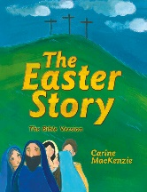](https://www.google.co.uk/url?sa=i&rct=j&q=&esrc=s&source=images&cd=&cad=rja&uact=8&ved=2ahUKEwj88vDt_JXhAhUMlhQKHcZpCAgQjRx6BAgBEAU&url=https://www.10ofthose.com/uk/products/18589/the-easter-story&psig=AOvVaw20lVmgqJImpU861V5MTwes&ust=1553351878508464)[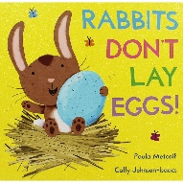](https://www.google.co.uk/url?sa=i&rct=j&q=&esrc=s&source=images&cd=&cad=rja&uact=8&ved=2ahUKEwiu7P3W_ZXhAhW06uAKHUjqDCYQjRx6BAgBEAU&url=https://www.theworks.co.uk/p/picture-books/rabbits-dont-lay-eggs/9781447282778&psig=AOvVaw0I24Ogt8bS9B9BsrNdnTxN&ust=1553352105255978)[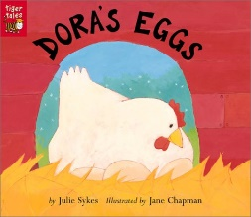](https://www.goodreads.com/book/show/222029.Dora_s_Eggs)[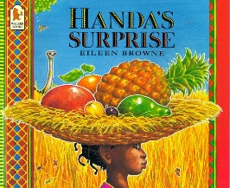](https://www.google.co.uk/url?sa=i&rct=j&q=&esrc=s&source=images&cd=&cad=rja&uact=8&ved=2ahUKEwjt68rn-5XhAhWGHxQKHbZ5BSYQjRx6BAgBEAU&url=https://www.amazon.co.uk/Handas-Surprise-Eileen-Browne/dp/0744536340&psig=AOvVaw2z3ElCCLbgMsjf-uVMF2je&ust=1553351602401785)

**As explorers and investigators, we will:**

Explore the season of spring.

Observe and care for the spring flowers in the garden (UF &LF)

Plant a variety of seeds (UF LF)

Incubate eggs (LF)

Learn about the life cycle of a hen (LF)

Explore different plants/flowers (UF LF)

Learn the different parts of a flower/plant.

Investigate mini beasts in the outdoor area (UF LF)

.

**As communicators, we will:**

Take part in Helicopter Stories (UF&LF)

Talk about the signs of spring.

Learn new vocabulary such as shoot, root and carbon dioxide.

Take part in speaking and listening activities.

Listen and respond to others.

Learn actions to help us retell stories, draw story maps write and rewrite traditional stories (UF)

**To promote British Values we will:** Have a class target and individual targets (Investors in Pupils). Tigers will vote for class representatives to join the School Council and will vote for their favourite pancake topping and favourite fruit after tasting them.

Nursery will have the opportunity to choose a story. Our value of the term is honesty.

Ready Steady Grow, spring 2 2019 UF Tigers (Reception) & LF Tiger Cubs (Nursery). This is our topic for this half term. Please use it to add your own research or bring things into school to support your child’s learning.

**As healthy movers, we will:**

Handle tools in the classroom safely.

Learn how to keep healthy. (UF LF)

Eat and make healthy food (fruit kebabs (UF), tasting vegetables (LF)

Take part in PE (UF)

Strengthen our fingers by taking part in Funky Finger’s activities.

Take part in wake up shake up

Move in different ways

Use flipper flappers to build up

our strength for writing

**As individuals and friends, we will:**

Continue to learn about right and wrong behaviours and the importance of our Golden Rules.

Learn how to be a good friend. (LF)

**As readers and writers we will:**

Listen to the stories shown and many more (daily).

Read our reading books (UF).

Take part in daily phonics sessions.

Write daily and give meaning to the marks we make/ write recognisable letters.

Write about our walk to Lidl (UF)

Retell stories (UF & LF)

Make our own books.

Take part in guided reading (UF)

Take part in a book swap (LF)

Take part in World Book Day (UF LF)

[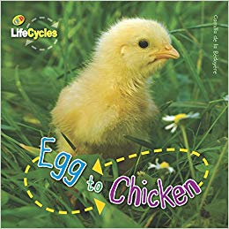](https://www.google.co.uk/url?sa=i&rct=j&q=&esrc=s&source=images&cd=&cad=rja&uact=8&ved=2ahUKEwj93aev_ZXhAhXBDGMBHSw5CRwQjRx6BAgBEAU&url=https://www.amazon.com/Egg-Chicken-LifeCycles-Camilla-Bedoyere/dp/1682970299&psig=AOvVaw11rzaIZkrVtrScCOZys7Kf&ust=1553352011921580)[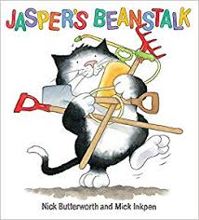](http://www.google.co.uk/url?sa=i&rct=j&q=&esrc=s&source=images&cd=&cad=rja&uact=8&ved=2ahUKEwiP046p-5XhAhVYBWMBHT_EBEwQjRx6BAgBEAU&url=/url?sa%3Di%26rct%3Dj%26q%3D%26esrc%3Ds%26source%3Dimages%26cd%3D%26ved%3D%26url%3Dhttps://www.amazon.co.uk/Jaspers-Beanstalk-Nick-Butterworth/dp/0340945117%26psig%3DAOvVaw3z4RaARHVZAH2pyDNL7ljD%26ust%3D1553351471211076&psig=AOvVaw3z4RaARHVZAH2pyDNL7ljD&ust=1553351471211076)

**As artists, actors and musicians we will:**

Learn about artist Giuseppe Archimboldi’s work (LF)

Make observational paintings of spring flowers (LF UF)

Learn new songs and rhymes (UF & LF)

Act out the story of Jack and the Beanstalk (UF) Jasper’s Beanstalk (LF)

Learn how to make light and dark shades with the paint.

Make an Easter bonnet (stay and play session and take part in an Easter bonnet parade (LF)

Make Easter crafts (stay and play session UF)

(LF)

Work with an artist in school (UF LF)

**As mathematicians, we will**:

Recognise numbers 1-10 (LF) using the number rhymes to help us, 1-20 (UF)

Order numbers 1-20 (UF)

Understand what the digits mean in 2 digit numbers (UF)

Explore shape (LF)

Name shapes 2D & 3D (UF)

Use numicon daily (LF & UF)

Match number to quantity (LF)

Count things that cannot be moved. (LF)