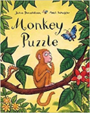[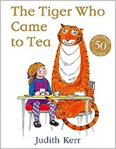](https://www.google.co.uk/url?sa=i&rct=j&q=&esrc=s&source=images&cd=&cad=rja&uact=8&ved=2ahUKEwjR17zt7YrdAhXLKVAKHZRqBx4QjRx6BAgBEAU&url=https://www.amazon.fr/Tiger-Who-Came-Tea/dp/0007215991&psig=AOvVaw3D6yOH9DF3mVVarXD8XlKh&ust=1535377689433904)

**As individuals and friends, we will:** Learn new

routines and become independent learners.

Learn our friend’s names.

Build up relationships with each other and the adults.

Learn about the importance of sharing and taking turns.

Discuss what feelings are.

Learn how to look after our environment.

Learn about right and wrong behaviours and the importance of our Golden Rules in order to get along with each other.

**To promote British Values we will:** Learn about mutual respect and tolerance. We will treat others as we would like to be treated and learn to understand our similarities and differences.

Our value for this half term is Good Manners. 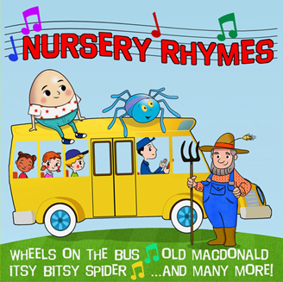

**As readers and writers we will:**

Listen to the stories shown and many more (daily).

Read our flash cards and reading books. (Tigers).

Join in with Nursery Rhymes for our rhyme challenge. (Tiger Cubs)

Take part in daily phonics sessions.

Find out information from non-fiction books.

Write daily and give meaning to the marks we make. Write recognisable letters. Use our phonic knowledge to attempt to write words.

Learn the letter formation rhymes.

**As explores and investigators we will:**

Learn how to navigate different programmes on the laptop.

Learn how to use the talking tins and cameras.

Explore technological toys and equipment.

Discover the sights and sounds of autumn.

Create an autumn investigation table.

Discuss similarities and differences.

Explore the water wall outdoors.

.

**As healthy movers, we will:**

Handle tools in the classroom safely.

Make marks with different tools, write recognisable letters and write our name.

Use the climbing equipment to develop our gross motor skills.

Use the ‘funky finger’ area to develop our fine motor skills.

Use the scissors to snip and cut.

Take part in PE (dance and games) and use the balance bikes (Tigers).

Become independent with our self-care.

Join in with wake up shake up and dough disco.

Learn about the importance of eating healthy food and bake a variety of dishes. (nursery)

Learn to mould and manipulate a variety of materials.

**As artists, actors and musicians we will:**

Create collages, paper plate faces, using a variety of materials.

Learn how to draw a recognisable picture.

Make an autumn collage/leaf man picture using natural materials.

Learn how to mix colours with paint.

Learn new songs/rhymes and dances.

Construct different structures using a variety of resources.

Use the stage area outdoors to perform songs, dances and create musical sounds.

x

[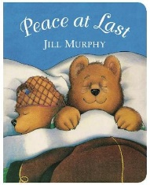](https://www.google.co.uk/url?sa=i&rct=j&q=&esrc=s&source=images&cd=&cad=rja&uact=8&ved=2ahUKEwji2OTjgovdAhWSLFAKHfGPDcwQjRx6BAgBEAU&url=https://www.waterstones.com/book/peace-at-last/jill-murphy/9781447225850&psig=AOvVaw1zPC1Z3-Isa2B-XAairk3H&ust=1535383323072050)[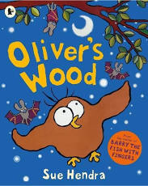](https://www.google.co.uk/aclk?sa=L&ai=DChcSEwj4w-TulZTlAhUCyt4KHZnfBzoYABABGgJ3Yg&sig=AOD64_1fHnuWme6HywInFf3sr5jdQ7aYiQ&ctype=5&rct=j&q=&ved=0ahUKEwjc4d7ulZTlAhXRUBUIHbymAzsQvhcIYA&adurl=)[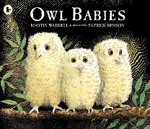](https://www.google.co.uk/url?sa=i&rct=j&q=&esrc=s&source=images&cd=&cad=rja&uact=8&ved=2ahUKEwjzyLj-8IrdAhWFIlAKHZF9DD4QjRx6BAgBEAU&url=https://www.amazon.co.uk/Owl-Babies-Martin-Waddell/dp/0744531675&psig=AOvVaw2bV0lUIydNMMcPiC6PkVWq&ust=1535378554734604)[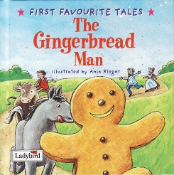](http://www.google.co.uk/url?sa=i&rct=j&q=&esrc=s&source=images&cd=&ved=&url=http://eyfs.bowlingparkprimary.net/2016/09/27/week-4-the-gingerbread-man/&psig=AOvVaw3bKtYV9YLEepIIUuZY633H&ust=1568467892860236)[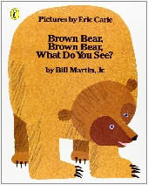](https://www.google.co.uk/url?sa=i&rct=j&q=&esrc=s&source=images&cd=&cad=rja&uact=8&ved=2ahUKEwjSt5KK7ordAhWCKlAKHU7ZADEQjRx6BAgBEAU&url=https://www.amazon.co.uk/Brown-Bear-What-Picture-Puffin/dp/0140502963&psig=AOvVaw2cj7VMPV8gxyENKFCid6Qv&ust=1535377776147257)

**As mathematicians, we will**:

Subitize 1-10

Explore Numicon and order numbers 1-10.

Learn number rhymes.

Recognise numbers 1-10 and learn how to write them (Tigers).

Compare quantities and count objects.

Make arrangements using shapes.

Match number to quantity.

Use and learn about posisional language.

Compare weight and length.

What a Wonderful World (EYFS)

**Autumn 1 2019**

This is our topic for this half term. Please use it for your own research or bring things into school that will support your child’s learning. Thank you

**As communicators, we will:** Develop

our attention and listening skills in a

variety of situations.

Build up our vocabulary.

Talk about the contents of our ‘all

about me/family’ bags.

Express our needs and follow instructions.

Hold conversations with adults and our peers.

Listen to stories and rhymes and join in with Helicopter Stories.