Literacy Challenge 1

Keep a diary of the fruit and vegetables you eat this week.
Each day draw and label the fruit and vegetables you eat.
Try something new and ask an adult to take a photo as you bite into it for the first time. Add the picture to your diary.
Add a sentence to describe what they look or taste like.
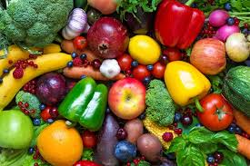

Literacy Challenge 2
Set up a healthy shop or café
Write a menu or shopping list for your shop or café.
