

FOR SALE BY PRIVATE TREATY

Gelli Gelynog

Carway, Kidwelly, Carmarthenshire SA17 4HU
Asking Price with offers invited in the region of £595.000.00

25 Acre Equestrian /Livery Centre

Gelly Gelynog offers an exceptional family / business opportunity to acquire this 25 acre established equestrian/livery centre with deceptively spacious 6 bedroom adaptable family accommodation and detached annexe due to the current owners pending retirement situated on the periphery of the village of Carway with the Fos Las race course and Glyn Abbey golf course.

The 25 acre pasture land is approached by a driveway off the B4317 and includes a woodland area with stream boundary 25 stables, various out buildings, sand school and views over the surrounding countryside.
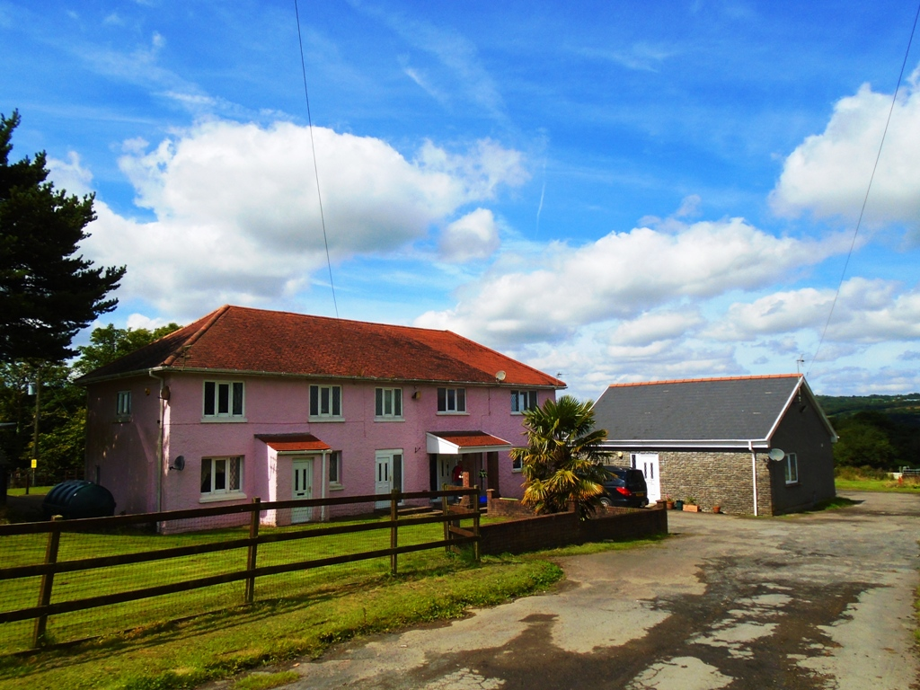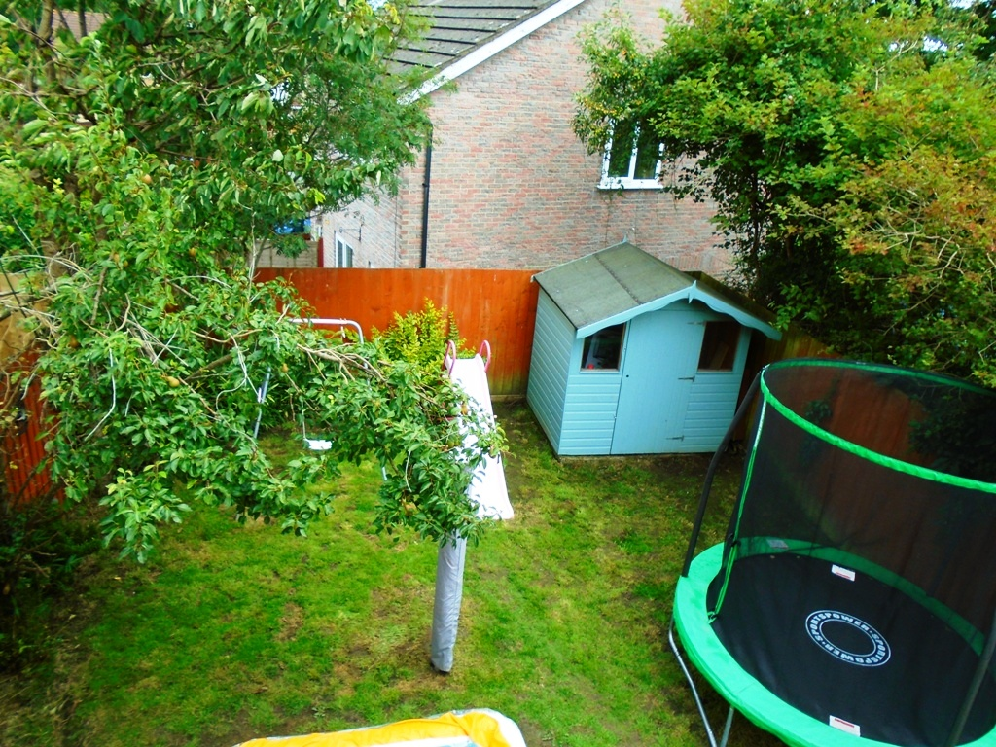
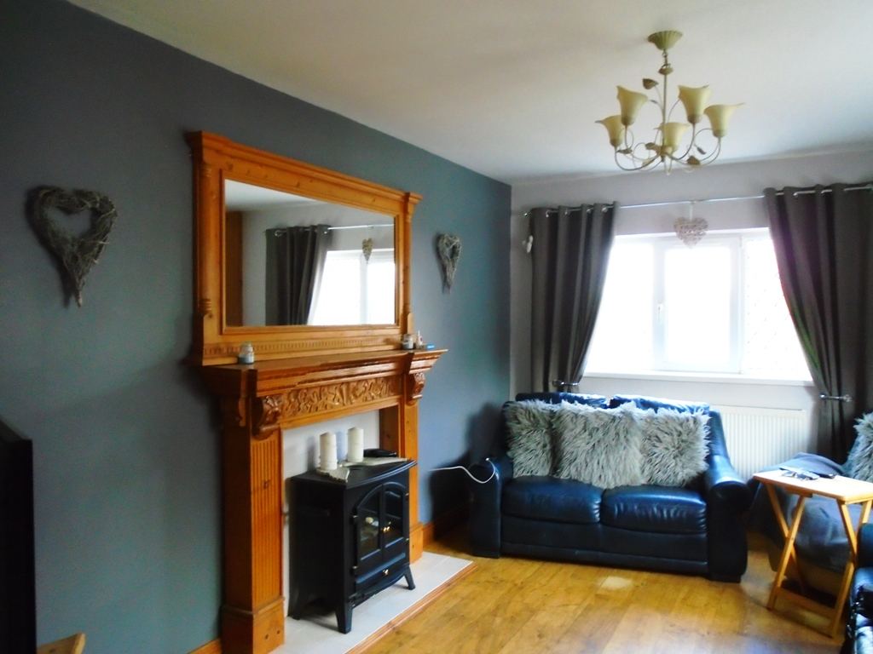

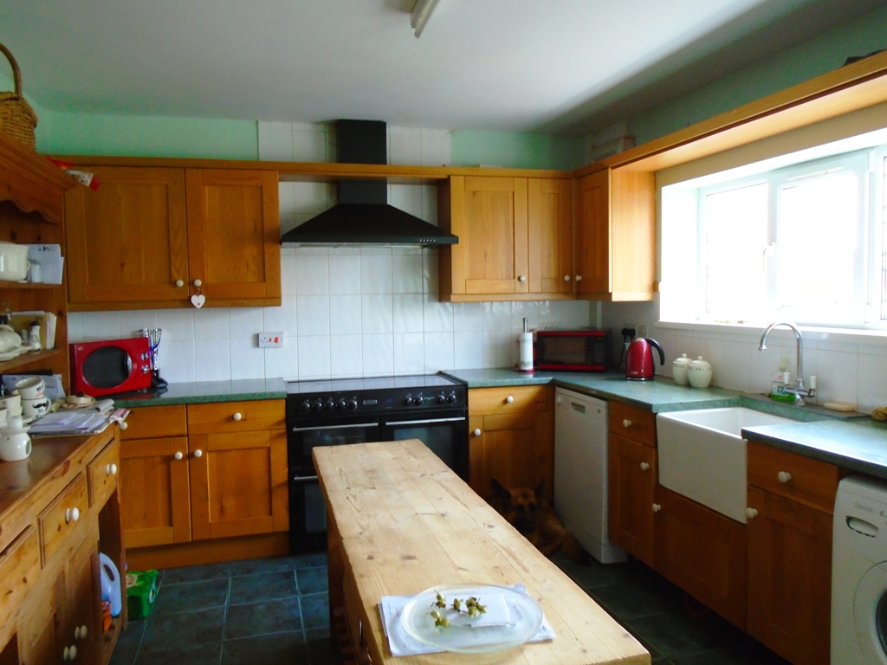

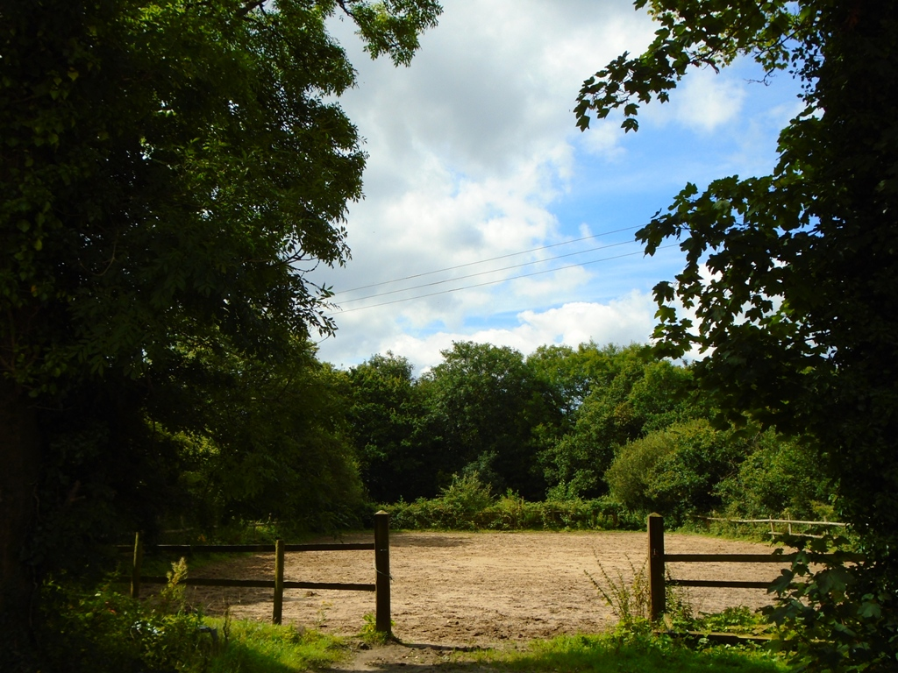
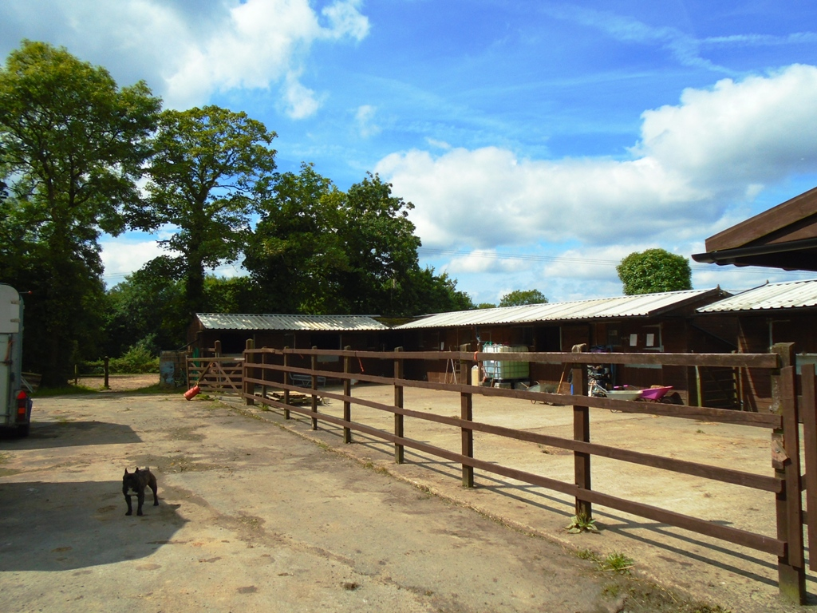
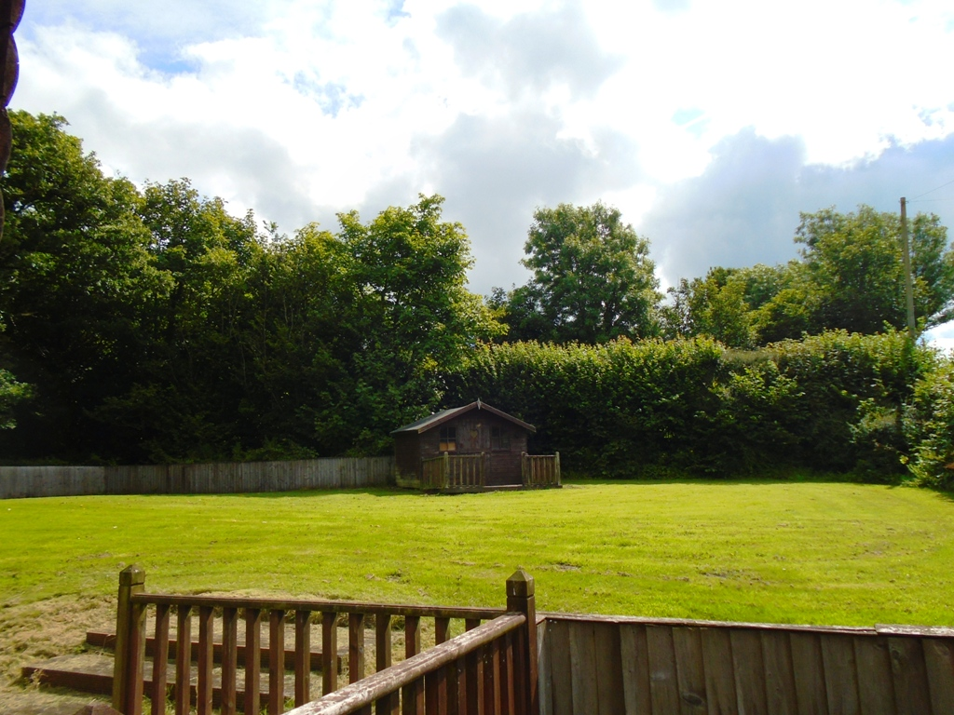

The accommodation of the main house briefly comprises 2 kitchens, 2 receptions rooms, 2 summer lounge conservatories, 6 bedrooms, 2 loft spaces, family bathrooms, master ensuite and benefits from double glazing and oil central heating. The annexe briefly comprises: lounge, bedroom, kitchen/breakfast room, shower room and benefits double glazing and oil central heating. Viewing is Strictly By Appointment Only through Swift Move Estate Agents.

Main House:
Entrance hallway: Double glazed entrance door. Staircase to first floor. Radiator. Oak finish flooring. Intern connecting door

Lounge: 15’3 x 10’7 2 double glazed windows. Electric fire in feature fireplace. Radiator. Oak finish flooring.

Kitchen/breakfast room:16’2 x 11’4 Double glazed window with open view. Double glazed door to garden. Fitted base and wall units. Work surfaces. Sink unit and drainer. Belfast sink with mixer tap. New Home Range with 4 burner ceramic hob, ovens and hot plate. Extractor canopy. Plumbing for dish washer and washing machine. Tiled floor. Radiator.

Living room/dining room: 12’9 x 11’3 Double glazed window with open view. Feature fireplace. Radiator.
Oak finish flooring. Archway leading to:

Sun lounge: 12’ x 11’3 Double glazed with dwarf. Radiator. Oak finish flooring. French doors to garden.

First floor: Staircase to attic storage 30’ x 13’6 with 3 velux windows. 4 radiators. Storage into eaves.

Bedroom 1: 14’10 x 7’ Double glazed window. Radiator. Built in wardrobe with radiator. Oak finish flooring.

Bedroom 2: 14’1 x 10’9 2 double glazed windows. Radiator. Oak finish flooring.

Master bedroom: 12’11 x 11’3 Double glazed window. Radiator. Oak finish flooring.
Ensuite: Fitted bath with shower over, wash hand basin and w.c. Radiator. Walls tiled. Laminate flooring. Double glazed tilt and turn window.

Family bathroom: Feature freestanding roll top bath bath with claw feature, wash hand basin and w.c. part tiled walls. Laminate flooring. Feature radiator. Heated towel rail.

Adjoing House No 2:
Entrance: Double glazed entrance door. 22’10 x 8’ Connecting inner door. Fitted with range of base and wall units. Work surfaces incorporating breakfast bar. Plumbing for dish washer and washing machine. Electric cooker point. Radiator. Tiled floor. Double glazed window.

Inner hallway: Staircase to first floor. Built in cupboard housing central heating boiler. Radiator. Oak finish flooring.

Dining room: 2 double glazed windows. 2 radiators. Oak finish flooring. French doors leading to:

Sun lounge: Double glazed with dwarf wall. Oak finish flooring. Radiator. French doors to garden.

Family lounge: 21’2 x 12’11 2 double glazed windows. Feature fireplace. 2 radiators.
Oak finish flooring.

First floor landing: Double glazed window. Oak finish flooring. Staircase leading to attic storage 2 velux windows. Storage into eaves.

Bedroom 1: 14’11 x 11’10 double glazed windows. Built in cupboard. Oak finish flooring. Radiator.

Bedroom 2: 13’ x 10’7 Double glazed window. Radiator. Oak finish flooring.

Bedroom 3: 22’8 x 8’ 2 double glazed windows. 2 radiators. Oak finish flooring.

Bathroom: Double glazed window. Fitted shower cubicle, bath wash hand basin and wc Heated towel rail.

Detached Annexe:
Entrance hallway: Double glazed entrance door. Radiator. Laminate flooring. Access opening to attic space with 4 radiators. 2 velux windows. Built in wardrobes.

Bedroom: 14’ x 9’ Double glazed window. Radiator.

Lounge: 13’7 x 12’7 Double glazed window. Feature fireplace with electric fire. Radiator.

Shower room: Fitted shower cubicle, wash hand basin and w.c. Part wall tiling. Radiator.

Kitchen/breakfast room: 13’7 x 8’11 Double glazed window. Fitted base and wall units. Work surfaces. Sink unit and drainer. Plumbing for washing machine. Part wall tiling. Radiator. Tiled floor. Electric oven and hob.

External: The land is separated into 4 enclosures with woodland and stream boundary. Various outbuildings which comprise in part of
Log chalet 17’11 x 17’11 light oak finish flooring. Fitted base and wall units. Work surfaces. Sink unit Water Geyser for hot water.
Office space 14’2 x 9’6 Double glazed window. Velux window. Walk in wardrobe. Cloak room: W.c. Wash hand basin. Double glazed window.

Sheltered stable block 12 x 12’ stables with 2 measuring 18’ x 12’ 12 with concrete yard with drainage, power and light. Timber tack room with toilet and wet room. 3 further stables 12’ x 11’ General purpose barn 60’ x 30’ with 3 stables 10’ x 10’ with additional 4 stable block incorporated into the barn 15’ x 15’. Sand school / exercise area. Store shed housing Trianco central heating boiler. Garden areas with decking seating areas. External lights. Cold water taps. 3 oil tanks.

Services: We have been advices that each property has own meter electric supply further details available via Vendors. Private cesspit drainage.

Tenure: Freehold – as advised by Vendors.

Council Band Rating: E

Energy Performance Rating: Main House E & D Annexe: C

ALL SIZES ARE APPROXIMATE. SERVICES AND APPLIANCES NOT TESTED BY AGENTS.

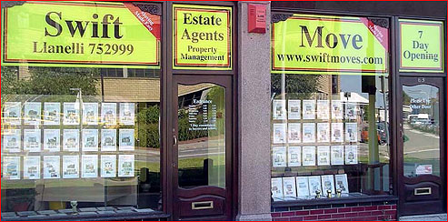

Office Opening Hours: Monday to Friday 9.30 – 5,

Saturday 9.30 – 12,

PROPERTY MISDESCRIPTIONS ACT 1991 MISREPRESENTATION ACT 1967 NOTICE
All reasonable steps have been taken to ensure These particulars are for guidance only and their
That these particulars do not contain any error, accuracy is not guaranteed and neither do they form
Mistake or misdescription as prescribed by the P.M.A. part of any offer or contract.

