Delegates meeting – 22nd July 2016
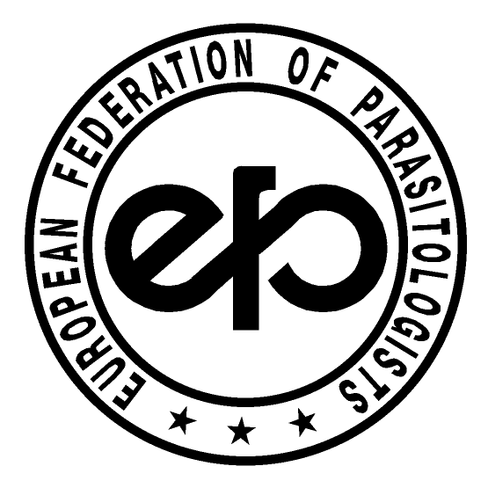
EUROPEAN FEDERATION OF PARASITOLOGISTS
- EFP -
Location: EMOP 12, Turku, Finland

- Opening
The meeting commenced at 6 pm. Present: J. Dupouy-Camet (JDC), E. Pozio (EP), Thomas Romig (TR), Antii Oksanen, Titia Kortbeek (TK) C. Holland (CH) from the Board and 25 delegates: M.B. Rokni (Iran), A. Oksanen (Finland), T. Romig (Germany), V. Cozma (Romania), , F. Bruschi (Italy), L. Rivaldi (Italy), S. Mattiucci (Italy), O. Djurkovic (Serbia), B. Webster (UK), R. Salamatin (Russia), D. Rollinson (UK), B. Gottstein (Switzerland), H. Cortes (Portugal), C. Holland (Ireland), S. Mas-Coma (Spain). T. Kuzmina (Ukraine), B. Lassen (SBSP), P. Jokelainen (Finland), J. Deksne (Latvia), E. Dvoroznakova (Slovakia), E. Papadopoulos (Greece), C. Feliu (Spain), I. Villena (France), S. Sotiraki (Greece), Kirill Galaktionov (Russia).

- Apologies for absence
Apologies from Doina Codreanu (Romania)

- Acceptance of the AGENDA
The AGENDA was approved.

- General report by the President
JDC emphasized the importance of the EFP and its increasing activity. He also stated that EFP is now 50! with 30 affiliated societies, a web page, and newsletters every 6 months. He encouraged societies and their members to provide information that they would like to disseminate.

- Treasurer’s report
EP provided a detailed presentation on the pattern of payments over the period 2012-2016. Some societies have never paid during this time period. It was noted that it is difficult to fund Young Scientist awards and scholarships if Societies do not contribute financially.
6. Revamping of the EFP bylaws
It was decided to conduct this piece of business by email, as there was not a quorum present at the meeting. The General Secretary prior to the meeting had circulated changes to the by-laws and only very minor comments were received.

7. EFP Committees
There are three expert committees associated with the EFP. These are the website and editorial committee (headed by the President), the student grants and Young student award committee (headed by the First Vice President) and the Parasitic Diseases Threat Quick Response Committee (headed by Santiago Mas-Coma). The recent outbreak of schistosomiasis in Corsica and the emerging threat of the Zikka virus in Europe underline the key importance of the PDTQR committee.

8. New EFP Board and Members
Three existing Board members have completed their eight-year term (JDC, EP, CH). The new Board will be as follows:

President: Thomas Romig (Germany)
First Vice President: Vasile Cozma (Romania)
Second Vice President: Antti Oksanen (Finland)
Treasurer: Laura Rinaldi (Italy)
General Secretary: Olgica Djurkovic (Serbia)

Members at large:
Titia Kortbeek (Netherlands)
Pierre Dorny (Belgium)
Isabelle Villena (France)
Bonnie Webster (UK)

- Senior Scientist award
The award for EMOP 12 was presented to Eduardo Pozio, for his outstanding scientific contribution to the field of Parasitology and to trichinosis in particular.

- Presentation concerning British Ecological Society Special Interest
group by Joanne Lello
Joanne Lello presented on the BES Special interest group that is a group of interested scientists focusing upon parasite and pathogen ecology and evolution. The website is http://www.britishecologicalsociety.org/
The group consists of about 300 members and anyone is free to join. The group is very keen to interact with the wider European community.
Joanne also presented on her very interesting research – PARACORT; the role of macroparasite co-infection in rodent-borne microparasite transmission.

11. Country Candidature for EMOP 12 2016
Oligica Djurkovic-Djakovic presented the bid for EMOP 13 2020 in Serbia on behalf of the Serbian Society for Parasitology. Oligica emphasized the long-standing tradition of Parasitology in the country and its geographical position in S.E. Europe at the crossroads of East and West. The proposed location is Belgrade and EMOP will take place in the last week of August with the title ”Changing climate changing parasites”. The delegates unanimously accepted the bid.

12. Any other Business
None

Celia Holland
18th August 2016

