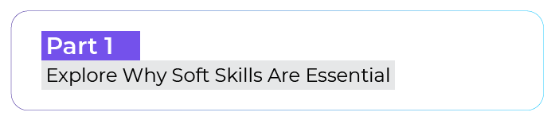


Commencez votre exploration

This assessment aims to help you become aware of your behavior and observe how you react in certain situations. There's no right or wrong answer. To keep track of your answers, you can use this guided journal or just a paper and pen. Answer straight away, without too much thinking.

You want to change jobs, and after two interviews for two different companies, both of them call you back to offer you a position. Faced with this important decision:
- It's generally a formality; you don't think too long and are ready to make your choice.
- You take a relatively long time to think about it.
- Most of the time, you ask for help or advice.
- You have great difficulty deciding, sometimes to the point of missing an opportunity.

Speaking, whether in an interview or presentation, is:
- A real pleasure – no need for preparation, you like to improvise.
- A challenge that you're ready to take on but that requires some preparation.
- Quite complicated – you've always been a little shy when speaking.
- Truly paralyzing - you might not sleep the night before the event.


Your colleagues are debating a current issue and disagree. To position yourself:
- You learn about the topics using verified sources.
- You try to present your point of view in a way that won't offend anyone.
- You say as little as possible. The less one knows about your opinions, the better off you are.
- You agree with the person who appears the most knowledgeable.


Creativity is:
- A skill that can be developed daily and applied to a large number of professions.
- A skill only used in specific occupations.
- A skill reserved for artists.
- A collection of ideas that already exist.

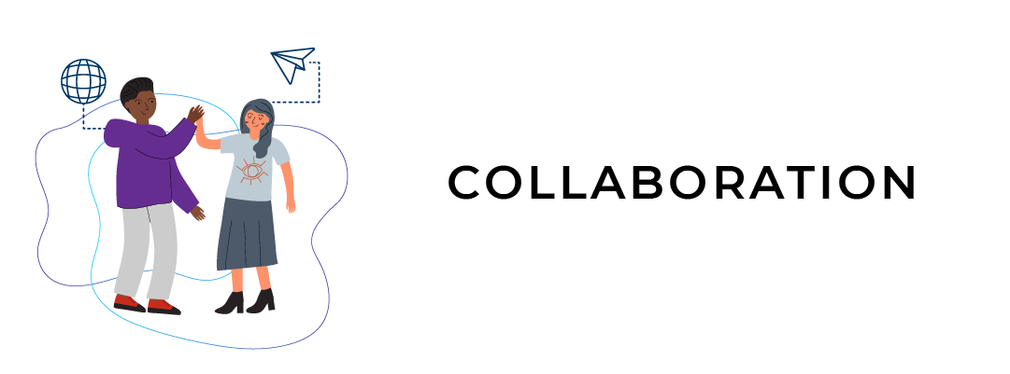
When someone (or a group) offers to collaborate with you:
- It's not a problem – you love discussing and co-developing projects with others. You'll go ahead without asking too many questions.
- You tend to ask about who you'll work with. From experience, you prefer to avoid unpleasant surprises.
- The very idea of collaborating tends to stress you out and you very hesitant.
- You try to avoid collaboration.


A new colleague joins your team. What's your reaction?
- You go directly to them and let them know how the team works and your role.
- You let them find their place and offer help and advice.
- You greet them and wait for them to come and ask you questions.
- You don't let yourself be disturbed and proceed with your usual work.


When faced with a situation that makes you angry or scares you, you tend to:
- Own the emotion and let it take control.
- Take a little time to breathe and get some perspective on the situation to manage your feelings.
- Try to ignore your emotions by acting as if they aren't there.
- Are pessimistic, resenting others for a while.


You think it's possible to learn:
- From every life situation that you go through, whether you fail, succeed, or face obstacles.
- Primarily when you're young, at school, with teachers.
- Much better when you're alone.
- By interacting with others.


In terms of organization, you tend to:
- Be very well organized.
- Have difficulty managing your priorities.
- Want to do several things at the same time.
- Quickly panic.

Have you finished?
You've already started to develop your soft skills! By taking stock of your behaviors and observing your reactions, you are already placing yourself in a learning process.

Now draw your own conclusions:
Among the situations mentioned, which scenario appeared the most difficult for you?

By contrast, in which situations do you feel most comfortable?

Explorez deux univers complémentaires : soft et hard skills

Choose three people who you think have been successful. They could be family members, former colleagues, classmates, or public figures.
Identify examples of the soft skills these people possess that have allowed them to succeed.

Name:
Hard skills: | Soft skills:

Name:
Hard skills: | Soft skills:

Name:
Hard skills: | Soft skills:

