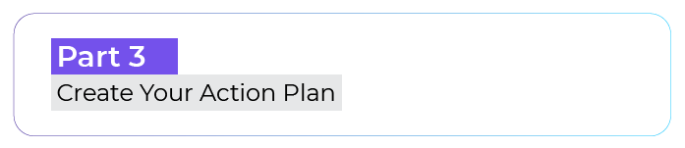


Step 1 – Formulate Your Goal
1) Identify a desire, project, dream, or goal that is close to your heart.
My desire is to...

2) Choose which soft skill you can develop to achieve this goal.
The soft skills I can develop are...

3) State your goal clearly and precisely, including the soft skill that can help you achieve it.
My goal is...

Step 2 – Check the Sincerity of Your Statement

Do you feel ready to make a real leap to achieve your soft skill goal?

If the answer is "Yes," write a mini-contract with yourself.

Starting today, I'm going to...

Step 3 – Visualize Your Skill Development

Visualize your skill-building by answering the following question: What thoughts come to mind when you think about your goal?

My goal makes me think of…

You can create a mind map using a tool, for example the XMind software.

Step 4 – Identify Your Levers and Brakes

Take your mind map and try to capture the emotions your thoughts bring up.
What thoughts evoke unpleasant emotions? Write them down, preceded by a minus sign "-."
What thoughts give you pleasant emotions? Write them down, preceded by a plus sign "+."

Step 5 – Cultivate Counter Thoughts
For each of the parasitic thoughts, you'll formulate a counter thought. It involves looking at your parasitic thinking from another angle to find a more optimistic one.
Parasitic thought n°1 : …
Counter thought : …

Parasitic thought n°2 : …
Counter thought : …

Step 6 – Act Methodically

Take Baby Steps

A baby step is a concrete action that you can apply even today without disrupting your daily life. It is often small actions, when done every day, that bring you closer to your goal.
Baby step n°1 : … Date : --/--/--
Baby step n°2 : … Date : --/--/--
Baby step n°3 : … Date : --/--/--
Baby step n°4 : … Date : --/--/--
Baby step n°5 : … Date : --/--/--
Baby step n°6 : … Date : --/--/--
Baby step n°7 : … Date : --/--/--

Take Inspiration From Role Models

Identify three people who embody the goal that you set for yourself. The goal is that you will be inspired to act by watching them. It will also motivate you to take baby steps.

Role model 1 - If I was… I would...
Role model 2 - If I was… I would...
Role model 3 - If I was… I would...

Step 7 – Rely on the Buddy System

Choose a trusted person who will be your "coach" and with whom you will discuss your progress.

Name of my buddy: ...

