
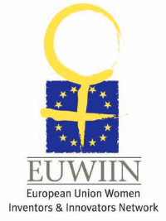
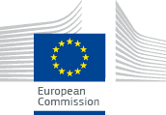

BRIDGING THE GENDER GAP

AND ACCELERATING INNOVATIVE, SUSTAINABLE GROWTH

FRINGE SESSION, STUDIO 213, MARCH 11, 2014, 9H00 – 10H45

EUROPEAN INNOVATION CONVENTION 2014 SQUARE - BRUSSELS MEETING CENTRE - RUE MONT DES ARTS, B-1000 BRUSSELS

PROGRAMME
Moderator:
Bola Olabisi, Director, European Women Inventors & Innovators Network (EUWIIN), United Kingdom

9H00 INTRODUCTION AND PURPOSE
9H05 EUROPEAN WOMEN INVENTORS & INNOVATORS NETWORK (EUWIIN)
CASE STUDIES AND CAPACITY BUILDING MEASURES - A CRUCIAL OPTION
Speakers:
Ylva Ryngebo, Managing Director, Medical Innovation Design, Sweden
Sheena Lewis, Professor, Queen's University Belfast, Northern Ireland, United Kingdom
Elinora Inga Sigurdardottir, Founder And Chairman of KVENN, QUIN - (Icelandic Women Inventors and Innovators Network) Iceland

9H55 EUROPEAN PLATFORM OF WOMEN SCIENTISTS EPWS
GENDER AND INNOVATION
Would you like to generate values within your process of Innovation? Gendered Innovations is the right resource!
Speaker:
Marie-Hélène Therre, Member of European Platform of Women Scientists, Contributor to the EU project ‘Gendered Innovations’ and Member of the European COST-GenderSTE Network, France

Gender balanced science Culture to foster Innovation
Speakers:
Brigitte Muehlenbruch, President, European Platform For Women Scientists, Germany
Claudine Hermann, Vice-President, European Platform For Women Scientists, France

10H35 INTERACTIVE DISCUSSION, with the participation of Ms Gitte Neubauer, Laureate of the EU Prize for Women Innovators 2011, and the winners of the 2014 Awards, AND CONCLUSION
10H45 CLOSE

