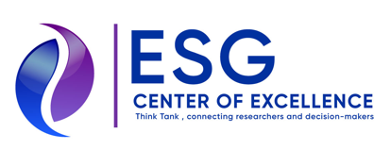

Media release, 18th June, 2026

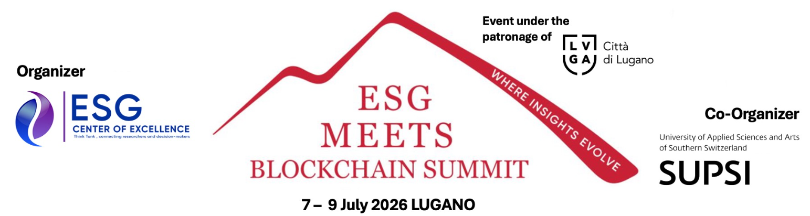

ESG Center of Excellence Award Winners 2026 are Dr. Anino Emuwa, Sir Cristopher Pissarides and the City of Lugano
The following winners of this year’s ESG Center of Excellence Awards will be honoured in occasion of the 4th ESG meets Blockchain Summit on July 8 at The University of Applied Sciences and Arts of Southern Switzerland (SUPSI).

- “Visionary Award 2026”
Dr. Anino Emuwa, Founder 100 Women @ Davos, Distinguished Fellow École de Ponts Business School

- “Academic Excellence Award 2026”
Sir Christopher Pissarides, Professor of Economics at the London School of Economics, Nobel Prize in Economics in 2010

- “Impact Award 2026”
City of Lugano

“We are very proud to honour also this year with Dr. Anino Emiuwa and Sir Christopher Pissadirdes two impressive personalities and with the City of Lugano our Host City for its various initiatives like the Plan B, the LUGA token and its blockchain based bonds, where Lugano was the World‘s first mover municipality”, says Prof. Aditya Singh (Chairman ESG Center of Excellence), who is also Chairing the jury, and he adds: "This award ceremony on July 8th will be an absolute highlight of this year’s ESG meets Blockchain Summit.”
“Also this year two additional Awards will be given during the ESG meets Blockchain Summit in the categories “Bold” and “Game-Changing”, says Marco Casanova (Director of the International Think Tank ESG Center of Excellence located in Lugano and host of the Summit) and he explains “ten shortlisted projects - of which two from SUPSI’s Start-Up Garage - will pitch on the morning of July 8. Attendees can vote for the Game-Changing and Bold awards on-site and via live stream and the Winners will be announced during the evening ceremony.”

4th ESG meets Blockchain Summit & Awards 2026 at-a-Glance
- July 7: Boat trip on Lake Lugano (on invitation only)
- July 8 (Morning):
  - Opening (Prof. Aditya Singh, Michele Foletti, Prof. Dr. Tiziano Leidi)
  - Pitch sessions by ten shortlisted projects
  - Keynote Speeches by the Award Winners
- July 8 (Evening): Award Ceremony followed by a standing dinner
- July 9: Summit continues with Inputs and Panels on Leveraging blockchain towards UN SDGs with Focus on EDUCATION & SKILLS, INFRASTRUCTURE & COMMUNITY BUILDING and on HUMAN DIGINITY
Link to the program, the speakers and the Award Winners: www.esgmeetsblockchain.com
Link to the registration: https://esgcenter-ch-events.myshopify.com/
For further information please contact: Marco Casanova (Director ESG Center of Excellence) / m.casanova@esgcenter.ch / +41 79 344 76 06 / www.esgcenter.ch

